CORE JAVA
What is Java?
Java is a popular programming language, created in 1995.
It is owned by Oracle, and more than 3 billion devices run Java.
It is used for:
- Mobile applications (especially Android apps)
- Desktop applications
- Web applications
- Web servers and application servers
- Games
- Database connection
- And much, much more!



Why Use Java?
- Java works on different platforms (Windows, Mac, Linux, Raspberry Pi, etc.)
- It is one of the most popular programming languages in the world
- It has a large demand in the current job market
- It is easy to learn and simple to use
- It is open-source and free
- It is secure, fast and powerful
- It has huge community support (tens of millions of developers)
- Java is an object-oriented language which gives a clear structure to programs and allows code to be reused, lowering development costs
- As Java is close to C++ and C#, it makes it easy for programmers to switch to Java or vice versa

Born | James Arthur Gosling  May 19, 1955 (age 69)  Calgary, Alberta, Canada
Alma mater | - University of Calgary (BSc, 1977)  - Carnegie Mellon University (MA; PhD, 1983)
Known for | Java (programming language)
Children | 2
Awards | Officer of the Order of Canada  IEEE John von Neumann Medal The Economist Innovation Award NAE Foreign Member  Fellow Computer History Museum
Scientific career
Institutions | - Sun Microsystems  - Oracle Corporation  - Google  - Liquid Robotics^{[1]}  - Amazon Web Services
Thesis | Algebraic Constraints (1983)
Doctoral advisor | Bob Sproull and Raj Reddy^{[2]}


James Gosling
James Gosling OC (born 19 May 1955) is a Canadian computer scientist, best known as the founder and lead designer behind the Java programming language.^{[3]}
Gosling was elected a member of the National Academy of Engineering in 2004 for the conception and development of the architecture for the Java programming language and for contributions to window systems.
He is known as the father of the Java programming language.[

Gosling was with Sun Microsystems between 1984 and 2010 (26 years). At Sun he invented an early Unix windowing system called NeWS, which became a lesser-used alternative to the still used X Window System, because Sun did not give it an open source license. He got the idea for the Java VM while writing a program to port software from a PERQ by translating Perq Q-Code to VAX assembler and emulating the hardware. He is generally credited with having invented the Java programming language in 1994.

3 TIER ARCHITECTURE

Database
Middleware
Web-Technologies

Sql, MySql, MangoDB
-Data Of the Application.

Core Java, Advanced Java
-Logic Of the Application.

Html, Css, JavaScript ReactJS
-Look & Feel

FRONT-END
BACK-END
DATABASE

Language

-It is Predefined set of rules and regulations that must be followed in order to established the communication between two different entities.
-Language are categorized into two types.
1]Verbal Language
2]Programming Language.
1]Verbal Language

-The type of language which we can read, write and speak that can be categorized as verbal language.
e.g. :- English,Hindi,Marathi,Spannish.

2]Programming Language

-Programming language it is set of instruction to perform a particular task by the machine which is given by the programmer is called as Programming language.
OR
-The type of language we can read, write but cannot speak that can be categorized as Programming language.
-It is generally used to communicate the machine.
-Based on its application programming language are further categorized into two types: -
-Based on its application programming language are further categorized into two types: -
- 1]General Purpose Language
- 2]Domain Specific Language.
- General Purpose Language

-The Programming Language which can be used for all the purposes is called as General-Purpose Programming language.
-With the help of General-Purpose Language, we can build entire application.
e.g. :- Java, Python, C, C++, Ruby, Dot Net.
-General purpose Programming Language are further more classified into three types.
  - High Level Language
  - Low Level Language
  - Middle Level Language.

- High Level Language
-The Programming Language which is writeable, Readable, Understandable & Executable by the programmer such language are called as High Level Programming Language.
e.g.: - Java, Python, C, C++, Ruby, Dot Net.

- Low Level Language
-The Language which is Understandable & Executable by the machine is called as Low-Level Programming Language.
e.g.: - Binary language, Assembly Language.

- Middle Level Language
-The Programming Language with having features of both Low Level & High Level Programming Language such languages are called as Middle Level programming Language.
e.g.: - Java, Python, C, C++, Ruby, Dot Net.

2]Domain Specific Language

-The Programming language which help to build only specific part of application that language can be called as Domain Specific Programming Language.
e.g.: -Sql, MySql

WHAT IS JAVA?

-Java is general purpose, Class-based, Object-Oriented Programming Language.
-Java is widely-used programming language for coding Web application. It has been a popular choice among the developers for over two decades.
-It is faster, Secure, Reliable Programming Language for coding everything from Mobile Apps and Enterprise Software to Big Data Applications and Server-Side Technologies.
-Java is a Multithreading, Object-Oriented and Network Centric Language that can be used as platform in itself.
-Currently, Java is owned by Oracle and more than 3 billion devices run Java.
-Java is a general-purpose programming language intended to let programmers Write Once, Run Anywhere (WORA). This means that compiled Java code can run on all platforms that support Java without the need to recompile.
-It is used for:
- Mobile applications (especially Android apps)
- Desktop applications
- Web applications
- Web servers and application servers
- Games
- Database connection
And much, much more.

What is Java programming language used for?
-Because Java is a free-to-use and a versatile language, it builds localized and distributed software. Some common uses of Java include:
1. Game Development
-Many popular mobile, computer, and video games are built in Java. Even modern games that integrate advanced technology like machine learning or virtual reality are built with Java technology.
2. Cloud computing
-Java is often referred to as WORA – Write Once and Run Anywhere, making it perfect for decentralized cloud-based applications. Cloud providers choose Java language to run programs on a wide range of underlying platforms.
3. Big Data
-Java is used for data processing engines that can work with complex data sets and massive amounts of real-time data.
4. Artificial Intelligence
-Java is a powerhouse of machine learning libraries. Its stability and speed make it perfect for artificial intelligence application development like natural language processing and deep learning.
5. Internet of Things
-Java has been used to program sensors and hardware in edge devices that can connect independently to the internet.

HISTORY OF JAVA?

-The history of java was very interesting Java was Originally designed for Interactive Television but it was too advanced technology for that the digital cable television industry at that time.
-The History of Java Starts with the Green Team Members also known as Green Team initiated the project to develop a language are digital device such as Set-Up Boxes, Television etc.
-The Principles of Creating Java Programming were “Simple, Robust, Portable, Platform Independent, Secured, High Performance, Multithreaded, Architecture, Neutral, Object-Oriented, Interpreted, Dynamic, Platform Independent.
-Java Programming Language was originally developed by Sun-Microsystem which has initiated by James Gosling and released in 1995 as Core Component of Sun Microsystem.

Java Name History

GreenTalk
-James Gosling was leading a team named as 'Green' team. Target of this team was to create a new project which can. Initially C++ was the original choice to develop the project. James Gosling wanted to enhance C++ to achieve the target but due to high memory usage, that idea was rejected and team started with a new language initially named as GreenTalk. The file extension used as .gt. Later this language was termed as Oak and finally to Java.

Oak
-James Gosling renamed language to Oak. There was an Oak tree in front of his office. James Gosling used this name as Oak represents solidarity and Oak tree is the national tree of multiple countries like USA, France, Romania etc. But Oak technologies already had Oak as a trademark and James team had to brainstorm another title for the language.

Finally Java
-Team put multiple names like DNA, Silk, Ruby and Java. Java was finalized by the team. James Gosling tabled Java title based on type of espresso coffee bean. Java is an island in Indonesia where new coffee was discovered termed as Java coffee. As per James Gosling, Java was among the top choice along with Silk. Finally Java was selected as it was quite unique and represented the essence of being dynamic, revolutionary and fun to say.
-Sun released the first public implementation as Java 1.0 in 1995. It promised Write Once, Run Anywhere (WORA), providing no-cost run-times on popular platforms.
-On 13 November, 2006, Sun released much of Java as free and open source software under the terms of the GNU General Public License (GPL).
-On 8 May, 2007, Sun finished the process, making all of Java's core code free and open-source, aside from a small portion of code to which Sun did not hold the copyright.
-The latest release of the Java Standard Edition is Java SE 21. With the advancement of Java and its widespread popularity, multiple configurations were built to suit various types of platforms. For example: J2EE for Enterprise Applications, J2ME for Mobile Applications.
Learn Java in-depth with real-world projects through our Java certification course. Enroll and become a certified expert to boost your career.

JAVA VERSIONS HISTORY

-Over the period of nearly 30 years, Java has seen many minor and major versions. Following is a brief explaination of versions of java till date.
Sr.No. | Version | Date | Description
1 | JDK Beta | 1995 | Initial Draft version
2 | JDK 1.0 | 23 Jan 1996 | A stable variant JDK 1.0.2 was termed as JDK 1
3 | JDK 1.1 | 19 Feb 1997 | Major features like JavaBeans, RMI, JDBC, inner classes were added in this release.
4 | JDK 1.2 | 8 Dec 1998 | Swing, JIT Compiler, Java Modules, Collections were introduced to JAVA and this release was a great success.
5 | JDK 1.3 | 8 May 2000 | HotSpot JVM, JNDI, JPDA, JavaSound and support for Synthetic proxy classes were added.
6 | JDK 1.4 | 6 Feb 2002 | Image I/O API to create/read JPEG/PNG image were added. Integrated XML parser and XSLT processor (JAXP) and Preferences API were other important updates.
7 | JDK 1.5 or J2SE 5 | 30 Sep 2004 | Various new features were added to the language like foreach, var-args, generics etc.
8 | JAVA SE 6 | 11 Dec 2006 | 1. notation was dropped to SE and upgrades done to JAXB 2.0, JSR 269 support and JDBC 4.0 support added.
9 | JAVA SE 7 | 7 Jul 2011 | Support for dynamic languages added to JVM. Another enhancements included string in switch case, compressed 64 bit pointers etc.
10 | JAVA SE 8 | 18 Mar 2014 | Support for functional programming added. Lambda expressions,streams, default methods, new date-time APIs introduced.
11 | JAVA SE 9 | 21 Sep 2017 | Module system introduced which can be applied to JVM platform.
12 | JAVA SE 10 | 20 Mar 2018 | Unicode language-tag extensions added. Root certificates, threadlocal handshakes, support for heap allocation on alternate memory devices etc were introduced.
13 | JAVA SE 11 | 5 Sep 2018 | Dynamic class-file constants,Epsilon a no-op garbage collector, local-variable support in lambda parameters, Low-overhead heap profiling support added.
14 | JAVA SE 12 | 19 Mar 2019 | Experimental Garbage Collector,Shenandoah: A Low-Pause-Time Garbage Collector, Microbenchmark Suite, JVM Constants API added.
15 | JAVA SE 13 | 17 Sep 2019 | Feature added - Text Blocks (Multiline strings), Enhanced Thread-local handshakes.
16 | JAVA SE 14 | 17 Mar 2020 | Feature added - Records, a new class type for modelling, Pattern Matching for instanceof, Intuitive NullPointerException handling.
17 | JAVA SE 15 | 15 Sep 2020 | Feature added - Sealed Classes, Hidden Classes, Foreign Function and Memory API (Incubator).
18 | JAVA SE 16 | 16 Mar 2021 | Feature added as preview - Records, Pattern Matching for switch, Unix Domain Socket Channel (Incubator) etc.
19 | JAVA SE 17 | 14 Sep 2021 | Feature added as finalized - Sealed Classes, Pattern Matching for instanceof, Strong encapsulation of JDK internals by default. New macOS rendering pipeline etc.
20 | JAVA SE 18 | 22 Mar 2022 | Feature added - UTF-8 by Default, Code Snippets in Java API Documentation, Vector API (Third incubator), Foreign Function, Memory API (Second Incubator) etc.
21 | JAVA SE 19 | 20 Sep 2022 | Feature added - Record pattern, Vector API (Fourth incubator), Structured Concurrency (Incubator) etc.
22 | JAVA SE 20 | 21 Mar 2023 | Feature added - Scoped Values (Incubator), Record Patterns (Second Preview), Pattern Matching for switch (Fourth Preview),Foreign Function & Memory API (Second Preview) etc.
22 | JAVA SE 21 | 19 Sep 2023 | Feature added - String Templates (Preview), Sequenced Collections, Generational ZGC, Record Patterns, Pattern Matching for switch etc.

-Following are the give significant point that describe the History of Java.
1]James Gosling, Mike Sheridan & Patrick Naughton initiated Project in June 1991 the small team of Sun Engineers called as Green Team.

2]Initially it was designed for small, embedded system in electronic appliance like set-up boxes.

3]Firstly it was called “GreenTalk” by James Gosling & the file extension was .g.

4]After that it was call “oak” and was developed as a part of the Green Project.

5]Why Java was named as “oak”?
-oak is a Symbol of Strength and chosen as a national tree of many countries like the USA, France, Germany, Romania etc.

6]In 1995 oak was renamed as “Java” because it was already a trademark by “oak Technologies”.

Why Java Programming Named “Java”?
-Java is island in Indonesia where the first coffee produced called Java coffee.
-It is kind of espresso bean Java name was chosen by James Gosling while having a cup of Coffee nearby his office.
-Initially developed by James Gosling at Sun Microsystem which is Now Subsidiary of oracle Corporation and released in 1995.

TYPES OF JAVA

-A Java Edition is a collection of Java libraries, APIs, and tools designed for a specific type of application. Since different applications have different requirements, Java is divided into different editions.
For example:
- A desktop application needs GUI components.
- A banking website needs security and web technologies.
- A smartwatch needs lightweight software.
- A media player needs graphics and animation.
-To meet these different needs, Java provides four editions:
- Java Standard Edition (Java SE)
- Java Enterprise Edition (Java EE)
- Java Micro Edition (Java ME).
- JavaFX

-Let’s discuss all the Java editions in detail:

1. Java Standard Edition (Java SE)
-Java Standard Edition (Java SE) is the basic and core edition of Java. It contains all the fundamental classes, libraries, and APIs required to develop general-purpose applications. It is the starting point for learning Java and forms the foundation for all other Java editions.
-Every Java programmer begins with Java SE because it includes all the essential features of the Java language.
-Main Purpose
- Develop desktop applications.
- Develop console applications.
- Learn Core Java.
- Build utility software.
- Create small and medium-sized applications.
Major Features
1. Object-Oriented Programming (OOP)
Supports:
- Classes
- Objects
- Inheritance
- Polymorphism
- Abstraction
- Encapsulation

2. Platform Independent
-Java programs can run on any operating system that has the Java Virtual Machine (JVM).
Example:
- Windows
- Linux
- macOS
-Write Once, Run Anywhere (WORA).

3. Collections Framework
-Provides ready-made data structures like:
- ArrayList
- LinkedList
- HashMap
- HashSet
- TreeMap
- Queue
- Stack

4. Exception Handling
-Helps handle runtime errors using:
- try
- catch
- finally
- throw
- throws

5. Multithreading
-Allows multiple tasks to run simultaneously.
Example:
-While downloading a file, the user can still browse the application.

6. File Handling
Supports:
- Reading files
- Writing files
- Creating files
- Deleting files

7. Database Connectivity
-Uses JDBC (Java Database Connectivity) to connect with databases like:
- MySQL
- Oracle
- PostgreSQL
- SQL Server

8. Networking
-Supports communication over the internet using:
- Socket Programming
- URL
- HTTP Connections

9. GUI Development
Provides:
- AWT
- Swing
to build desktop windows.

10. Security
Provides:
- Bytecode Verification
- Secure Class Loader
- JVM Security

Components Included in Java SE
- JVM (Java Virtual Machine)
- JRE (Java Runtime Environment)
- JDK (Java Development Kit)

Applications Developed Using Java SE
- Calculator
- Notepad
- Student Management System
- Banking Software
- Hospital Software
- Inventory Management
- Library Management

Advantages
- Easy to learn
- Platform independent
- Secure
- Robust
- Portable
- Rich API
- High Performance
- Large community support

Disadvantages
- Limited web development support
- Not suitable for very large enterprise applications
- GUI is less modern compared to newer frameworks

Real-Life Example
-A college creates software to manage student records on Windows computers.Since it is a desktop application, Java SE is the best choice.
-Java SE includes the following key components:
- Java Development Kit (JDK): The JDK is a software package that includes tools such as the Java compiler (javac), the Java Virtual Machine (JVM), and various utilities for developing and running Java applications. It also includes libraries and documentation.
- Java Runtime Environment (JRE): The JRE is a subset of the JDK and contains only the runtime components necessary to run Java applications. It includes the JVM and core class libraries.
- Core Libraries: Java Standard Edition provides a rich set of core libraries that offer functionalities for data structures, input/output operations, networking, graphical user interfaces (GUIs), and more. These libraries help developers build robust and efficient applications.
- Java APIs: Java SE includes a vast collection of APIs that developers can use to access various functionalities. These APIs cover areas like networking, file handling, concurrency, security, and more.
- Language Features: Java SE introduces the Java programming language itself, with features such as object-oriented programming, platform independence, and strong type checking.
- Compatibility: Java SE emphasizes backward compatibility, allowing older Java applications to run on newer versions of the platform without major modifications.
2. Java Enterprise Edition (Java EE)

-Java Enterprise Edition (Java EE) is an advanced edition of Java used to develop large-scale, distributed, secure, and web-based enterprise applications.
-It is built on top of Java SE.
-Today, Java EE is officially called Jakarta EE.

Main Purpose
Develop:
- Banking Systems
- E-commerce Websites
- ERP Software
- CRM Systems
- Hospital Management Systems
- Government Portals
- Airline Reservation Systems

Enterprise Means
-Enterprise applications are software used by:
- Banks
- Companies
- Government Offices
- Universities
- Hospitals
- Airlines
These applications support thousands or even millions of users.

Major Technologies
1.Servlet
Processes client requests.

2.JSP (JavaServer Pages)
Creates dynamic web pages.

3.EJB (Enterprise JavaBeans)
Implements business logic.

4.JPA (Java Persistence API)
Stores Java objects into databases.

5.JDBC
Connects Java with databases.

6.REST API
Creates web services for communication between applications.

7.Dependency Injection (CDI)
Automatically manages objects and their dependencies.

8.Security
Supports:
- Authentication
- Authorization
- Encryption

9.Transactions
-Ensures database operations are completed safely.
Example:-
Money transfer between bank accounts.

10.WebSocket
-Provides real-time communication.
Example:
Chat applications.

Features
- Distributed Computing
- Scalability
- High Security
- Transaction Management
- Session Management
- Load Balancing
- Cloud Support

Applications
- Amazon-like Shopping Website
- Banking Portal
- Railway Reservation
- Online Examination System
- Employee Portal
- University Management

Advantages
- Highly Secure
- Scalable
- Reliable
- Supports Multiple Users
- Enterprise Ready
- Cloud Compatible

Disadvantages
- Complex
- Requires Application Servers
- Higher Learning Curve

Common Servers
- Apache Tomcat
- GlassFish
- WildFly

Real-Life Example
An online banking system serving millions of customers uses Java EE because it provides:
- Security
- Transactions
- Database support
- Scalability
Commonly-used features of Enterprise Edition Java are as follows:
- Java Persistence API (JPA): It allows Java developers to access an object/relational mapping mechanism so they can manage relational data in Java applications.
- Java Server Pages (JSP): JSP is a server-side programming language used to create device-independent and dynamic ways to build web applications.
- Enterprise Java Beans (EJB): It is among the Java APIs that are used for the development of corporate applications. EJB is a server-side software component that describes the business logic of an application.
- Java Server Faces (JSF): JSF API provides elements, such as commandButtons, inputText, and more, and assists in managing their states. It also offers server-side validation, data translation, etc.

3. Java Micro Edition (Java ME)
- The full form of Java ME is Micro Edition. It is also one of the platforms of Java that was developed to facilitate mobile and embedded device applications.
-Java ME is a lightweight edition designed for devices with limited memory, processing power, and battery life.

Main Purpose
-Develop software for:
- Feature Phones
- Embedded Systems
- Smart Cards
- GPS Devices
- Printers
- Medical Equipment
- IoT Devices

Features
- Small Runtime
- Low Memory Usage
- Lightweight APIs
- Device-Specific Libraries
- Portable

Components
1.CLDC
-Connected Limited Device Configuration
-Used for low-memory devices.

2.CDC
-Connected Device Configuration
-Used for slightly powerful devices.

3.MIDP
-Mobile Information Device Profile
-Used for mobile applications.

Applications
- Nokia Games
- ATM Machines
- Barcode Scanners
- Smart TVs
- Ticket Machines

Advantages
- Lightweight
- Low Power Consumption
- Portable
- Fast

Disadvantages
- Limited Features
- Outdated for Mobile App Development
- Less Popular Today

Real-Life Example
-Old Nokia mobile phones used Java ME to run games like Snake and Bounce.

4. JavaFX

-JavaFX is a framework used to build modern, attractive, and interactive desktop applications with rich graphical user interfaces.

Main Purpose
Develop:
- Desktop Software
- Dashboards
- Media Players
- Business Applications
- Educational Software

Features
Modern UI Controls
Includes:
- Button
- Label
- Table
- Menu
- TreeView
- ListView

CSS Styling
Design applications using CSS.

Animation
Supports:
- Fade
- Rotate
- Scale
- Translate
- Timeline Animation

Multimedia
Supports:
- Audio
- Video
- Images

Charts
Provides:
- Pie Chart
- Line Chart
- Bar Chart
- Area Chart

2D and 3D Graphics
Can build:
- Games
- Visualizations
- Simulations

FXML
Separates UI design from Java code.

Scene Builder
Allows drag-and-drop UI design without writing layout code manually.

Applications
- Music Player
- Video Player
- Hospital Dashboard
- Employee Dashboard
- Attendance System
- Stock Market Dashboard

Advantages
- Beautiful User Interface
- Rich Graphics
- Multimedia Support
- Easy Styling with CSS
- Animation Support
- Responsive UI

Disadvantages
- Desktop Only
- Less Popular Compared to Web Technologies
- Requires Additional Libraries in modern Java versions

Real-Life Example
-A company wants a dashboard with animated charts, modern buttons, and videos. JavaFX is a suitable choice because it supports rich graphics and multimedia.
-Below, we have mentioned the key applications of JavaFX.
- GEONS Ground System Software (GGSS) Nasa is used in space technology.
- NEOS (New Eurovision Operations System) is used in television media.
- FORUM Carl Zeiss Meditec AG is used in the field of medicine.
- Quote Monitor application is used in the finance sector.

Comparison Table
SrNo | Feature | Java SE | Java EE (Jakarta EE) | Java ME | JavaFX
 | Full Form | Standard Edition | Enterprise Edition | Micro Edition | JavaFX Platform
 | Main Purpose | Core Java Programming | Enterprise & Web Applications | Embedded Devices | Modern Desktop GUI
 | Used For | Desktop & Console Apps | Banking, E-commerce, Enterprise Systems | Feature Phones & IoT | Desktop Applications
 | Platform | JVM | Application Server + JVM | Embedded JVM | JVM
 | GUI Support | Swing, AWT | Limited | Limited | Excellent
 | Database Support | JDBC | JDBC + JPA | Limited | Through Java
 | Web Support | No | Yes | No | No
 | Multimedia | Basic | Basic | Limited | Excellent
 | Target Users | Students & Developers | Large Organizations | Device Manufacturers | Desktop Developers

JDK [JAVA DEVELOPMENT KIT]
-Most of the beginners find it difficult to understand the difference between these jargons. In short,
- Java Development Kit (JDK) is a collection of tools used to develop, compile, debug, and run Java programs.
- Java Runtime Environment (JRE) provides the runtime environment required to run Java applications. It includes the JVM and Java libraries.
- Java Virtual Machine (JVM) is a virtual computing machine that loads and executes Java bytecode and provides platform independence.
- Just-In-Time Compiler (JIT) is a component of the JVM that improves program performance by compiling frequently executed bytecode into native machine code during runtime.
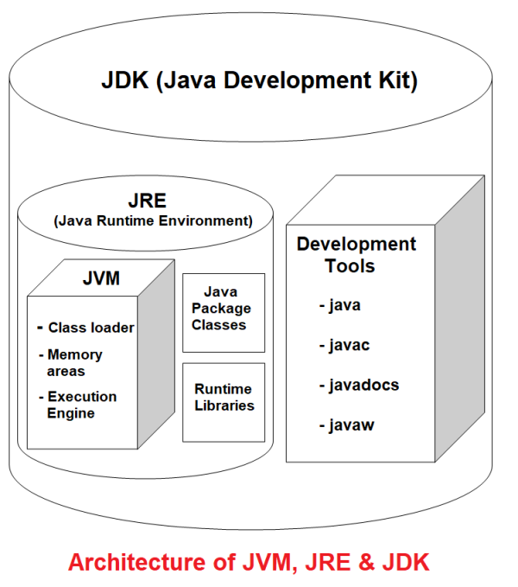

-The Java Development Kit (JDK) is a core software package used by developers to write, compile, debug, and run Java applications.
- JDK stands for Java Development Kit
- JDK is used to develop and run Java applications.
- It contains JRE + Development Tools.
- Developers need JDK to write, compile, and execute Java programs.
- It contains the compiler and debugger
- It contains all the related set of libraries and files to build and compile the java program
- Without JDK we can’t build any java program
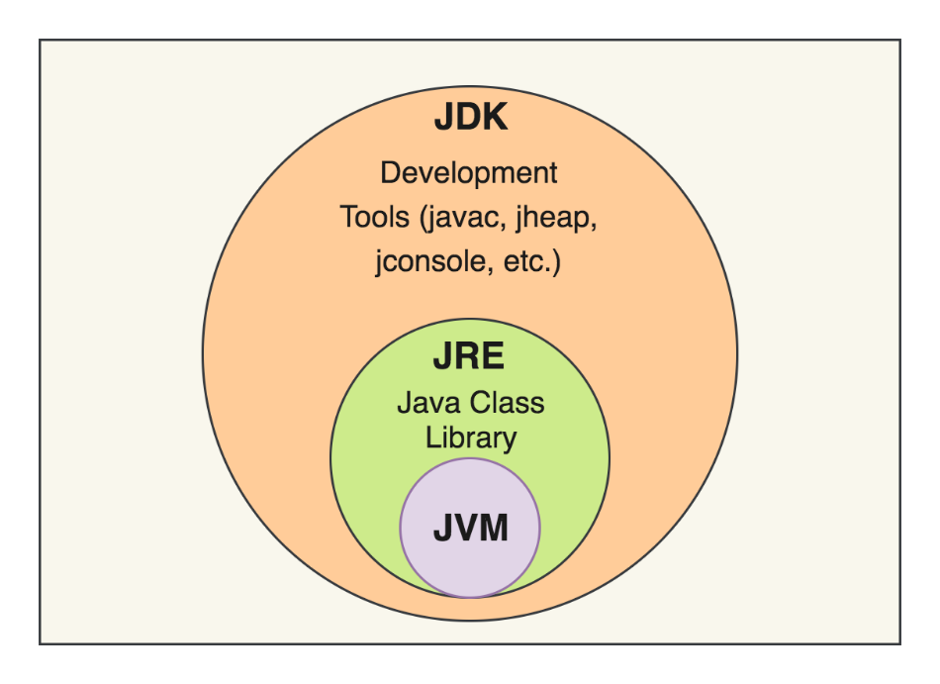
Important JDK Tools:
- javac → Compiles Java source code into bytecode.
- java → Runs Java applications.
- javadoc → Generates documentation.
- jdb → Java debugger.
- jar → Creates and manages JAR files.

Working Process of JDK
- Compilation- It consists of a Java compiler (javac) which is responsible for translating the Java code to the bytecode. The bytecode is an intermediate code that is understood by the Java Virtual Machine (JVM).
- Execution- The Java code is executed by the JVM which is a part of JDK.
- Debugging- There might be errors and bugs in our Java code which is debugged using the tools provided by JDK.

1. JRE (Java Runtime Environment)
- JRE provides the environment required to run Java applications.
- It does not contain all the development tools required for Java programming.
- It contains JVM + Java Class Libraries.
Formula:
JRE = JVM + Java Libraries
JRE Includes:
- JVM
- Java Class Libraries
- Supporting files required to run Java applications

2. JVM (Java Virtual Machine)
- JVM is responsible for executing Java bytecode.
- JVM converts bytecode into machine-understandable instructions.
- JVM makes Java platform-independent.

Installation of JDK
Step-by-Step Guide to Install JDK
Step 1: Download JDK
- Visit the Official Oracle Website:
  - Navigate to the Oracle Java Downloads page.
- Choose the JDK Version:
  - Select the desired JDK version. As of now, the latest version is JDK 21, but older versions like JDK 17 (LTS) are also available for long-term support.
- Select Your Operating System:
  - Choose the appropriate installer for your operating system:
    - Windows (.exe)
    - macOS (.dmg)
    - Linux (.tar.gz or .deb/.rpm)
- Download the Installer:
  - Click the download link and accept the license agreement to start the download.
Step 2: Install JDK on Windows
- Run the Installer:
  - Double-click the downloaded .exe file to start the installation wizard.
- Follow the Installation Wizard:
  - Click “Next” to proceed through the steps.
  - By default, JDK is installed in the C:\Program Files\Java directory. You can change this location if needed.
- Complete the Installation:
  - Once the installation is complete, click “Close” to exit the wizard.
- Set Environment Variables:
  - Open the Start menu and search for “Environment Variables”.
  - In the “System Properties” window:
    - Click “Environment Variables.”
    - Under “System Variables,” find Path and click “Edit.”
    - Add the path to the JDK’s bin directory (e.g., C:\Program Files\Java\jdk-XX\bin).
- Verify Installation:
  - Open Command Prompt and type: java -version
  - You should see the installed JDK version.

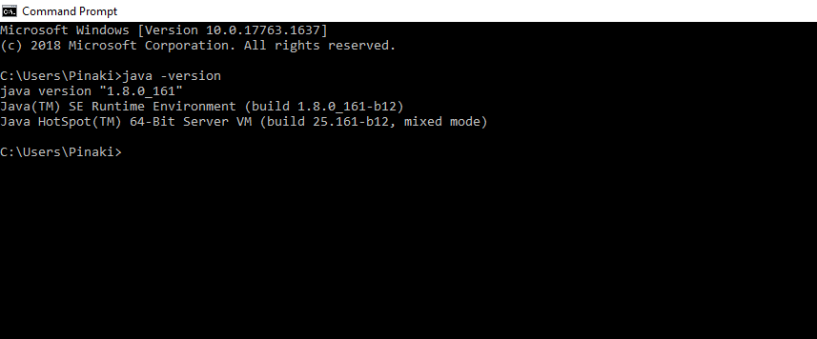

Important Components of JDK
-Below there is a comprehensive list of mostly used components of Jdk which are very useful during the development of a java application.
SrNo | Component | Use
 | javac | Java compiler converts source code into Java bytecode
 | java | The loader of the java apps.
 | javap | Class file disassembler,
 | javadoc | Documentation generator,
 | jar | Java Archiver helps manage JAR files.
 | appletviewer | Debugging of Java applets without a web browser,
 | xjc | Accepts an XML schema and generates Java classes,
 | apt | Annotation-processing tool,
 | jdb | Debugger,
 | jmc | Java Mission Control,
 | JConsole | Monitoring and Management Console,
 | pack200 | JAR compression tool,
 | extcheck | Utility tool to detects JAR file conflicts,
 | idlj | IDL-to-Java compiler,
 | keytool | The keystore manipulating tool,
 | jstatd | jstat daemon (experimental)
 | jstat | JVM statistics monitoring tool
 | jshell | jshell introduced in java 9.
 | jstack | Prints Java stack traces(experimental)
 | jrunscript | Java command-line script shell.
 | jhat | Java Heap Analysis Tool (experimental)
 | jpackage | Generate self-contained application bundles.
 | javaws | Web Start launcher for JNLP applications,
 | javah | C header and stub generator,
 | jarsigner | jar signing and verification tool
 | jinfo | configuration information(experimental)
 | javafxpackager | Package and sign JavaFX applications
Most Popular JDKs
- Oracle JDK: the most popular JDK and the main distributor of Java11,
- OpenJDK: Ready for use: JDK 15, JDK 14, and JMC,
- Azul Systems Zing: efficient and low latency JDK for Linux os,
- Azul Systems: based Zulu brand for Linux, Windows, Mac OS X,
- IBM J9 JDK: for AIX, Linux, Windows, and many other OS,
- Amazon Corretto: the newest option with the no-cost build of OpenJDK and long-term support.
JDK Development Tools
-JDK (Java Development Kit) provides various development tools that help developers write, compile, run, debug, document, inspect, and package Java applications.

JDK Development Tools
JDK Development Tools
│
├── javac → Compile Java Code
├── java → Run Java Program
├── javadoc → Generate Documentation
├── jdb → Debug Java Program
├── jar → Create JAR Files
├── javap → Inspect Bytecode
├── jshell → Run Java Code Interactively
├── keytool → Manage Keys & Certificates
├── jdeps → Analyze Dependencies
└── jlink → Create Custom Runtime

1. javac – Java Compiler
- javac stands for Java Compiler.
- It is used to compile Java source code.
- It converts Java source files (.java) into bytecode files (.class).
- The generated bytecode is executed by the JVM.
- It also checks for syntax and compilation errors.
Example
Hello.java
↓
javac
↓
Hello.class
Command
javac Hello.java

Example
public class Hello {

public static void main(String[] args) {
System.out.println("Hello World");
}
}

2. java – Java Application Launcher
- The java command is used to run Java applications.
- It starts the JVM.
- It loads the compiled .class file.
- It executes the main() method of the program.

Command
java Hello
Important Point
# Correct
java Hello
# Incorrect
java Hello.class
Flow
Hello.class
↓
java
↓
JVM
↓
Program Execution
↓
Output

3. javadoc – Documentation Generator
- javadoc is used to generate documentation for Java programs.
- It generates documentation in HTML format.
- It reads special documentation comments from Java source code.
- It is commonly used for APIs and libraries.
Javadoc Comment
/**
* This is a Javadoc comment.
*/
Example
/**
* This class displays a message.
*/
public class Hello {
/**
* Main method of the program.
*
* @param args Command line arguments.
*/
public static void main(String[] args) {
System.out.println("Hello World");
}
}

Command
javadoc Hello.java
Common Javadoc Tags
@author
@param
@return
@throws
@deprecated

4. jdb – Java Debugger
- jdb stands for Java Debugger.
- It is used to find and fix errors in Java programs.
- It allows developers to execute programs step by step.
- It helps inspect variable values during program execution.
- It can be used to set breakpoints and analyze program flow.
Compile with Debug Information
javac -g Hello.java
Start Debugger
jdb Hello
jdb Helps With
- Finding logical errors.
- Checking variable values.
- Executing code step by step.
- Setting breakpoints.
- Understanding program execution flow.

5. jar – Java Archive Tool
- jar stands for Java Archive.
- It is used to package multiple files into a single file.
- A JAR file usually has the .jar extension.
- It is commonly used to distribute Java applications and libraries.
A JAR File Can Contain
- .class files.
- Images.
- Configuration files.
- Resource files.
- Metadata.
Example
Hello.class
User.class
Product.class
↓
jar
↓
MyApplication.jar

Create a JAR File
jar cf MyApplication.jar Hello.class
Benefits
- Easy application distribution.
- Multiple files are packaged together.
- Easy deployment.
- Can contain application resources.

6. javap – Java Class File Disassembler
- javap is used to inspect compiled Java class files.
- It displays information about a .class file.
- It can display Java bytecode instructions.
- It is useful for learning Java internals and debugging.
Command
javap Hello
View Bytecode
javap -c Hello
Flow
Hello.java
↓
javac
↓
Hello.class
↓
javap
↓
Class Information / Bytecode

7. jshell – Java Shell
- jshell is an interactive Java programming tool.
- It allows developers to execute Java code directly.
- It does not require creating a complete Java class for simple programs.
- It is useful for learning, testing, and experimenting with Java code.
Start JShell
jshell
Example
System.out.println("Hello World");
Output
Hello World
Variable Example
int number = 10;
number * 2
Output
20

8. keytool – Key and Certificate Management Tool
- keytool is used to manage security keys and digital certificates.
- It is used to create and manage keystores.
- It is commonly used in Java security.
keytool Can Be Used To
- Generate keys.
- Generate certificates.
- Manage keystores.
- Import certificates.
- Export certificates.
Command
keytool -help

9. jdeps – Java Dependency Analyzer
- jdeps stands for Java Dependency Analysis Tool.
- It is used to analyze dependencies in Java applications.
- It helps identify package and module dependencies.
- It is useful for large Java applications.
Command
jdeps Hello.class
jdeps Can Analyze
- Package dependencies.
- Module dependencies.
- Library dependencies.

10. jlink – Java Runtime Image Generator
- jlink is used to create a custom Java Runtime Environment.
- It allows developers to create a smaller runtime containing only required Java modules.
- It is useful for application deployment.
Benefits
- Smaller application size.
- Includes only required modules.
- Better deployment options.
- Custom runtime environment.

Complete Java Development Process
1. Write Java Program
↓
Hello.java
↓
2. Compile Program
↓
javac
↓
Hello.class
↓
3. Inspect Bytecode
↓
javap
↓
4. Debug Program
↓
jdb
↓
5. Run Program
↓
java
↓
Output
↓
6. Generate Documentation
↓
javadoc
↓
HTML Files
↓
7. Package Application
↓
jar
↓
Application.jar

JRE [JAVA RUNTIME ENVIRONMENT]
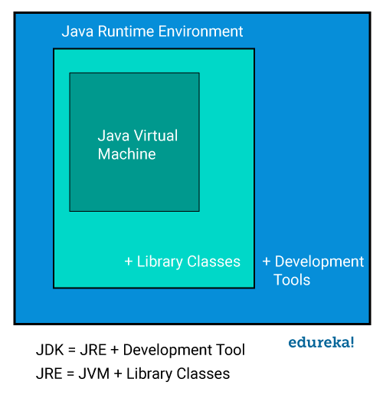
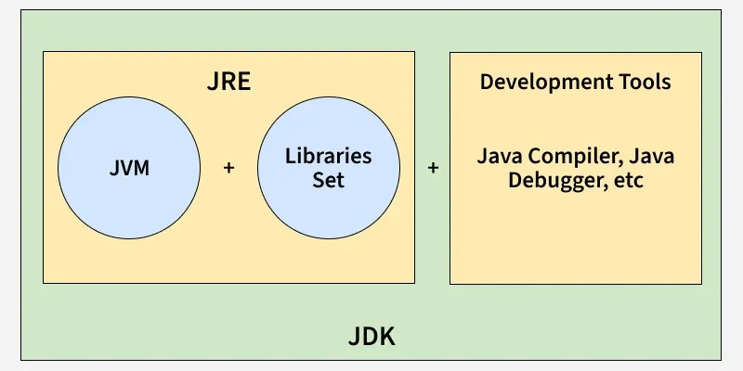

- JRE stands for Java Runtime Environment.
- It provides the environment required to execute Java programs.
- JRE contains the JVM (Java Virtual Machine).
- JRE also contains Java Class Libraries and other supporting files.
- JRE is mainly responsible for providing everything needed to run compiled Java applications.
Note: JDK is used for development, while JRE provides the runtime environment for executing Java application
Java Source Code
↓
Hello.java
↓
Java Compiler (javac)
↓
Bytecode
Hello.class
↓
JRE
│
├── JVM
├── Java Class Libraries
└── Supporting Files
↓
JVM Executes Bytecode
↓
Machine-Level Instructions
↓
Output

Working of JRE
Step 1: Java Source Code is Written
First, the developer writes a Java program.
public class Hello {

public static void main(String[] args) {
System.out.println("Hello World");
}

}

The Java source file is saved with the .java extension.
Hello.java

Step 2: Java Source Code is Compiled
The Java compiler (javac) compiles the source code.
javac Hello.java
The compiler converts:
Hello.java
↓
javac
↓
Hello.class

The generated .class file contains Java Bytecode.

Step 3: JRE Provides the Runtime Environment
When the Java application is executed using:
java Hello
-The JRE provides the environment required to run the application.
-The JRE contains:
JRE
│
├── JVM
│
├── Java Class Libraries
│
└── Supporting Files

Step 4: Java Class Libraries are Loaded
Java programs often use predefined Java classes and packages.
For example:
System.out.println("Hello World");
Here, Java uses predefined classes from the Java Class Library.
Common Java Libraries
- java.lang
- java.util
- java.io
- java.net
- java.sql
These libraries provide ready-made functionality required by Java applications.
Examples
java.lang → String, System, Math, Object
java.util → ArrayList, Scanner, Date
java.io → File and Input/Output Operations
java.sql → Database Connectivity

Step 5: JVM Loads the Bytecode
The JRE contains the JVM.
The JVM receives the compiled Java bytecode.
Hello.class
↓
JVM
The JVM loads the required .class files into memory.

Step 6: JVM Verifies the Bytecode
Before executing the program, the JVM checks the bytecode.
The JVM verifies:
- Whether the bytecode is valid.
- Whether the bytecode follows Java rules.
- Whether the bytecode is safe to execute.
Bytecode
↓
Verification
↓
Valid Bytecode
↓
Execution

Step 7: JVM Executes the Bytecode
After loading and verification, the JVM executes the bytecode.
The JVM converts bytecode into instructions that the computer can execute.
Java Bytecode
↓
JVM
↓
Machine-Level Instructions
↓
Execution

Step 8: Program Produces Output
Finally, the Java application produces the required output.
System.out.println("Hello World");
Output
Hello World

Components Involved in JRE Working
1. Class Loader
The Class Loader loads required classes into memory during program execution.
- Loads classes dynamically.
- Loads classes only when required.
- Reduces memory usage.
2. Bytecode Verifier
The Bytecode Verifier checks the generated bytecode before execution.
- Verifies code validity.
- Checks memory access rules.
- Prevents unauthorized operations.
3. Interpreter
The Interpreter executes the verified bytecode.
- Reads bytecode instructions.
- Converts them into machine-specific instructions.
- Executes the program on the underlying operating system.
Working diagram of JRE
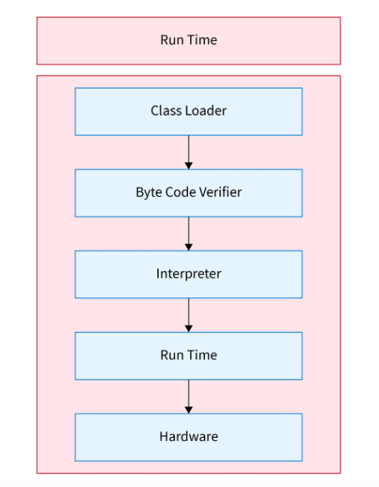
-JRE has an object of JVM with it, development tools, and library classes. To understand the working of Java Runtime Environment let us see an example of a simple Java program that prints "GeeksForGeeks".

Example:
// Java class
class GFG {

// Main driver method
public static void main(String[] args) {

// Print statement
System.out.println("GeeksForGeeks");
}
}--

Output
GeeksForGeeks

JVM [JAVA VIRTUAL MACHINE]
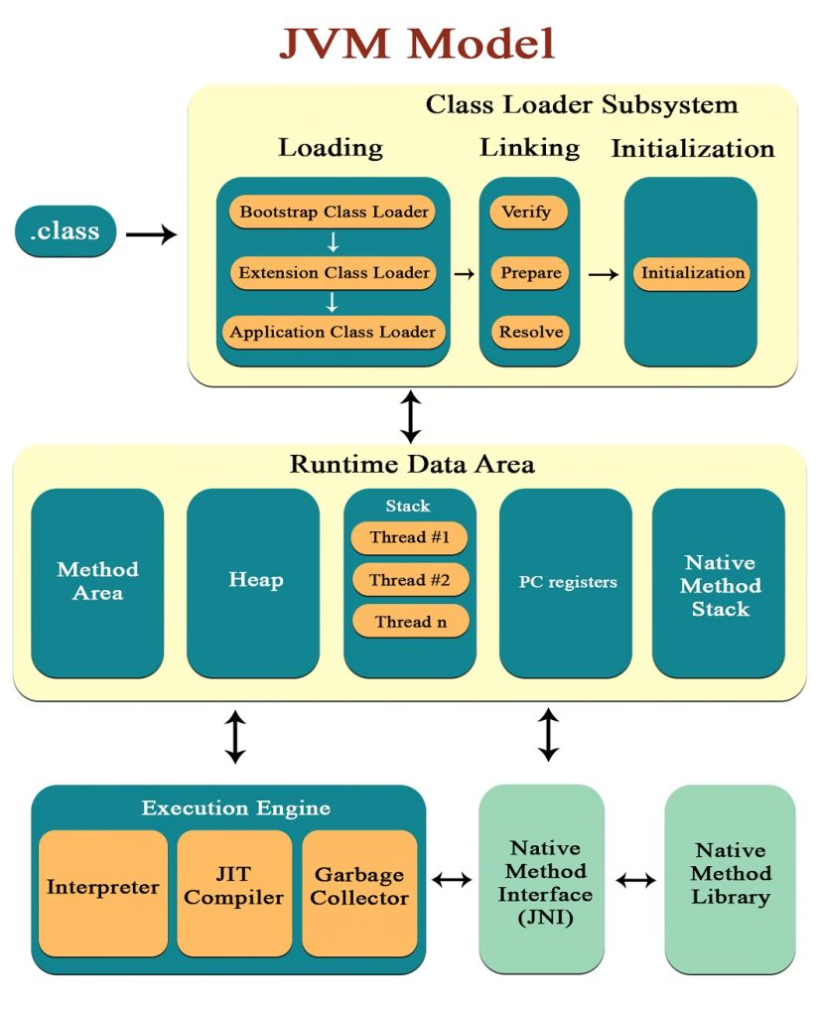

-JVM (Java Virtual Machine) is a virtual machine that provides an environment for executing Java bytecode.
-The JVM is one of the most important components of Java because it makes Java programs platform independent.
- JVM stands for Java Virtual Machine
- JVM is platform dependent
- It is responsible for executing Java bytecode.
- JVM converts bytecode into machine-level instructions.
- JVM takes (.class) files and executes it by managing the memory
- JVM contains JIT
- JVM loads, verifies and executes the code and provides the runtime environment
- It is known as a virtual machine as it is not present physically.
- JVM provides a runtime environment for Java applications.
- JVM manages memory during program execution.
- JVM performs automatic memory management using the Garbage Collector.
Working Process of JVM
- The JVM is responsible for loading, linking and initialization.
- During runtime, JVM becomes an instance of JRE.
- Loading- Loading involves bringing the bytecode of a class into memory. It is the first step of execution in JVM.
- Linking- Here, the bytecode verification takes place. The class file is parsed by the JVM and divided into basic elements like methods, fields, etc. It is important to verify the bytecode to prevent unauthorized access and ensure memory safety.
Main Components of JVM
The JVM architecture can be divided into the following components:
- Class Loader Subsystem
- Runtime Data Areas
- Execution Engine
- Native Method Interface (JNI)
- Native Method Libraries
- Initialization- During initialization, the sequence of static initializers and static fields’ execution follows the order they are defined in the code. This is to make sure that the classes are properly initialized before they are put into use.

1. Class Loader Subsystem
- The Class Loader Subsystem is responsible for loading Java class files into JVM memory.
- It loads the .class files required for program execution.
- It performs the process of loading, linking, and initializing classes.
- Java classes are generally loaded when they are needed during program execution.
Main Functions of Class Loader
- Loads .class files into memory.
- Verifies the loaded bytecode.
- Allocates memory for class-level data.
- Resolves symbolic references.
- Initializes static variables and static blocks.
Class Loader Process
Class Loading
↓
Linking
↓
Initialization

2. Loading
- Loading is the first phase of the Class Loader Subsystem.
- In this phase, the Class Loader reads the required .class file.
- The class information is loaded into JVM memory.
- The JVM creates the internal representation of the loaded class.
Example
Student.class
↓
Class Loader
↓
JVM Memory

3. Linking
- Linking is the second phase of the Class Loader process.
- It prepares the loaded class for execution.
- Linking consists of three main phases:
- Verification
- Preparation
- Resolution

3.1 Verification
- Verification checks whether the bytecode is valid.
- It ensures that the bytecode follows Java rules.
- It checks whether the .class file has the correct structure.
- It helps prevent invalid bytecode from being executed.
- It improves the security of the Java application.

3.2 Preparation
- Preparation allocates memory for static variables.
- Static variables are initialized with their default values.
- Actual values are not assigned during the preparation phase.
Example
static int number = 10;
During preparation:
number = 0

3.3 Resolution
- Resolution converts symbolic references into actual references.
- The JVM identifies the required classes, methods, and variables.
- It connects the references used in the program.
- Resolution helps the JVM locate the required program components.

4. Initialization
- Initialization is the final phase of the Class Loader process.
- Static variables are assigned their actual values.
- Static blocks are executed.
- Class initialization happens before the class is actively used.
Example
static int number = 10;

static {
System.out.println("Class Initialized");
}

5. Runtime Data Areas
- Runtime Data Areas are memory areas used by the JVM during program execution.
- JVM divides memory into different areas for different purposes.
- Some memory areas are shared by all threads.
- Some memory areas are created separately for each thread.
Main Runtime Data Areas
- Method Area
- Heap Memory
- Java Stack
- PC Register
- Native Method Stack

6. Method Area
- The Method Area stores class-level information.
- It stores information about loaded classes.
- It is shared among all threads.
- It stores static information related to classes.
Method Area Stores
- Class information.
- Method information.
- Field information.
- Static variables.
- Runtime Constant Pool.
- Method bytecode.
Example
class Student {

static String college = "ABC College";

void display() {
System.out.println("Hello");
}

}
The JVM stores class-level information related to Student in the Method Area.

7. Heap Memory
- The Heap is used to store objects.
- Arrays are also stored in Heap Memory.
- Objects are usually created using the new keyword.
- Heap Memory is shared among all threads.
- The Garbage Collector manages unused objects in Heap Memory.
Example
Student student = new Student();
Memory Representation
Stack
│
│ student
│
└──── Reference
↓
Heap
┌─────────────┐
│ Student │
│ Object │
└─────────────┘

Important Points
- Objects are stored in Heap Memory.
- Arrays are stored in Heap Memory.
- Heap is shared among threads.
- Garbage Collector manages Heap Memory.

8. Java Stack
- Every thread has its own Java Stack.
- The Java Stack stores information related to method execution.
- Each method call creates a new Stack Frame.
- When a method completes, its Stack Frame is removed.
Java Stack Stores
- Local variables.
- Method parameters.
- Method calls.
- Partial results.
- References to objects.
Example
public void display() {

int number = 10;

}
The local variable:
number
is stored in the method's Stack Frame.

9. Stack Frame
- A Stack Frame is created whenever a method is called.
- Each method gets its own Stack Frame.
- Stack Frames store data related to method execution.
- The Stack Frame is removed when the method finishes execution.
Stack Frame Contains
- Local variables.
- Method parameters.
- Operand Stack.
- Return information.
Example
┌─────────────────┐
│ method2() │
├─────────────────┤
│ method1() │
├─────────────────┤
│ main() │
└─────────────────┘

10. PC Register
- PC stands for Program Counter.
- Every thread has its own PC Register.
- It keeps track of the current JVM instruction.
- It helps the JVM know which instruction should be executed.
- It is important for managing program execution.
Example
Instruction 1
↓
Instruction 2
↓
Instruction 3
The PC Register tracks the currently executing instruction.

11. Native Method Stack
- The Native Method Stack is used when native methods are executed.
- Native methods are written in languages other than Java.
- Native methods are commonly written using C or C++.
- Each thread can use a Native Method Stack for native method execution.
- It supports interaction between Java and platform-specific code.

12. Execution Engine
- The Execution Engine is responsible for executing Java bytecode.
- It receives bytecode after the class is loaded.
- It converts and executes the bytecode.
- It is one of the main components of the JVM.
Main Components of Execution Engine
- Interpreter
- JIT Compiler
- Garbage Collector

13. Interpreter
- The Interpreter executes bytecode instruction by instruction.
- It reads one bytecode instruction at a time.
- It executes instructions sequentially.
- It helps start program execution quickly.
- Repeatedly executed code can be slower when interpreted multiple times.
Flow
Bytecode
↓
Interpreter
↓
Instruction 1
↓
Instruction 2
↓
Instruction 3

14. JIT Compiler
- JIT stands for Just-In-Time Compiler.
- JIT Compiler improves Java program performance.
- It identifies frequently executed code.
- Frequently executed code is often called Hot Code.
- JIT converts frequently executed bytecode into native machine code.
- The generated machine code can be reused for faster execution.
Flow
Frequently Used Bytecode
↓
JIT Compiler
↓
Machine Code
↓
Faster Execution

15. Garbage Collector
- The Garbage Collector (GC) automatically manages memory.
- It mainly works with objects stored in Heap Memory.
- It identifies objects that are no longer reachable.
- It reclaims memory occupied by unused objects.
- Developers do not need to manually free Java object memory.
Example
Student student = new Student();

student = null;
The object may become eligible for Garbage Collection if no other reference points to it.
Important Points
- Garbage Collection is automatic.
- It helps manage Heap Memory.
- It removes unreachable objects.
- It reclaims unused memory.
- The exact time of Garbage Collection is not guaranteed.

16. Java Native Interface (JNI)
- JNI stands for Java Native Interface.
- JNI allows Java code to interact with native code.
- It acts as a bridge between Java and other programming languages.
- Native code is commonly written in C or C++.
- JNI allows Java applications to use platform-specific functionality.
Flow
Java Program
↓
JNI
↓
Native Code
(C / C++)

17. Native Method Libraries
- Native Method Libraries contain native code required by Java.
- These libraries are platform-specific.
- They are generally written in languages such as C or C++.
- Java accesses these libraries using JNI.
- They help Java interact with the underlying operating system.
Flow
Java Code
↓
JNI
↓
Native Method Library
↓
Operating System

JIT [JUST IN TIME]
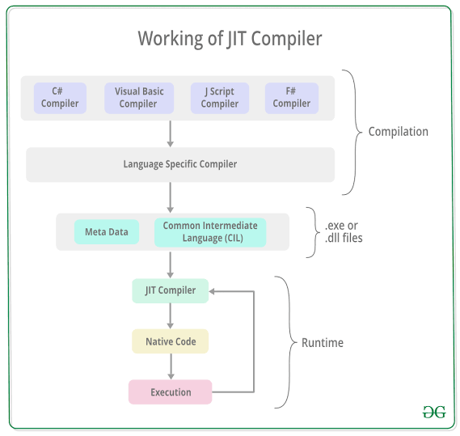
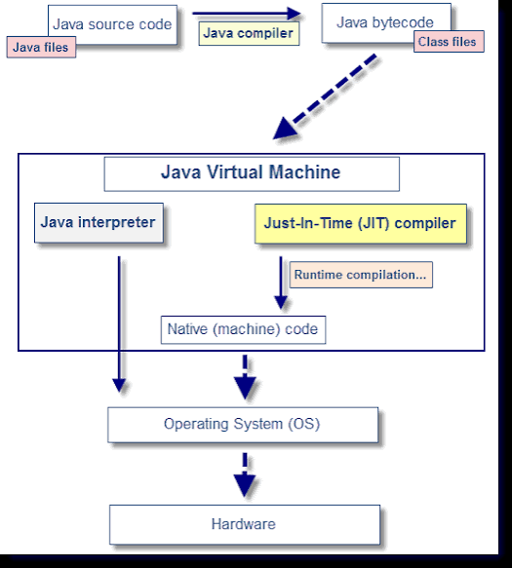
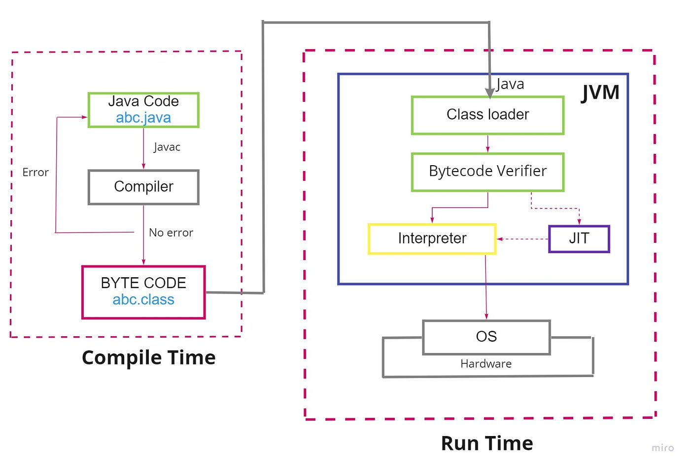
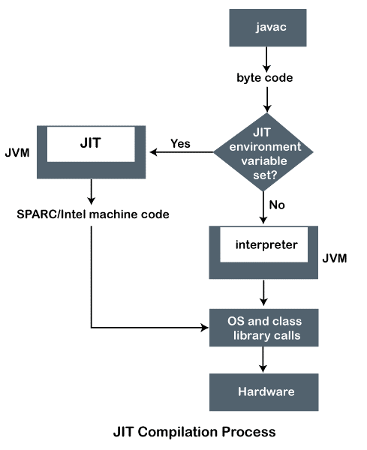

1. What is JIT Compiler?
- JIT stands for Just-In-Time Compiler.
- JIT Compiler is a component of the JVM Execution Engine.
- It is used to improve the performance of Java applications.
- It converts Java bytecode into native machine code during program execution.
- The compiled machine code can be executed faster by the computer.

2. Why is JIT Compiler Needed?
Before understanding JIT, we need to understand the Interpreter.
- The Interpreter executes bytecode instruction by instruction.
- If the same code is executed multiple times, the Interpreter may interpret it repeatedly.
- Repeated interpretation can reduce performance.
- JIT helps solve this problem by compiling frequently executed code into machine code.
Without JIT
Bytecode
↓
Interpreter
↓
Execute Instruction
↓
Execute Again
↓
Execute Again
↓
Slower for Repeated Code

With JIT
Bytecode
↓
JIT Compiler
↓
Machine Code
↓
Stored for Reuse
↓
Faster Execution

3. How JIT Compiler Works
- When a Java program starts, the JVM begins executing bytecode.
- The JVM initially uses the Interpreter to execute bytecode.
- The JVM identifies code that is executed frequently.
- Frequently executed code is called Hot Code.
- JIT Compiler compiles Hot Code into native machine code.
- The compiled machine code is then reused for faster execution.

4. JIT Working Process
Java Program
↓
Java Compiler (javac)
↓
Bytecode (.class)
↓
JVM
↓
Interpreter
↓
Identify Frequently Executed Code
↓
Hot Code
↓
JIT Compiler
↓
Native Machine Code
↓
Faster Execution

5. What is Hot Code?
- Hot Code is code that is executed frequently during program execution.
- JIT Compiler identifies frequently used methods or code sections.
- JIT focuses on compiling Hot Code to improve performance.
- Not every piece of Java code needs to be immediately compiled by JIT.
Example
for (int i = 1; i <= 1000; i++) {
System.out.println(i);
}
- The code inside the loop is executed repeatedly.
- The JVM may identify frequently executed code as Hot Code.
- JIT can optimize and compile frequently executed code.

6. JIT Compiler and Interpreter
Interpreter
- Executes bytecode instruction by instruction.
- Starts program execution quickly.
- Does not need to compile the complete program before execution.
- Can be slower for repeatedly executed code.
JIT Compiler
- Compiles frequently executed bytecode into machine code.
- Improves performance for repeatedly executed code.
- Optimizes code during runtime.
- Reuses compiled native code.

7. Interpreter vs JIT Compiler
Interpreter | JIT Compiler
Executes bytecode instruction by instruction | Compiles bytecode into native machine code
Starts execution quickly | Improves performance during execution
May execute the same bytecode repeatedly | Reuses compiled machine code
Better for initial execution | Better for frequently executed code
Can be slower for repeated code | Faster for repeated code

8. Example of JIT Working
-Consider the following code:

public class Demo {

public static void main(String[] args) {

for (int i = 1; i <= 100000; i++) {
calculate();
}

}

public static void calculate() {
int result = 10 * 20;
}

}

Initial Execution
- The JVM starts executing the program.
- The Interpreter executes the bytecode.
- The calculate() method is called repeatedly.
calculate()
↓
calculate()
↓
calculate()
↓
calculate()
JVM Detects Hot Code
- The JVM detects that calculate() is executed many times.
- The method becomes a candidate for JIT compilation.
Frequently Executed Method
↓
Hot Code
JIT Compilation
- JIT Compiler converts the frequently executed bytecode into native machine code.
Bytecode
↓
JIT Compiler
↓
Machine Code
Faster Execution
- The JVM can use the compiled machine code for subsequent execution.
- This improves application performance.

9. JIT Compiler Optimizations
JIT Compiler can perform runtime optimizations.
Some common optimizations include:
- Method inlining.
- Loop optimization.
- Dead code elimination.
- Code optimization.
- Optimization based on runtime information.
JIT can use information collected while the program is running to make optimization decisions.

10. Method Inlining
- Method inlining is an optimization technique.
- JIT may replace a method call with the method's actual code.
- This can reduce method call overhead.
- It can improve program performance.
Example
public int add(int a, int b) {
return a + b;
}
Instead of repeatedly calling:
add(10, 20);

-JIT may optimize the execution internally.

11. Advantages of JIT Compiler
- Improves Java application performance.
- Reduces repeated interpretation of frequently executed code.
- Converts bytecode into native machine code.
- Uses runtime information for optimization.
- Improves the execution speed of Hot Code.
- Compiled code can be reused during program execution.

12. JIT Compiler Limitations
- JIT compilation requires additional CPU resources.
- JIT compilation requires memory.
- Compilation itself takes some time.
- Performance may improve after the application has been running for some time.

13. JIT Compiler Position in JVM
JVM
│
├── Class Loader
│
├── Runtime Data Areas
│
└── Execution Engine
│
├── Interpreter
│
├── JIT Compiler
│
└── Garbage Collector

14. Complete JIT Working Flow
Java Source Code
↓
javac
↓
Bytecode
(.class)
↓
JVM
↓
Interpreter Starts Execution
↓
Code Executed Frequently?
│
├── No
│ ↓
│ Continue Interpretation
│
└── Yes
↓
Hot Code
↓
JIT Compiler
↓
Machine Code
↓
Faster Execution

JDK vs JRE vs JVM
Aspect | JDK | JRE | JVM
Full Form | Java Development Kit | Java Runtime Environment | Java Virtual Machine
Purpose | Develop and run Java applications | Provide the runtime environment | Execute Java bytecode
Main Users | Developers | Application users/runtime environments | Runtime engine
Contains | Development tools + runtime components | JVM + runtime libraries | Execution engine and runtime subsystems
Compiler | Includes javac | Does not provide the compiler | Does not compile .java source code
Runs Java programs | Yes | Yes, conceptually | Yes
Platform | JDK builds are platform-specific | Runtime implementation is platform-specific | JVM implementation is platform-specific
Bytecode | Produces bytecode using javac | Provides environment to run bytecode | Executes bytecode
Memory Management | Through its JVM/runtime | Through its JVM | Directly manages runtime memory
Garbage Collection | Through its JVM | Through its JVM | Performs garbage collection

FEATURES OF JAVA

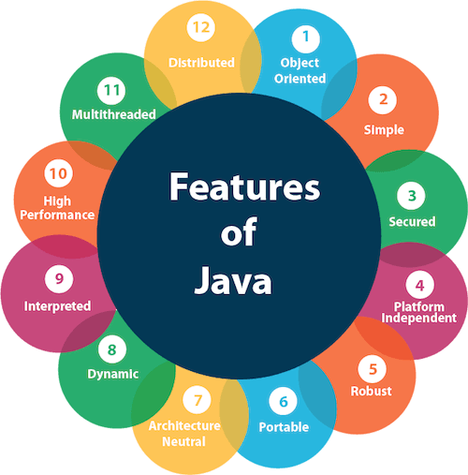

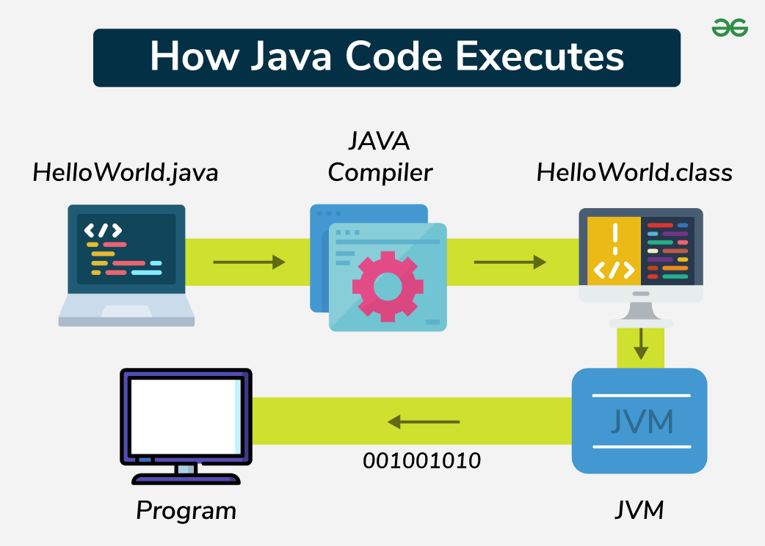
-The execution of a Java application code involves three main steps:
1. Creating the Program
-Java programs are written using a text editor or an Integrated Development Environment (IDE) like IntelliJ IDEA, Eclipse, or NetBeans. The source code is saved with a .java extension.
2. Compiling the Program
-The Java compiler (javac) converts the source code into bytecode, which is stored in a .class file. This bytecode is platform-independent and can be executed on any machine with a JVM.
3. Running the Program
-The JVM executes the compiled bytecode, translating it into machine code specific to the operating system and hardware.

CLASS
-In Java, a class is a user-defined blueprint or template from which objects are created.
Core Components
-A standard Java class typically contains:
- Fields (Attributes): Variables that represent the state or data of an object.
- Methods: Blocks of code that define the actions or behaviors an object can perform.
- Constructors: Special methods used to initialize new objects when they are created.
- Blocks: Groups of code that run when the class is loaded or an object is instantiated.
Key Characteristics
- Memory Allocation: A class itself does not occupy memory; memory is only allocated when an object is instantiated using the new keyword.
- Naming Convention: Class names should always start with an uppercase letter, and the source file name must match the public class name (e.g., public class MyClass must be in MyClass.java).
- Access Control: You can use modifiers like public, private, or protected to control which other classes can see or use your class.
- Root Class: In Java, every class implicitly inherits from the java.lang.Object class, which is the root of the class hierarchy.

Types of Classes
-Depending on how they are declared, classes can be:
- Concrete Class: A standard, fully implemented class that can be instantiated.
- Abstract Class: A class declared with the abstract keyword that cannot be instantiated and may contain unimplemented methods.
- Final Class: A class that cannot be inherited or subclassed (e.g., the String class).
- Inner/Nested Class: A class defined inside another class to group related functionality.

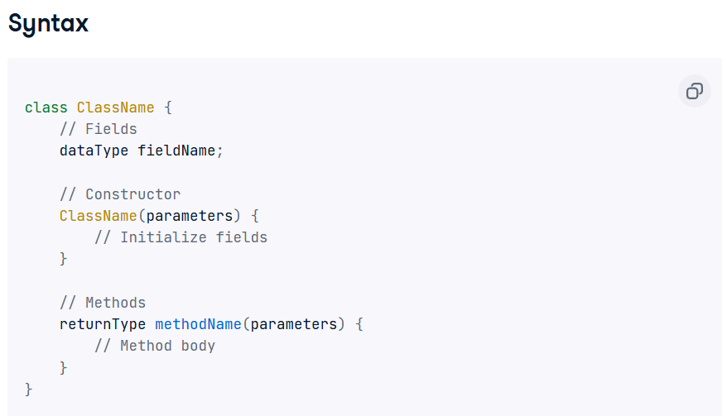
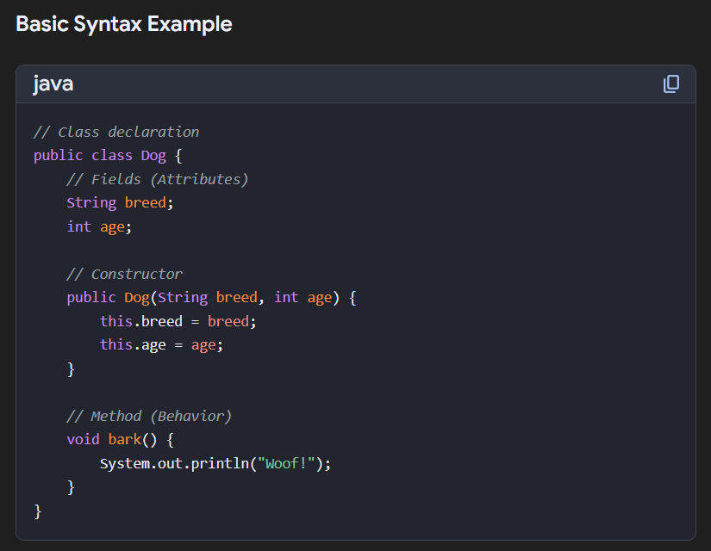

OBJECT
What is Object in Java?
-An Object is Real world entity.
-An object is a Runtime entity.
-The object is an entity which has State and Behaviour.
-The object is an instance of a class.
- In Java, an object is a fundamental unit of Object-Oriented Programming (OOP) that represents a real-world entity
Characteristics of Object
- State: Values stored in fields.
- Behavior: Actions defined through methods.
- Identity: Distinguishes one object from another.
1.Identity (Distinctness):
-Every object has a unique identifier that sets it apart from other objects, even if they share the same state, as discussed on TechTarget.
2.State (Attributes/Properties):
-This represents the data or current condition of the object, stored in fields or variables, according to Brainly.in and Study.com. This data can change over time.
3.Behavior (Methods/Actions):
-This defines what an object can do, implemented via methods that allow it to interact, process data, or respond to other objects,

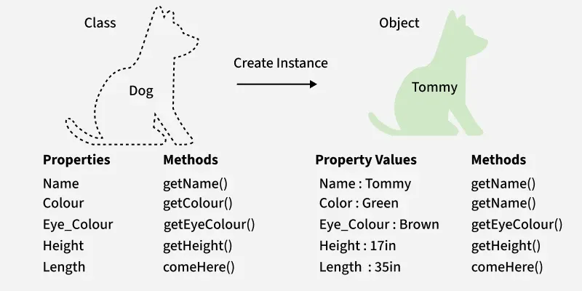
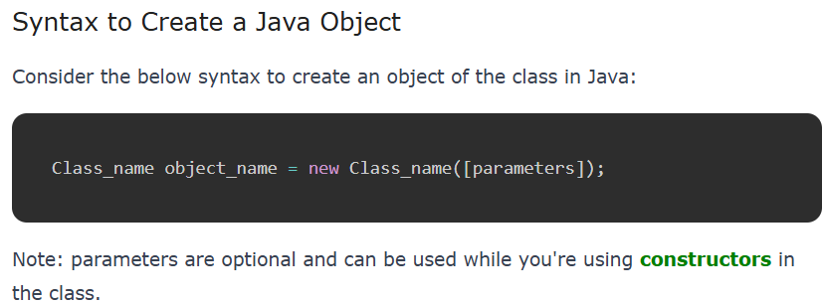

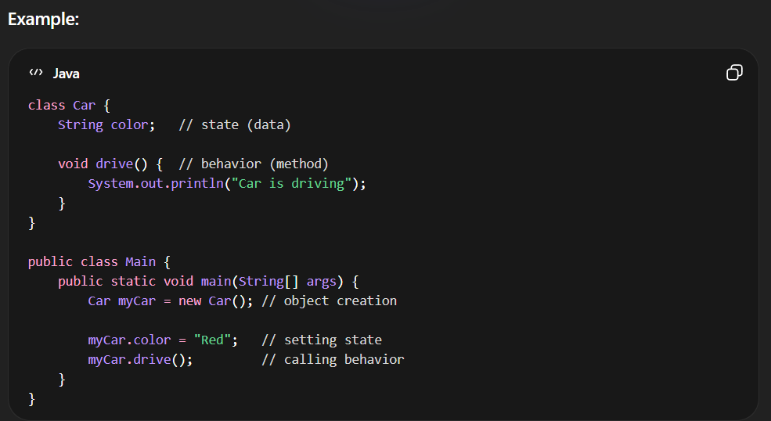
Object Instantiation
-Creating an object is known as instantiation. All instances of a class share structure and behavior while storing different state values.
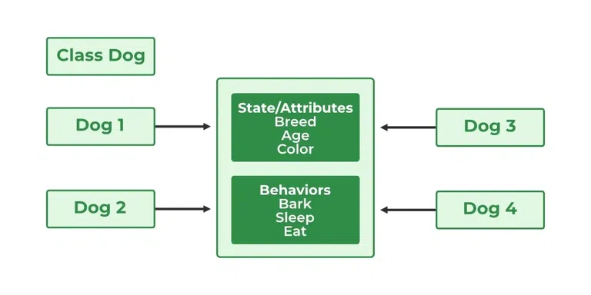

Declaration:
Dog tuffy;
-This only declares a reference. The object is not created and the reference holds null.
Initialization:
tuffy = new Dog("Tuffy", "Papillon", 5, "White")
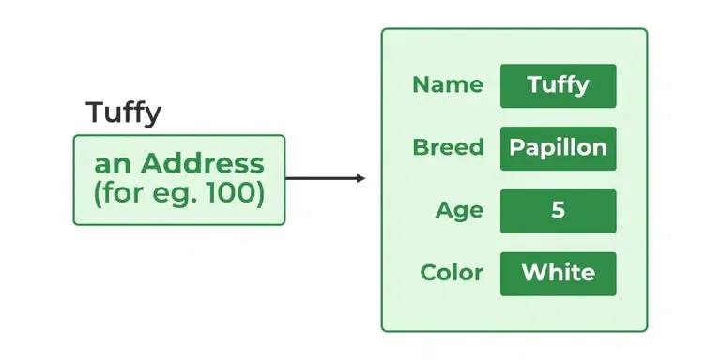
ESCAPE SEQUENCE CHARACTER
Common Java Escape Sequences
SrNo | Sequence | Description | Use Case Example
 | \n | New Line | Move text to the next line.
 | \t | Tab | Insert a horizontal tab (space).
 | \" | Double Quote | Insert " inside a string literal.
 | \\ | Backslash | Insert a literal \ character.
 | \' | Single Quote | Insert ' in a character or string literal.
 | \r | Carriage Return | Move the cursor to the start of the line.
 | \b | Backspace | Delete the preceding character or move back.
 | \f | Form Feed | Old method for page breaks.

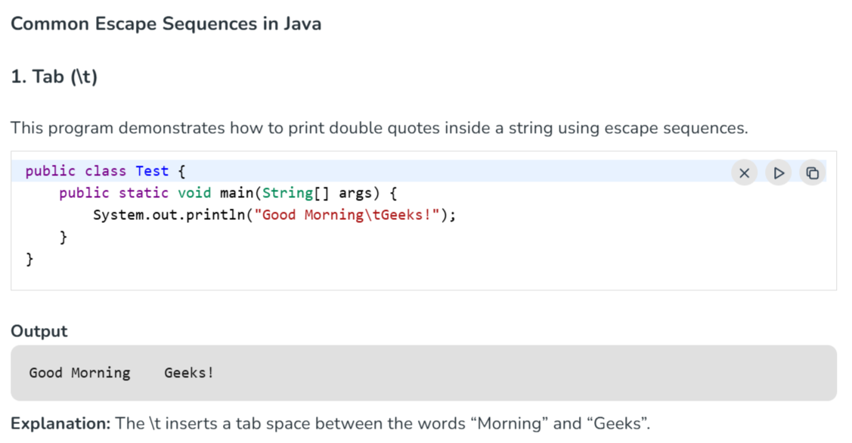
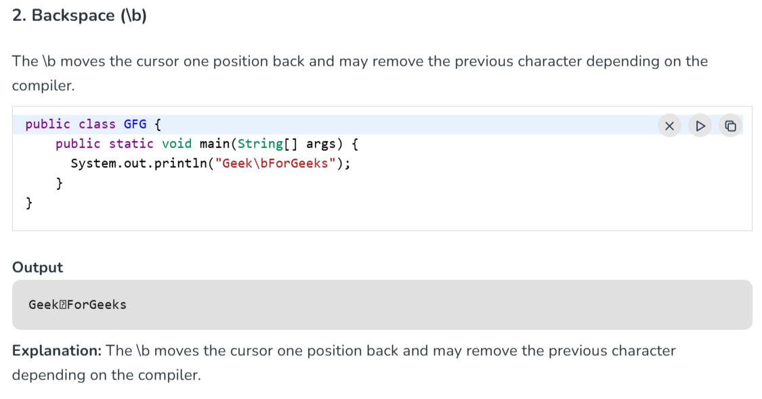
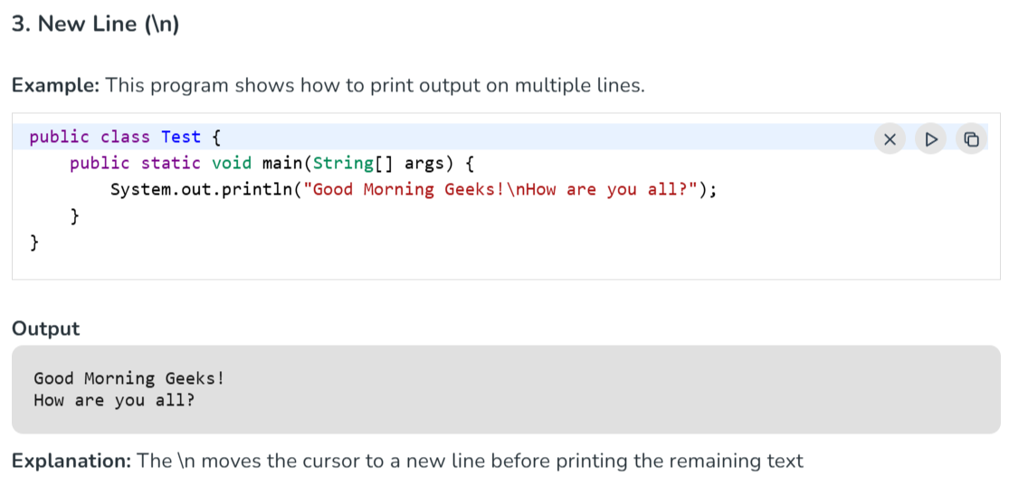
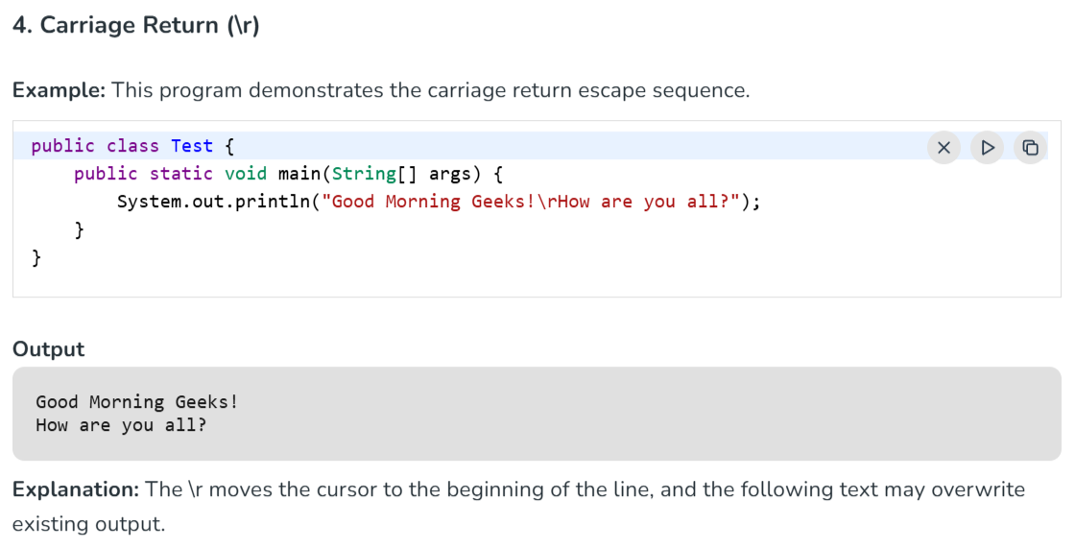
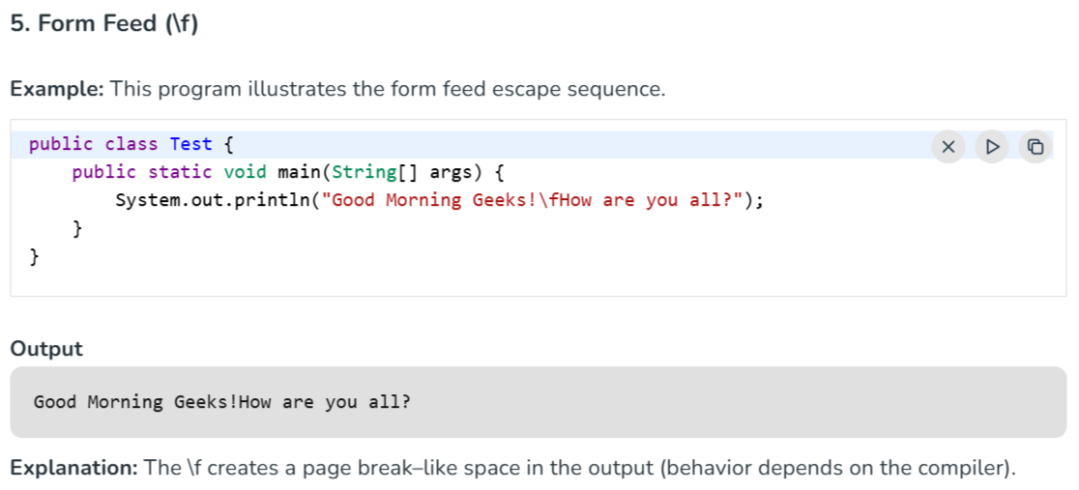
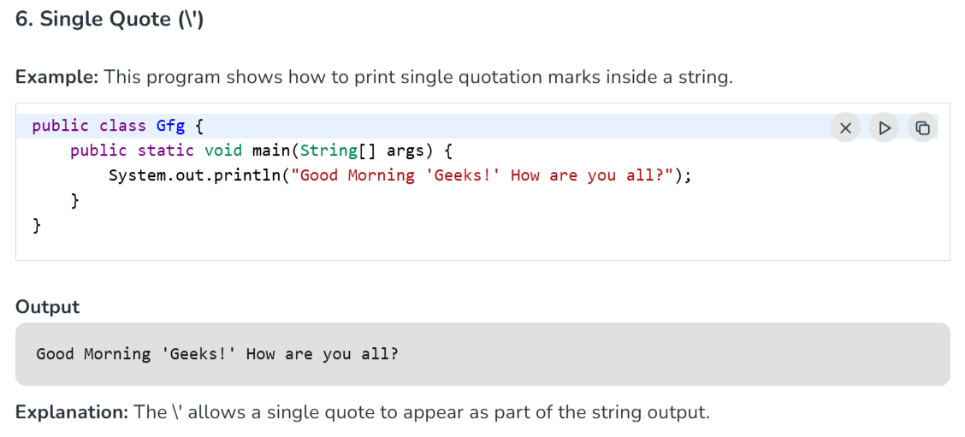
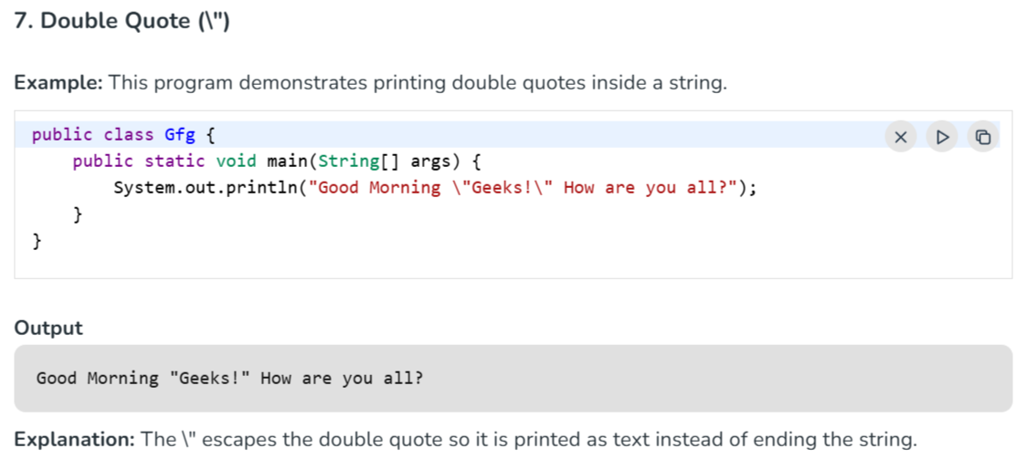
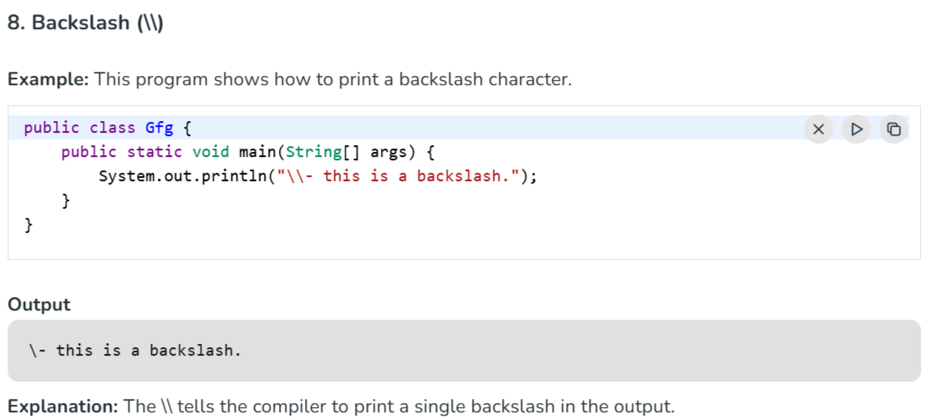

TOKENS

-Tokens are the smallest elements of Java.
-Token are classified into: -
1]KEYWORDS
2]IDENTIFIERS
3]SEPERATORS
4]LITERALS

- KEYWODRS

-Keywords are the words whose meaning actually known by the Compiler.
-There are 53 keywords in Java.
-The Keyword are the Predefined Words.
-Keywords are the Reserved words in Java.
-We can identify Keywords of Java in: -
1]They are Highlighted in Blue Colour.
2]They are written in terms of Lowercase.
e.g.:- class, public static, void etc
JAVA KEYWORD
abstract | assert | boolean | break | byte
case | catch | char | class | const
continue | default | do | double | else
enum | extends | final | finally | float
for | goto | if | implements | import
int | instance of | interface | long | native
new | package | private | public | protected
return | short | static | strictfp | super
switch | synchronized | this | throw | throws
transient | try | void | volatile | while

-Beside these keywords you cannot use true false & null as identifiers because it is Literals.

2.IDENTIFIERS

-Identifiers its name given for elements of Java for Identification purpose by Programmer.
-Elements of Identifiers in Java are: -
1]ClassName
2]VariableName
3]MethodName
4]InterfaceName
5]PackageName
Class Naming Conventions

RULES: -
1]Program Name should be start with letter (A-Z) (a-z)
Either its Uppercase or Lowercase depends on Company Standards.
e.g.: -Program.java
Not Mandatory
program.java
2]We cannot give space between Program Name.

3]The Underscore (_) and Doller ($) symbol are used between Program name.

4]The Program Name cannot start with Numeric Values.

3.LITERALS
-Literals in Java are constant values assigned directly to variables, such as numbers, characters, strings, and boolean values.
OR
-A literal is a value that does not change and is directly used in a program.
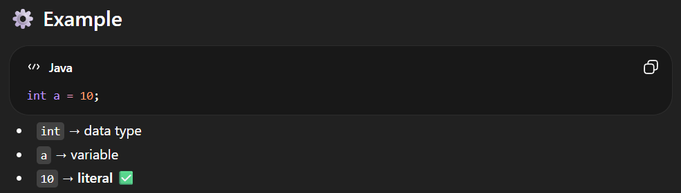

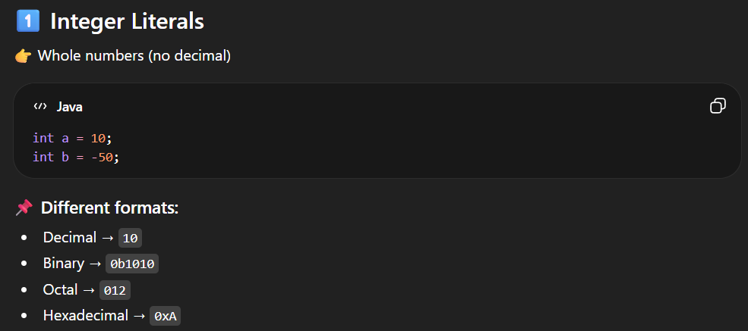
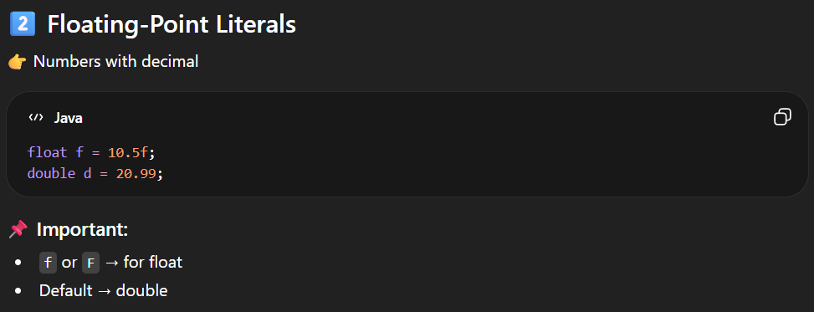
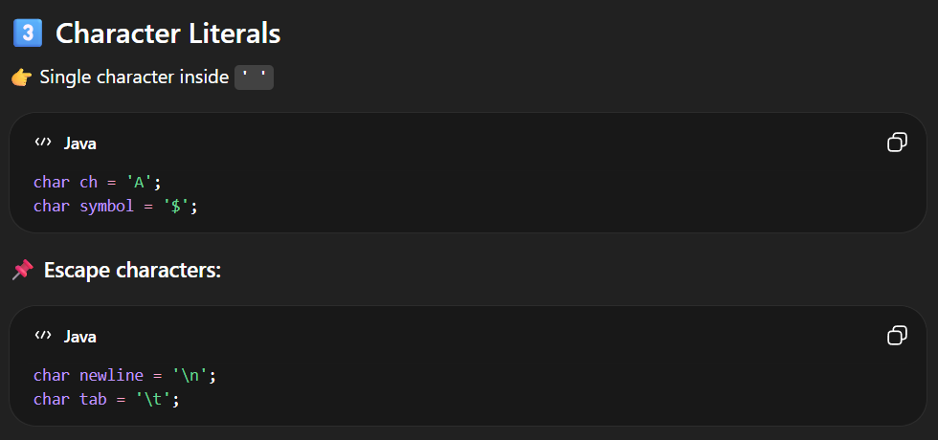
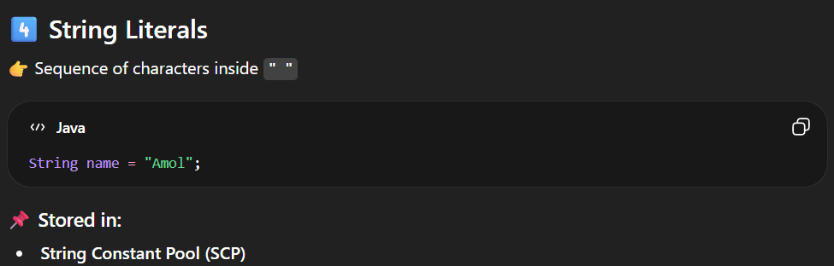
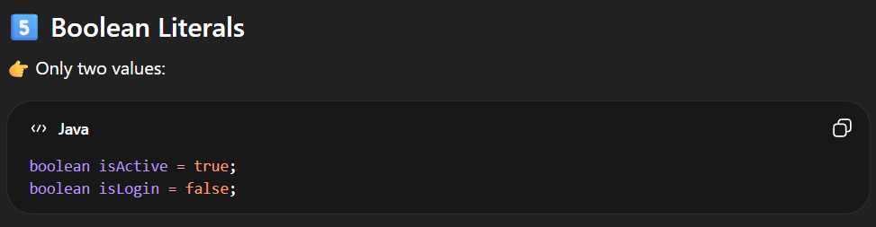
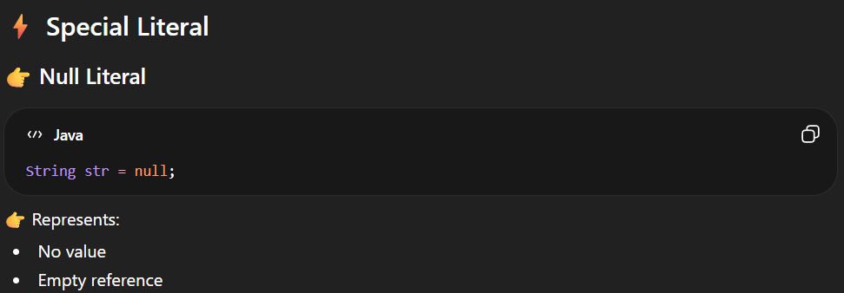

4]SEPERATORS

🔥 What are Separators in Java?
-Separators are special symbols used to separate different parts of a program.
👉 They help Java understand:
- Where a statement starts/ends
- How code is structured

🧠 Simple Definition
Separators are characters that divide code into meaningful parts.
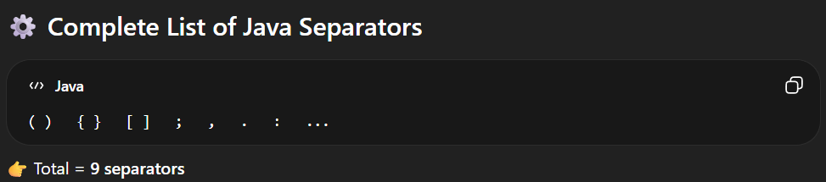
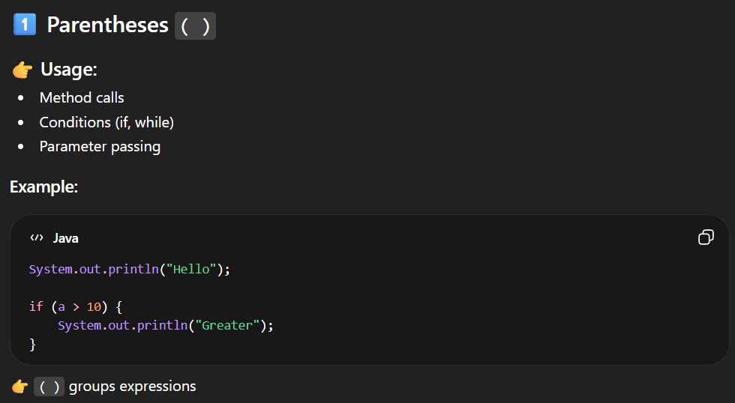
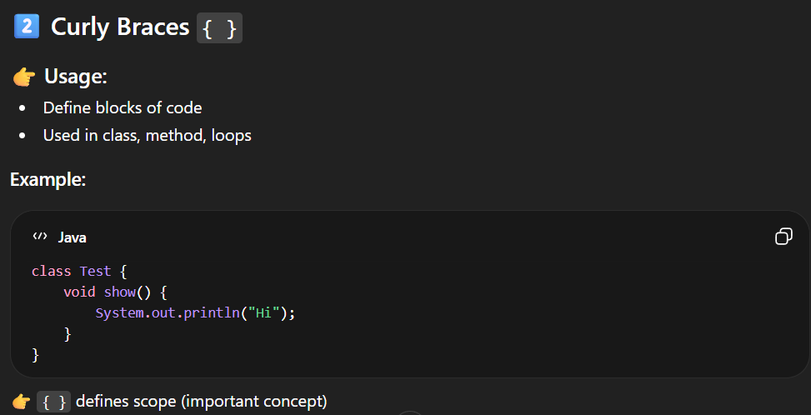
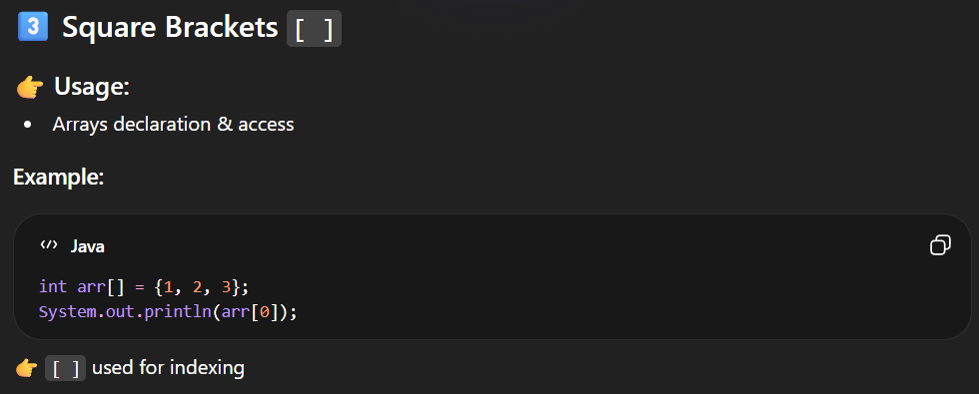
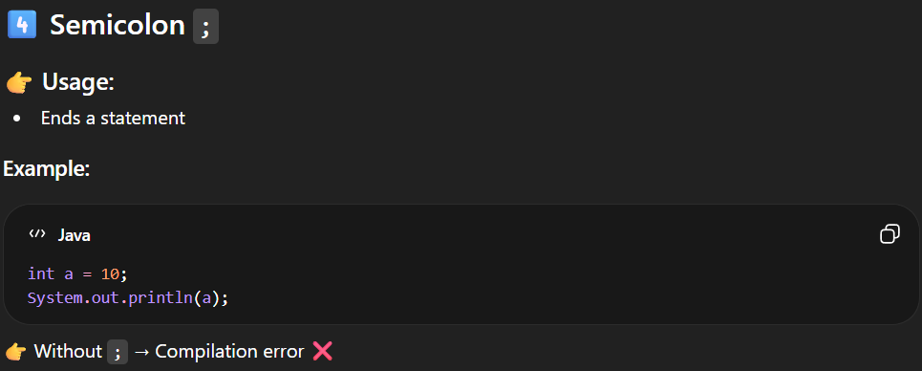
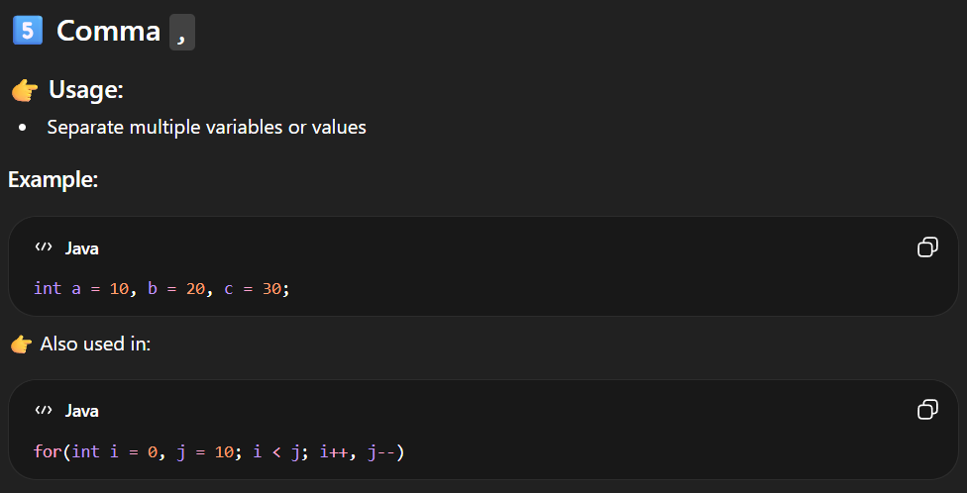
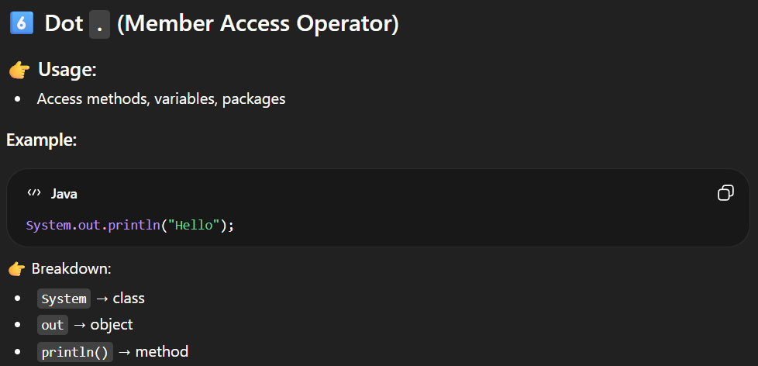
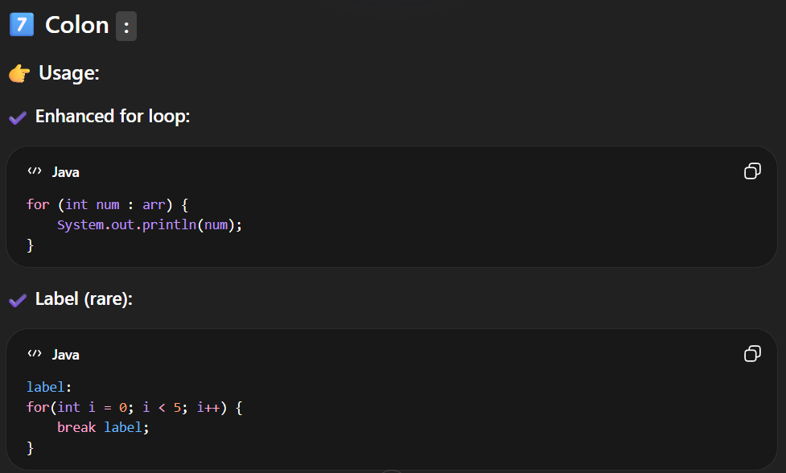
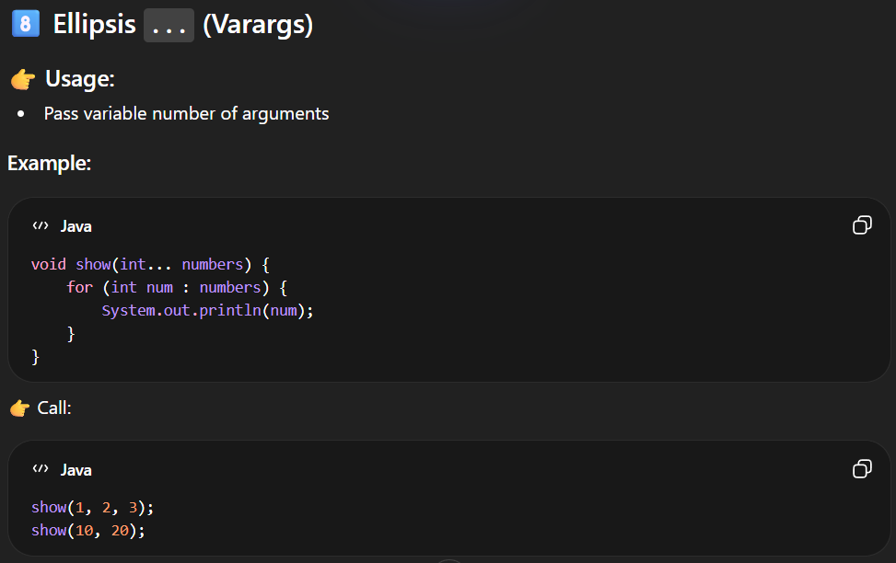
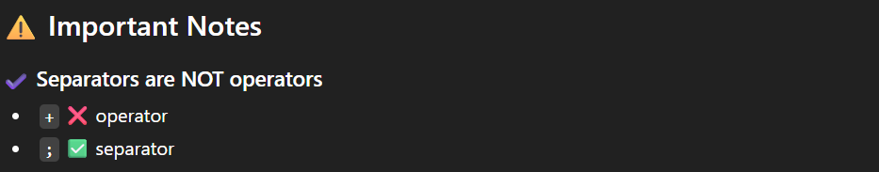

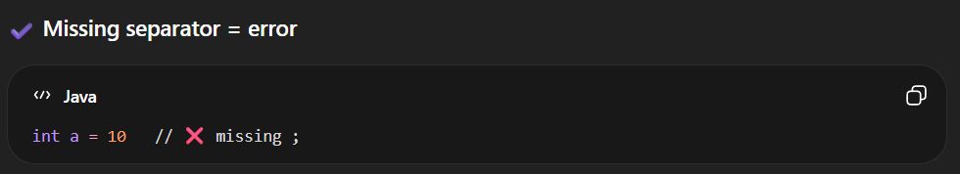

DATA UNITS

SrNo | Data Unit | Symbol | Value
 | Bit | bit / b | Smallest unit of data (0 or 1)
 | Nibble | - | 1 Nibble = 4 Bits
 | Byte | B | 1 Byte = 8 Bits
 | Kilobyte | KB | 1 KB = 1,024 Bytes
 | Megabyte | MB | 1 MB = 1,024 KB
 | Gigabyte | GB | 1 GB = 1,024 MB
 | Terabyte | TB | 1 TB = 1,024 GB
 | Petabyte | PB | 1 PB = 1,024 TB
 | Exabyte | EB | 1 EB = 1,024 PB
 | Zettabyte | ZB | 1 ZB = 1,024 EB
 | Yottabyte | YB | 1 YB = 1,024 ZB

SrNo | Type | Description | Default | Size | Example | Range
 | boolean | Logical values | false | Not JVM-defined | true, false | true or false
 | byte | 8-bit signed integer | 0 | 1 byte | 10 | -128 to 127
 | char | 16-bit Unicode character | \u0000 | 2 bytes | 'A', '\u0041' | 0 to 65,535
 | short | 16-bit signed integer | 0 | 2 bytes | 2000 | -32,768 to 32,767
 | int | 32-bit signed integer | 0 | 4 bytes | 1000, -500 | -2,147,483,648 to 2,147,483,647
 | long | 64-bit signed integer | 0L | 8 bytes | 123456789L | ±9.22e18
 | float | 32-bit floating point | 0.0f | 4 bytes | 3.14f | ~6–7 digits precision
 | double | 64-bit floating point | 0.0d | 8 bytes | 3.14159d | ~15–16 digits precision

DATATYPES
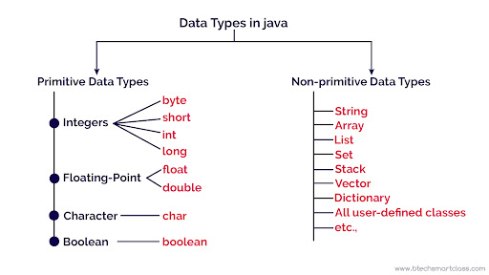
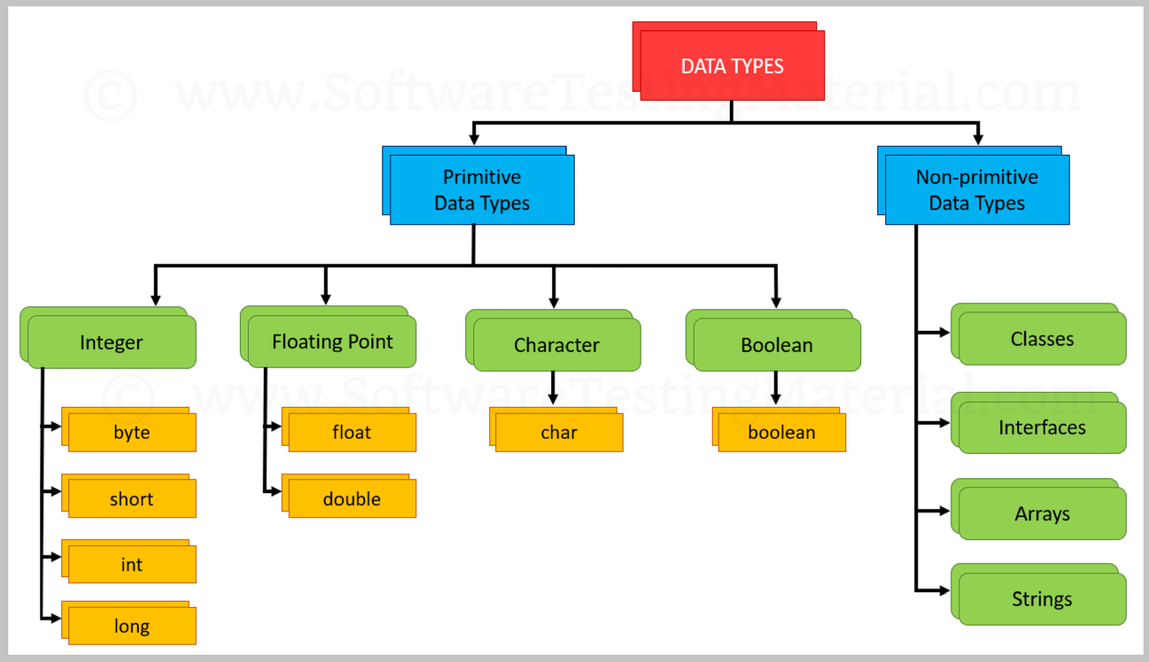
-There are two types of Datatypes available in the Java
1.Primitive Datatype
2.Non-Primitive Datatype
-Java is a statically typed programming language, which means the data type of every variable is known at compile time. The compiler enforces type safety and prevents invalid assignments such as:
int x = "GfG"; // Compile-time error
1.PRIMITIVE DATATYPE
-In Java, primitive data types are the most basic data types used to store simple values. They are not objects and store data directly in memory, which makes them fast and efficient.
- Store actual values (not references)
- Are predefined by Java
- Are faster and memory-efficient
- It holds single values.
- There are 8 primitive data types in Java:
👉 Java is strongly typed, so every variable must have a type.
Meaning of "Primitive"
-The term "primitive" refers to the fact that these types are:
- Direct Value Storage: Unlike objects that store a reference (memory address) to data, primitives store the actual value directly in memory.
- Predefined: They are built into the Java compiler and named by specific keywords; they are not created by the programmer.
- Fixed Size: Each type has a consistent memory size regardless of the operating system, supporting Java's "write once, run anywhere" goal.
- Non-Objects: Primitives do not have associated methods or properties.

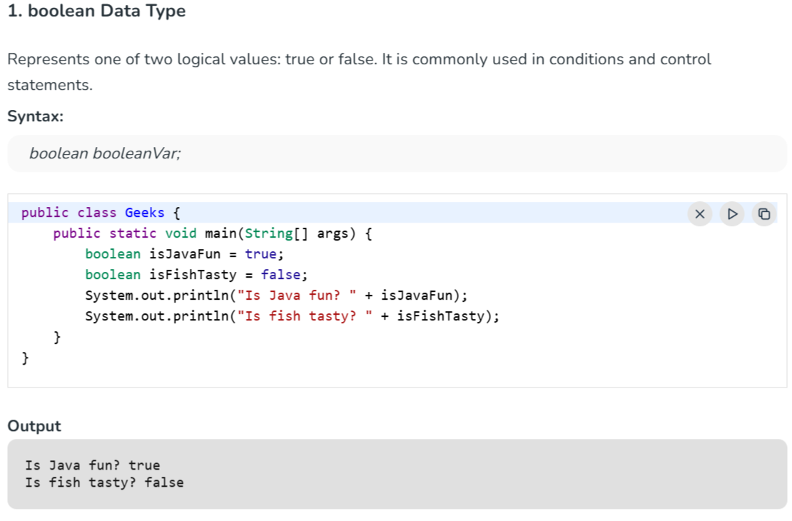
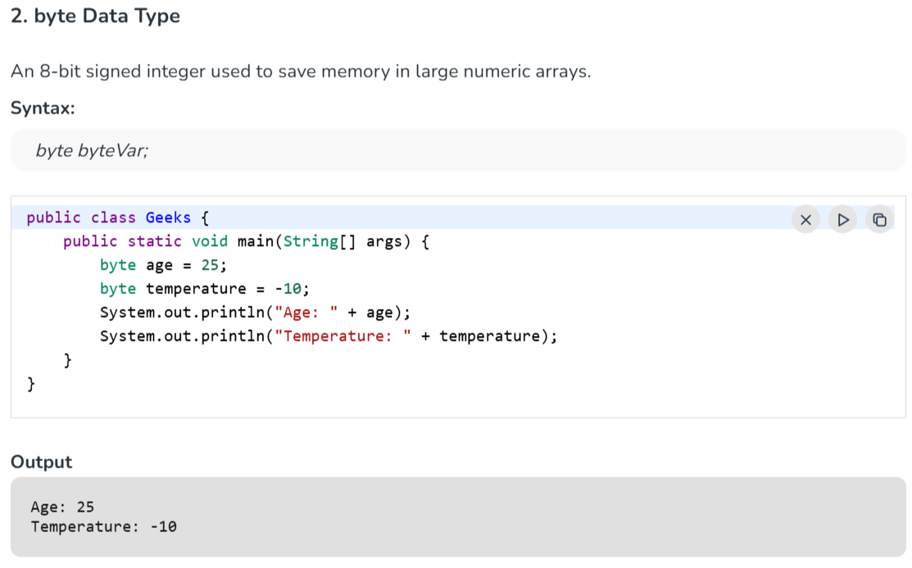
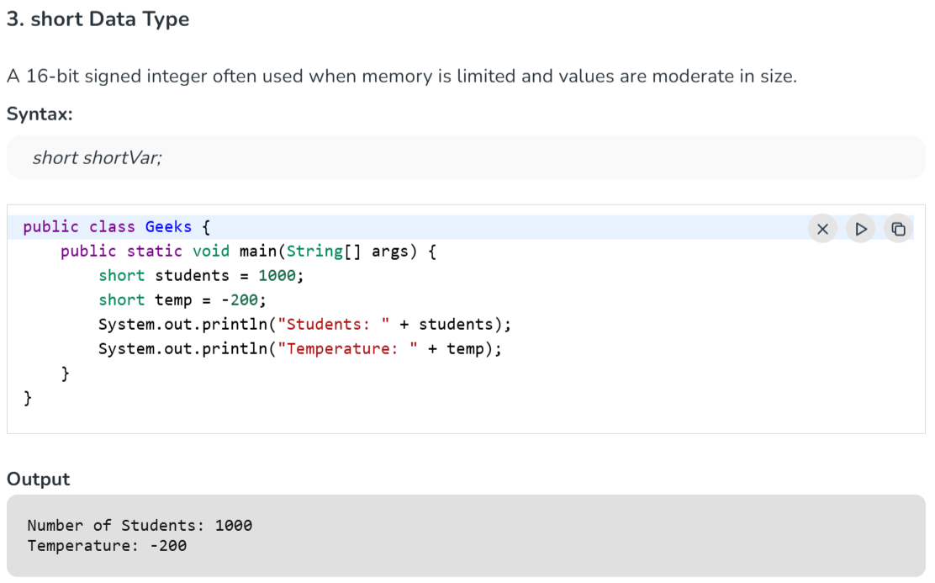
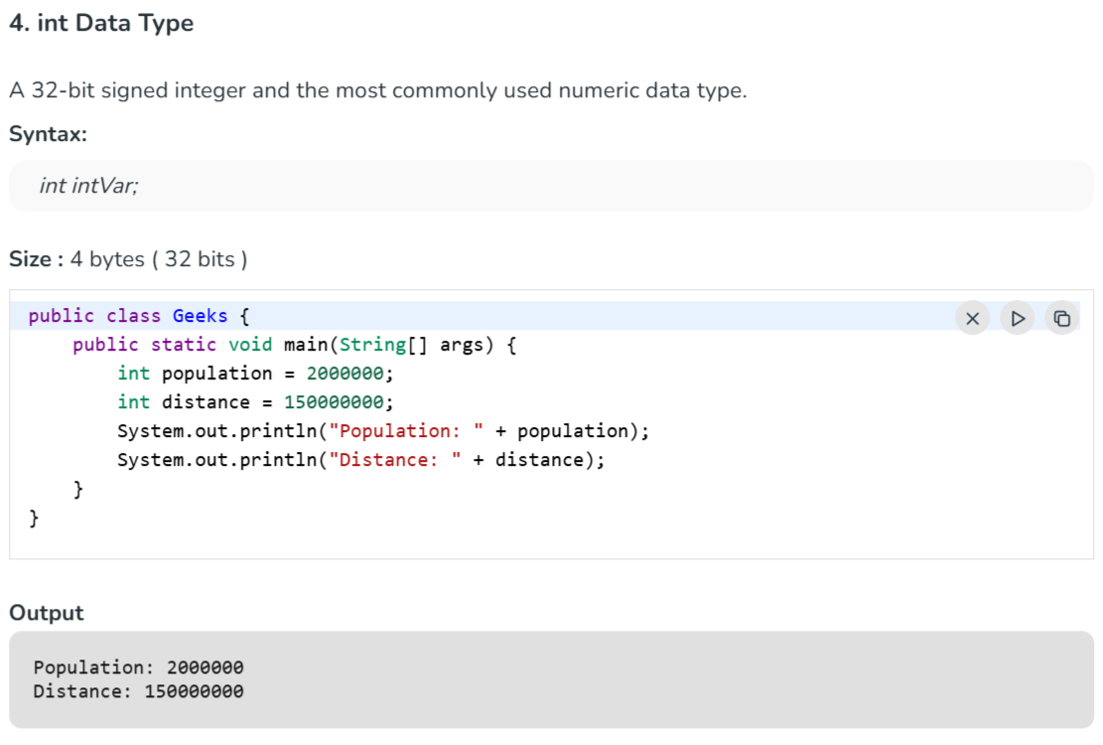
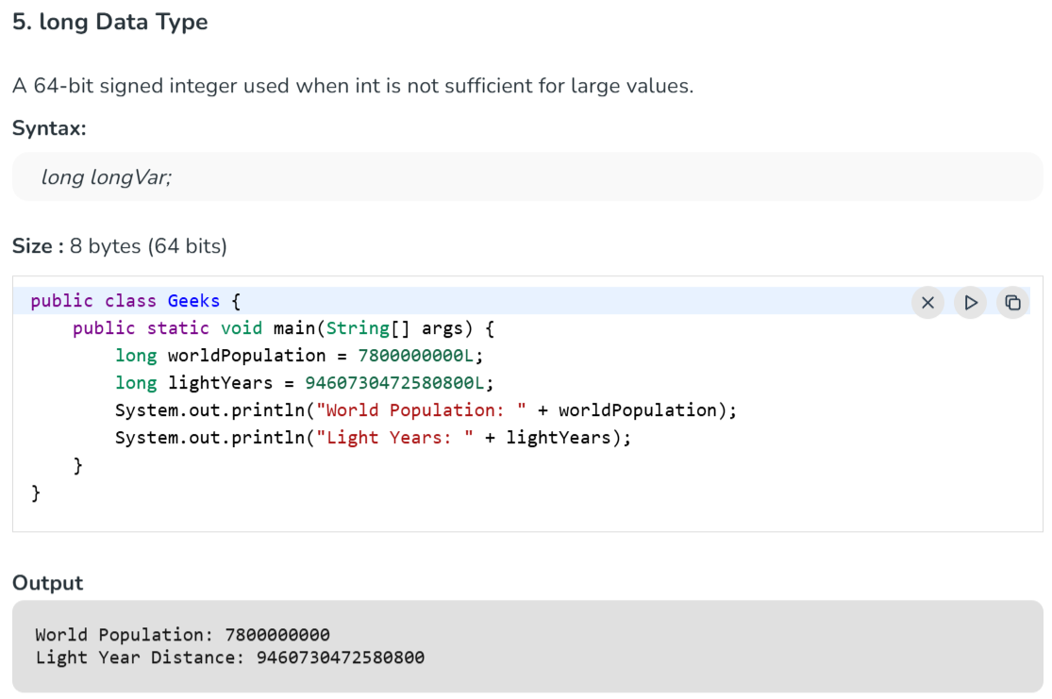
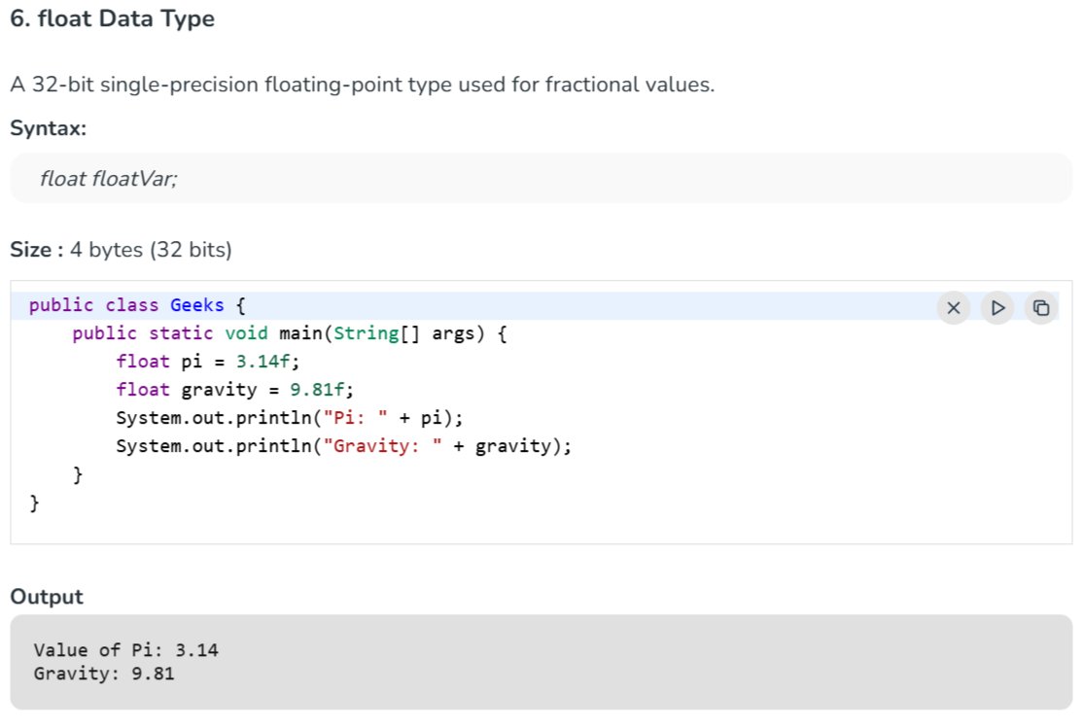
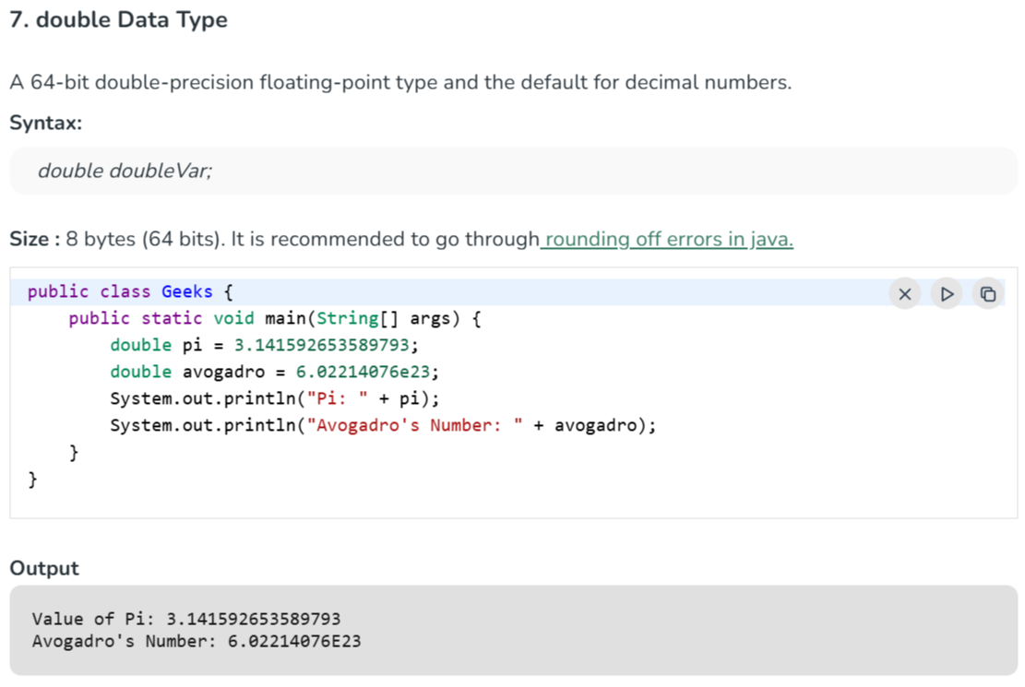
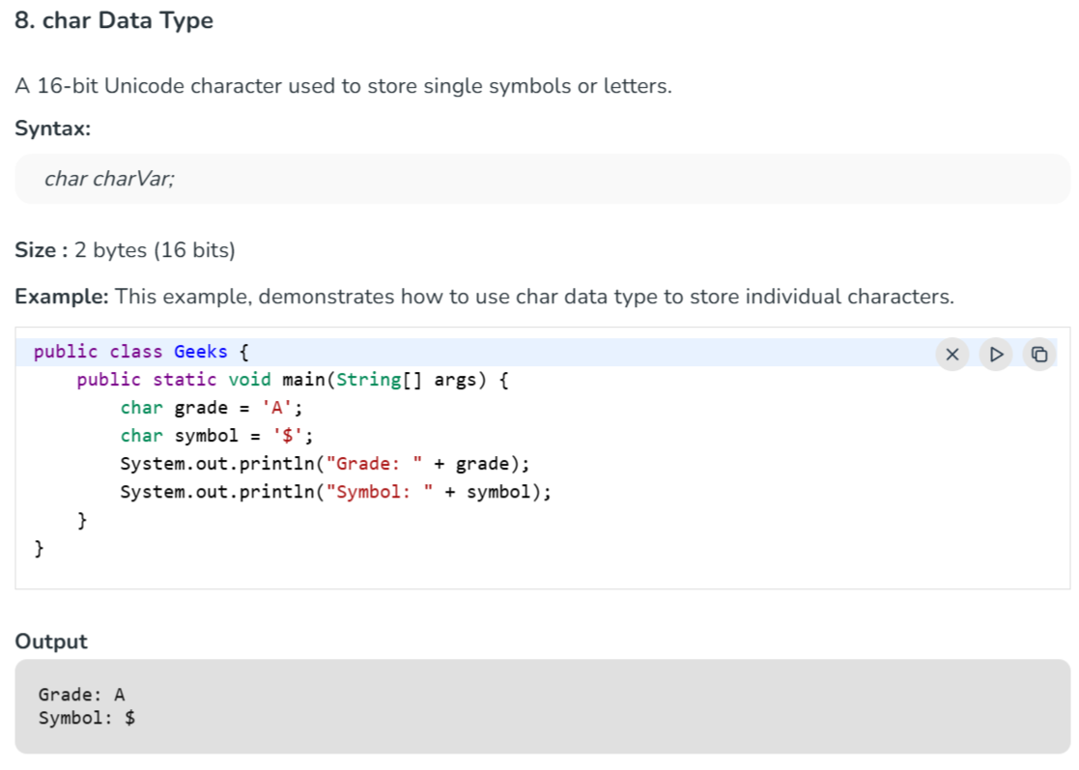

1.boolean

🧠 boolean Data Type in Java (Detailed Notes)
🔹 1. Definition
-boolean is a logical data type used to store only two values:
👉 true or false
-It is mainly used for:
- Decision making
- Conditions
- Control flow (if, loops)

🔹 2. Size
- Not precisely defined by Java (JVM dependent)
- Logically represents 1 bit (true/false)
👉 Unlike C/C++, Java does NOT treat boolean as a number

🔹 3. Syntax
boolean isActive = true;
boolean isLogin = false;
⚠️ Only lowercase:
- ✅ true, false
- ❌ True, False (invalid)

🔹 4. Default Value
Context | Default Value
Instance variable | false
Local variable | ❌ Must initialize

🔹 5. Where is boolean Used?
- if conditions
- while loops
- for loops
- Logical checks
Example:
boolean isLoggedIn = true;
if (isLoggedIn) {
System.out.println("Welcome!");
}

🔹 6. Boolean Expressions
A boolean value is usually the result of a condition:
int a = 10;
int b = 20;
boolean result = (a < b); // true

🔹 7. Logical Operators
Operator | Meaning | Example
&& | AND | true && false → false
` |  | `
! | NOT | !true → false
Example:
boolean a = true;
boolean b = false;
System.out.println(a && b); // false
System.out.println(a || b); // true
System.out.println(!a); // false

🔹 8. Important Rule (Very Important ⚠️)
👉 boolean is NOT convertible to int
int x = true; // ❌ Error
boolean b = 1; // ❌ Error
👉 Unlike C/C++, Java is strictly typed

🔹 9. Boolean in Control Flow
✅ If Statement
int age = 18;
if (age >= 18) {
System.out.println("Adult");
}

✅ Loop Example
boolean running = true;
while (running) {
System.out.println("Running...");
running = false;
}

🔹 10. Wrapper Class
- Primitive: boolean
- Wrapper: Boolean
Boolean obj = true;

🔹 11. Short-Circuit Evaluation (Important)
int a = 10;
if (a > 5 && a < 20) {
System.out.println("Valid");
}
👉 If first condition fails, second is NOT checked

🔹 12. Real Example
boolean isPasswordCorrect = true;
if (isPasswordCorrect) {
System.out.println("Login Successful");
} else {
System.out.println("Access Denied");
}

🔹 13. Interview Points
✔ Only two values: true/false
✔ Not numeric (unlike C/C++)
✔ Used in conditions
✔ Supports logical operators
✔ Default value = false

🔹 14. boolean vs int
Feature | boolean | int
Values | true/false | Numbers
Usage | Conditions | Calculations
Conversion | ❌ Not allowed | ✔ Allowed

🧠 Quick Summary
- Logical type for decision-making
- Works with conditions & operators
- Strict (no number conversion)
- Core part of control flow

2.byte

🧠 byte Data Type in Java (Detailed Notes)
🔹 1. Definition
-byte is the smallest integer data type in Java.
It is used to store small whole numbers efficiently.

🔹 2. Size & Range
- Size: 1 byte = 8 bits
- Range: -128 to 127
👉 Because Java uses signed 2’s complement representation

🔹 3. Syntax
byte a = 10;
byte b = -50;

🔹 4. Memory Representation
A byte uses 8 bits:
00001010 → 10
11111111 → -1
👉 Leftmost bit = sign bit
- 0 → positive
- 1 → negative

🔹 5. Default Value
Context | Default Value
Instance variable | 0
Local variable | ❌ No default (must initialize)

🔹 6. When to Use byte
Use byte when:
- Working with large arrays (saves memory)
- Handling binary data (files, streams)
- Network/data transfer
- Image/audio processing

🔹 7. Type Casting with byte
✅ Implicit Casting (Not allowed from larger types)
int x = 10;
byte b = (byte) x; // must cast explicitly

❌ Overflow Example
byte b = 130; // ❌ Error (out of range)

⚠️ Runtime Overflow (Important)
byte b = 127;
b++; // Overflow
System.out.println(b); // Output: -128
👉 Values wrap around due to 2’s complement

🔹 8. Type Promotion (Very Important)
byte a = 10;
byte b = 20;
byte c = a + b; // ❌ Error
👉 Why?
Java promotes byte → int during arithmetic
✔ Correct way:
byte c = (byte)(a + b);

🔹 9. Wrapper Class
- Primitive: byte
- Wrapper: Byte
Byte obj = 10;
👉 Used in collections like ArrayList<Byte>

🔹 10. Byte vs Int
Feature | byte | int
Size | 1 byte | 4 bytes
Range | Small | Large
Speed | Slightly faster | Standard
Use | Memory saving | General use

🔹 11. Important Interview Points
✔ byte range: -128 to 127
✔ Uses 2’s complement
✔ Arithmetic → promotes to int
✔ Needs casting for operations
✔ Overflow wraps around

🔹 12. Real Example
byte temperature = 25;
byte data = 100;
System.out.println(temperature + data); // result is int

🧠 Quick Revision
- Smallest integer type
- Saves memory
- Range limited
- Arithmetic converts to int
- Can overflow easily

3.short

🧠 short Data Type in Java (Detailed Notes)
🔹 1. Definition
-short is a 16-bit signed integer data type used to store small whole numbers (larger than byte, smaller than int).
👉 It is useful when you want to save memory but need a slightly larger range than byte.

🔹 2. Size & Range
- Size: 2 bytes = 16 bits
- Range: -32,768 to 32,767
👉 Uses 2’s complement representation

🔹 3. Syntax
short s = 1000;
short num = -200;

🔹 4. Memory Representation
Example:
00000011 11101000 → 1000
👉 First bit = sign bit
- 0 → positive
- 1 → negative

🔹 5. Default Value
Context | Default Value
Instance variable | 0
Local variable | ❌ Must initialize

🔹 6. When to Use short
Use short when:
- Memory optimization is needed
- Handling large arrays with moderate values
- Interfacing with hardware or legacy systems
⚠️ In real-world Java, int is preferred over short

🔹 7. Type Casting with short
❌ Direct Assignment (Error)
short s = 100000; // ❌ Out of range

✅ Explicit Casting
int x = 1000;
short s = (short) x;

🔹 8. Overflow Example (Important)
short s = 32767;
s++;
System.out.println(s); // Output: -32768
👉 Overflow wraps around due to 2’s complement

🔹 9. Type Promotion (Very Important)
short a = 10;
short b = 20;
short c = a + b; // ❌ Error
👉 Reason: Java promotes short → int
✔ Correct:
short c = (short)(a + b);

🔹 10. Wrapper Class
- Primitive: short
- Wrapper: Short
Short obj = 100;

🔹 11. short vs byte vs int
Feature | byte | short | int
Size | 1 byte | 2 bytes | 4 bytes
Range | Very small | Medium | Large
Usage | Rare | Rare | Most common

🔹 12. Important Interview Points
✔ Range: -32,768 to 32,767
✔ Uses 2’s complement
✔ Arithmetic → converted to int
✔ Needs casting in operations
✔ Rarely used in modern Java

🔹 13. Real Example
short marks = 250;
short bonus = 50;
int total = marks + bonus; // result is int
System.out.println(total);

🧠 Quick Summary
- short is bigger than byte, smaller than int
- Used for memory optimization
- Arithmetic converts to int
- Can overflow

4.char

🧠 char Data Type in Java (Detailed Notes)
🔹 1. Definition
char is a single-character data type used to store one Unicode character.
👉 Unlike other languages (like C/C++), Java uses Unicode, so it supports characters from all languages (English, Hindi, symbols, etc.)

🔹 2. Size & Range
- Size: 2 bytes (16 bits)
- Range: 0 to 65,535 (\u0000 to \uFFFF)
👉 It is unsigned (no negative values)

🔹 3. Syntax
char ch = 'A';
char grade = 'B';
⚠️ Always use single quotes (' '), not double quotes (" ")

🔹 4. Unicode Representation
Every char stores a Unicode value (number internally)
char ch = 'A'; // Unicode: 65
char ch2 = 65; // Also 'A'
👉 Both are valid and equivalent

🔹 5. Escape Sequences
-Special characters are written using escape sequences:
Escape | Meaning
\n | New line
\t | Tab
\\ | Backslash
\' | Single quote
\" | Double quote
Example:
char ch = '\n';

🔹 6. Default Value
Context | Default Value
Instance variable | '\u0000' (null character)
Local variable | ❌ Must initialize

🔹 7. Type Casting with char
✅ Implicit Conversion
char ch = 65; // 'A'

❌ Explicit Casting
int x = 97;
char ch = (char) x; // 'a'

🔹 8. Arithmetic with char (Important)
char behaves like an integer internally
char a = 'A';
char b = 'B';
int result = a + b;
System.out.println(result); // 131
👉 Because:
- 'A' → 65
- 'B' → 66
- 65 + 66 = 131

⚠️ Result is always int
char c = 'A' + 1; // 'B'

🔹 9. Comparison of Characters
char a = 'A';
char b = 'B';
System.out.println(a < b); // true
👉 Compared using Unicode values

🔹 10. Wrapper Class
- Primitive: char
- Wrapper: Character
Character ch = 'A';

🔹 11. Important Interview Points
✔ char is 2 bytes (not 1 byte like C/C++)
✔ Stores Unicode, not ASCII only
✔ It is unsigned
✔ Can behave like an integer in expressions
✔ Uses single quotes (' ')

🔹 12. Real Example
char letter = 'A';
if (letter == 'A') {
System.out.println("Matched!");
}

🔹 13. Difference: char vs String
Feature | char | String
Stores | Single character | Multiple characters
Quotes | 'A' | "ABC"
Type | Primitive | Object

🧠 Quick Summary
- Stores single Unicode character
- Uses 2 bytes
- Works like an integer internally
- Supports all languages

5.int

🧠 int Data Type in Java (Detailed Notes)
🔹 1. Definition
int is a 32-bit signed integer data type used to store whole numbers.
👉 It is the most commonly used numeric type in Java.

🔹 2. Size & Range
- Size: 4 bytes = 32 bits
- Range: -2³¹ to 2³¹ - 1
👉 i.e., -2,147,483,648 to 2,147,483,647
👉 Uses 2’s complement representation

🔹 3. Syntax
int a = 10;
int b = -500;

🔹 4. Default Value
Context | Default Value
Instance variable | 0
Local variable | ❌ Must initialize

🔹 5. Why int is Most Used?
- Balanced range + performance
- CPU handles 32-bit integers efficiently
- No need for casting in most operations
👉 That’s why Java internally promotes smaller types (byte, short, char) to int.

🔹 6. Memory Representation (Concept)
int uses 32 bits:
00000000 00000000 00000000 00001010 → 10
👉 First bit = sign bit

🔹 7. Arithmetic Operations
int a = 10;
int b = 20;
int sum = a + b; // 30
int diff = a - b; // -10
int mul = a * b; // 200
int div = a / b; // 0 (integer division)

🔹 8. Integer Division (Important)
int a = 5;
int b = 2;
System.out.println(a / b); // 2
👉 Decimal part is truncated, not rounded

🔹 9. Overflow & Underflow
⚠️ Overflow Example
int x = 2147483647;
x++;
System.out.println(x); // -2147483648
👉 Wraps around due to 2’s complement

🔹 10. Type Casting
✅ Implicit (Widening)
int a = 10;
double d = a; // int → double

❌ Explicit (Narrowing)
double d = 10.5;
int a = (int) d; // 10

🔹 11. Type Promotion
byte a = 10;
byte b = 20;
int result = a + b; // promoted to int
👉 All arithmetic operations return at least int

🔹 12. Wrapper Class
- Primitive: int
- Wrapper: Integer
Integer num = 100;
👉 Used in collections (ArrayList<Integer>)

🔹 13. Common Use Cases
- Loop counters
- Array indexing
- Mathematical calculations
- General-purpose programming

🔹 14. Important Interview Points
✔ Default integer type in Java
✔ Size: 4 bytes
✔ Arithmetic stays in int
✔ Integer division removes decimals
✔ Overflow wraps around

🔹 15. Real Example
int marks = 80;
int bonus = 20;
int total = marks + bonus;
System.out.println("Total: " + total);

🔹 16. int vs long
Feature | int | long
Size | 4 bytes | 8 bytes
Range | Moderate | Very large
Usage | Most common | Large values

🧠 Quick Summary
- Most used integer type
- Efficient and fast
- Handles most real-world cases
- Watch for overflow & division issues

6.long

🧠 long Data Type in Java (Detailed Notes)
🔹 1. Definition
long is a 64-bit signed integer data type used to store very large whole numbers.
👉 It is used when int is not enough.

🔹 2. Size & Range
- Size: 8 bytes = 64 bits
- Range: -2⁶³ to 2⁶³ - 1
👉 i.e.,
-9,223,372,036,854,775,808 to 9,223,372,036,854,775,807
👉 Uses 2’s complement representation

🔹 3. Syntax
long a = 100000L;
long b = -5000L;
⚠️ Always use L or l at the end for large numbers
👉 Prefer uppercase L (lowercase looks like 1)

🔹 4. Default Value
Context | Default Value
Instance variable | 0L
Local variable | ❌ Must initialize

🔹 5. Why Use long?
Use long when:
- Working with large numbers
- Handling timestamps (milliseconds)
- Financial calculations (big values)
- Large counters (loops, data processing)

🔹 6. Memory Representation
long uses 64 bits:
00000000 ... 00001010 → 10
👉 First bit = sign bit

🔹 7. Arithmetic Operations
long a = 100000L;
long b = 200000L;
long sum = a + b;
long mul = a * b;
👉 Works same as int, but with larger range

🔹 8. Overflow (Important)
long x = 9223372036854775807L;
x++;
System.out.println(x); // -9223372036854775808
👉 Overflow wraps around

🔹 9. Type Casting
✅ Implicit (Widening)
int a = 10;
long b = a; // int → long

❌ Explicit (Narrowing)
long x = 1000L;
int y = (int) x;

🔹 10. Integer Literals & long
long num = 10000000000L; // correct
❌ Without L:
long num = 10000000000; // ❌ error (treated as int)

🔹 11. Type Promotion
int a = 10;
long b = 20L;
long result = a + b; // result is long
👉 Smaller type is promoted to larger (int → long)

🔹 12. Wrapper Class
- Primitive: long
- Wrapper: Long
Long obj = 1000L;

🔹 13. long vs int
Feature | int | long
Size | 4 bytes | 8 bytes
Range | Smaller | Very large
Use | General | Large values

🔹 14. Important Interview Points
✔ Size: 8 bytes
✔ Must use L for large values
✔ Used for big numbers
✔ Overflow possible
✔ Supports arithmetic like int

🔹 15. Real Example
long population = 8000000000L;
long distance = 384400000L;
System.out.println("Distance: " + distance);

🧠 Quick Summary
- Larger version of int
- Used for big integer values
- Needs L suffix
- Watch for overflow
7.float

🧠 float Data Type in Java (Detailed Notes)
🔹 1. Definition
float is a 32-bit floating-point data type used to store decimal (fractional) numbers.
👉 It is used when you need decimal values with less precision and better memory efficiency than double.

🔹 2. Size & Range
- Size: 4 bytes = 32 bits
- Approx Range:
👉 ±3.4 × 10³⁸
- Precision: ~6 to 7 decimal digits

🔹 3. Syntax
float f = 10.5f;
float price = 99.99f;
⚠️ Important:
👉 You must add f or F suffix
❌ Wrong:
float f = 10.5; // Error (treated as double)

🔹 4. Default Value
Context | Default Value
Instance variable | 0.0f
Local variable | ❌ Must initialize

🔹 5. Memory Representation (IEEE 754)
float follows IEEE 754 standard:
Part | Bits
Sign | 1 bit
Exponent | 8 bits
Mantissa (Fraction) | 23 bits
👉 This is why precision is limited

🔹 6. Precision Issue (Very Important ⚠️)
float f = 0.1f;
System.out.println(f);
👉 Output may not be exactly 0.1
👉 Because floating-point numbers are stored in binary approximation

🔹 7. Arithmetic Operations
float a = 10.5f;
float b = 2.0f;
float sum = a + b; // 12.5
float div = a / b; // 5.25

🔹 8. Type Casting
✅ Implicit (Widening)
float f = 10; // int → float

❌ Explicit (Narrowing)
double d = 10.5;
float f = (float) d;

🔹 9. Type Promotion
float a = 10.5f;
double b = 20.5;
double result = a + b; // result is double
👉 Smaller type → promoted to larger

🔹 10. Special Values (IEEE 754)
float a = 10f / 0f; // Infinity
float b = -10f / 0f; // -Infinity
float c = 0f / 0f; // NaN
👉 NaN = Not a Number

🔹 11. Comparison Issue (Important)
float a = 0.1f + 0.2f;
if (a == 0.3f) {
System.out.println("Equal");
}
👉 May NOT print due to precision errors
✔ Correct approach:
if (Math.abs(a - 0.3f) < 0.0001)

🔹 12. Wrapper Class
- Primitive: float
- Wrapper: Float
Float obj = 10.5f;

8.double

🧠 double Data Type in Java (Detailed Notes)
🔹 1. Definition
double is a 64-bit floating-point data type used to store decimal (fractional) numbers with high precision.
👉 It is the default type for decimal values in Java.

🔹 2. Size & Range
- Size: 8 bytes = 64 bits
- Approx Range:
👉 ±1.7 × 10³⁰⁸
- Precision: ~15 to 16 decimal digits

🔹 3. Syntax
double d = 10.5;
double price = 99.99;
👉 No suffix needed (unlike float)

🔹 4. Default Value
Context | Default Value
Instance variable | 0.0
Local variable | ❌ Must initialize

🔹 5. Memory Representation (IEEE 754)
double follows IEEE 754 standard:
Part | Bits
Sign | 1 bit
Exponent | 11 bits
Mantissa (Fraction) | 52 bits
👉 More bits = higher precision than float

🔹 6. Precision (Important ⚠️)
double d = 0.1;
System.out.println(d);
👉 May not store exact 0.1 (binary approximation)

⚠️ Comparison Issue
double a = 0.1 + 0.2;
if (a == 0.3) {
System.out.println("Equal");
}
👉 Might NOT print due to precision
✔ Correct way:
if (Math.abs(a - 0.3) < 0.000001)

🔹 7. Arithmetic Operations
double a = 10.5;
double b = 2.0;
double sum = a + b; // 12.5
double div = a / b; // 5.25

🔹 8. Type Casting
✅ Implicit (Widening)
double d = 10; // int → double

❌ Explicit (Narrowing)
double d = 10.9;
int x = (int) d; // 10

🔹 9. Type Promotion
float a = 10.5f;
double b = 20.5;
double result = a + b; // result is double
👉 Smaller type promoted to double

🔹 10. Special Values (IEEE 754)
double a = 10.0 / 0; // Infinity
double b = -10.0 / 0; // -Infinity
double c = 0.0 / 0; // NaN

🔹 11. Wrapper Class
- Primitive: double
- Wrapper: Double
Double obj = 10.5;

🔹 12. double vs float
Feature | float | double
Size | 4 bytes | 8 bytes
Precision | Low | High
Default | ❌ No | ✔ Yes
Usage | Rare | Most common

🔹 13. When to Use double
Use double when:
- High precision is required
- Mathematical calculations
- Scientific data
- Default choice for decimals
👉 Preferred over float in most cases

🔹 14. Real Example
double price = 199.99;
double tax = 18.5;
double total = price + tax;
System.out.println("Total: " + total);

🔹 15. Important Interview Points
✔ Default decimal type
✔ High precision (15–16 digits)
✔ Uses IEEE 754
✔ Supports NaN & Infinity
✔ Better than float

🧠 Quick Summary
- Best choice for decimal values
- High precision and wide range
- No suffix required
- Beware of precision issues

TYPE CASTING

OPERATORS
-An operator is a special symbol or keyword used to perform an operation on values or variables.
int a = 10;
int b = 5;

int result = a + b;

- a → Operand
- + → Operator
- b → Operand
- result → Variable
Operand
-An operand is a value or variable on which an operator performs an operation.
1]Unary Operator
2]Binary Operator
3]Ternary Operator

1]UNARY OPERATOR

-The operator which takes One Value At a time Is called as unary Operator.
-A Unary Operator works with only one operand.
- Increment Operator
- Decrement Operator
- Cast Operator
- Unary Plus
- Unary Minus
- Logical NOT
- Bitwise Complement

Unary Operators in Java
Operator | Name
+ | Unary Plus
- | Unary Minus
++ | Increment
-- | Decrement
! | Logical NOT
~ | Bitwise Complement

I.INCREMENT OPERATOR

1]Post-Increment Operator
2]Pre-Increment Operator

1]POST-INCREMENT OPERATOR
Steps to Perform Post-Increment Operator: -
1]Use the value present inside the variable.
2]Later Increment the value which is present inside the variable by 1 & updated.

Example No 1: -
Class Program1
{
Public static void main (String args[])
{
int a=1;
int b=a++;
int c=b++;
System.out.println(a);
System.out.println(b);
System.out.println(c);
}
}

O/P: -
2
2
1

Example No 2: -
Class Program2
{
Public static void main (String args[])
{
int a=1;
System.out.println(a);
System.out.println(a++);
System.out.println(a);
}
}

O/P: -
1
2
2

2]PRE-INCREMENT OPERATOR
Steps to Perform Per-Increment Operator: -
1]Increment the value which is present inside the variable by 1 & updated.
2]Use the updated the value which is present inside the variable.
Example No 1: -
Class Program1
{
Public static void main (String args[])
{
int a=1;
int b=++a;
int c=++b;
System.out.println(a);
System.out.println(b);
System.out.println(c);
}
}

O/P: -
2
3
3

Example No 2: -
Class Program2
{
Public static void main (String args[])
{
int a=1;
int b=2;
int c=++a + ++b + ++a + ++b;
System.out.println(a);
System.out.println(b);
System.out.println(c);
}
}

O/P: -
3
4
12

Example No 3: -
Class Program3
{
Public static void main (String args[])
{
int a=2;
int b=2;
int c=a++ + ++a + ++b + b++ + ++a;
System.out.println(a);
System.out.println(b);
System.out.println(c);
}
}

O/P: -
5
4
17

QNO:-Write the Difference Between Post-Increment & Pre-Increment Operator?
Sr No | Pre-Increment Operator | Post-Increment Operator
1 | The Increment Operator Which is Prefixed to its Variable name is called as Pre-Increment Operator | The Increment Operator Which is Suffixed to its Variable name is called as Post-Increment Operator
2 | STEP-1: -Increment the value present inside the variable by 1 & updated. | STEP-1: -Use the updated value which is present inside the variable.
3 | STEP-2: -Use the updated value which is present inside the variable. | STEP-2: -Increment the value present inside the variable by 1 & updated.
4 | Ex: -++a; | Ex: -a++;

ii.Decrement Operator
-The Decrement operator is a Unary Operator
-It is used to decrement the value present inside the variable by 1 & updated.
-Decrement Operator is denoted by --.
-Decrement Operator IS Classified into 2 types: -
1]Post-Decrement Operator
2]Pre-Decrement Operator

Write a Difference Between Post-Decrement & Pre-Decrement Operator?
Ans: -
Sr No | Pre-Decrement Operator | Post-Decrement Operator
1 | The Decrement Operator Which is Prefixed to its Variable name is called as Pre-Decrement Operator | The Decrement Operator Which is Suffixed to its Variable name is called as Pre-Decrement Operator
2 | STEP-1: - Decrement the value present inside the variable by 1 & updated. | STEP-1: -Use the updated value which is present inside the variable.
3 | STEP-2: -Use the updated value which is present inside the variable. | STEP-2: - Decrement the value present inside the variable by 1 & updated.
4 | Ex: - --a; | Ex: - a--;

Que: - Can we perform the increment or decrement for the char, int, double, string, Boolean datatype?
Ans: - We can perform Increment & Decrement only char, long, double datatype.
-We can’t perform the Increment & Decrement for the Boolean & String Datatype.

iii.CAST OPERATOR
-It takes one value at time.
-It is used to convert one datatype into other in java.
QNO1: -Convert Double to Float
class DoubleToFloat
{
public static void main (String [] args)
{
double a=203;
float b=(float)a;
System.out.println(b);
}
}

O/P: -
203.0

QNO2: -Convert Double to Char
class DoubleToChar
{
public static void main (String [] args)
{
double a=97;
char b=(char)a;
System.out.println(b);
}
}

O/P: -
a

QNO3: -Convert Float to Int
class FloatToInt
{
public static void main (String[] args)
{
float a=20.6f;
int b=(int)a;
System.out.println(b);
}
}

O/P: -
20

QNo4: -Convert Float to Char

class FloatToChar
{
public static void main (String [] args)
{
float a=97.35f;
char b=(char)a;
System.out.println(b);
}
}

O/P: -
a

QNO5: -Convert long to char

class LongToChar
{
public static void main (String [] args)
{
long a=111;
char b=(char)a;
System.out.println(b);
}
}

O/P: -
o

QNO6: -Convert Float to Long
class FloatToLong
{
public static void main (String [] args)
{
float a=20.5f;
long b=(long)a;
System.out.println(b);
}
}

O/P: -
20

QNO7: -Convert Double to Long
class DoubleToLong
{
public static void main(String[] args)
{
double a=202435.55;
long b=(long)a;
System.out.println(b);
}
}

O/P: -
202435

IV.UNARY PLUS

-Used to indicate a positive value.
int a = 10;

System.out.println(+a);

O/P: -
10

-Therefore, + is a Unary Operator here.

V.UNARY MINUS

-The Unary Minus operator changes the sign of a value.
int a = 10;

System.out.println(-a);

O/P: -
-10

How It Works
a = 10
-a → -10

- Here - works on only a.
VI.LOGICAL NOT !

-The ! operator reverses a boolean value.
-! is a Unary Operator because it works with one operand.
-Not Operator belongs to Logical Operator
Truth Table: -
Input | Output
True | False
False | True

boolean result = true;

System.out.println(!result);

O/P: -
false

int age = 20;

System.out.println(!(age >= 18));

O/P: -
!true → false

VII.BITWISE COMPLEMENT ~

-The ~ operator reverses all bits of an integer value.
int a = 5;

System.out.println(~a);

O/P: -
-6

System.out.println(!result);

-! is a Unary Operator because it works with one operand.

-For simplicity, consider the 8-bit representation:
5 = 00000101

-Applying ~:
~5

00000101
↓
11111010

-Java uses two's complement representation for signed integer values, so this bit pattern represents -6.
Therefore:
~5 → -6
Important Rule
For an integer:
~n = -(n + 1)
Example:
~5 = -(5 + 1)
= -6

2]BINARY OPERATOR

- Relational / Comparison Operators
- Arithmetic Operators
- Logical Operators
- Bitwise Operators
- Shift Operators
- Assignment Operators
- Arithmetic Assignment / Compound Operators
- Bitwise Assignment Operators
- Shift Assignment Operators
- String Concatenation
- instanceOf Operator
I. Relational / Comparision Operator

-Relational operator it is an Binary Operator it takes two values at a time.
-The output type of relational operator is a Boolean Condition. [True/False].
- Used to compare two values.
- Relational operator is classified into:-
==
!=
>
<
>=
<=

Class RealtionalOperators
{
Public static void main (String args [])
{
int a=3;
int b=4;
System.out.println(a>b);
System.out.println(a<b);
System.out.println(a>=b);
System.out.println(a<=b);
System.out.println(a==b);
System.out.println(a!=b);
}
}

O/P: -
false
true
false
true
false
true

II. Arithmetic Operators

-Arithmetic operator it is a binary operator it takes two values at a time.
-Arithmetic operator is used to performs the Arithmetic operations
-Arithmetic operator is classified into: -
Class ArithematicOperator
{
Public static void main (String args[])
{
Int a=4;
Int b=2;
System.out.println(a+b);
System.out.println(a-b);
System.out.println(a*b);
System.out.println(a/b);
System.out.println(a%b);
}
}

O/P: -
6
2
8
2
0

III.Logical Operators

-Logical operator it is an Binary Operator Which Takes two value at a time
-Logical Operator is classified into: -
- AND &&
- OR ||

1.AND OPERATOR: -
Both Condition Are Satisfied Then It will Print True.
Truth Table: -
Input -1 | Input-2 | Output
True | True | True
True | False | False
False | True | False
False | False | False

2.OR OPERATOR: -
Anyone Condition Are Satisfied then it will print True.
Truth Table: -
Input -1 | Input-2 | Output
True | True | True
True | False | True
False | True | True
False | False | False

Class LogicalOperator
{
Public static void main (String args [])
{ //AND &&
System.out.println(true && true);
System.out.println(true && false);
System.out.println(false && true);
System.out.println(False && False);
//OR ||
System.out.println(true || true);
System.out.println(true || false);
System.out.println(false || true);
System.out.println(false || false);
}
}

IV. Bitwise Operators

Binary Bitwise Operators
- &
- |
- ^

1.Bitwise AND &
-Returns 1 when both corresponding bits are 1.
Example
int a = 5;
int b = 3;
System.out.println(a & b);
Binary Representation
5 = 0101
3 = 0011
Perform AND:
0101
& 0011
----
0001
Therefore:
0001 = 1
Output
1
How AND Works
A | B | A & B
0 | 0 | 0
0 | 1 | 0
1 | 0 | 0
1 | 1 | 1
Easy Rule
Both bits must be 1 → result is 1.

2.Bitwise OR |
-Returns 1 when at least one corresponding bit is 1.
Example
int a = 5;
int b = 3;

System.out.println(a | b);
Binary:
5 = 0101
3 = 0011
Operation:
0101
| 0011
----
0111
Therefore:
0111 = 7
Output
7

How OR Works
| A | B | A | B |
|---|---|---|
| 0 | 0 | 0 |
| 0 | 1 | 1 |
| 1 | 0 | 1 |
| 1 | 1 | 1 |
Easy Rule
At least one bit is 1 → result is 1.

3.Bitwise XOR ^
-XOR means Exclusive OR.
-It returns 1 when the two corresponding bits are different.
Example
int a = 5;
int b = 3;

System.out.println(a ^ b);
Binary:
5 = 0101
3 = 0011
Operation:
0101
^ 0011
----
0110
Therefore:
0110 = 6
Output
6
How XOR Works
A | B | A ^ B
0 | 0 | 0
0 | 1 | 1
1 | 0 | 1
1 | 1 | 0
Easy Rule
Different → 1, Same → 0.

V. Shift Operators

Shift operators move bits to the left or right.
Operators
<<
>>
>>>

1.Left Shift <<
Moves bits to the left.
Example
int a = 8;

System.out.println(a << 1);
Binary:
8 = 00001000
Shift left by 1:
00001000 << 1

00010000
00010000 = 16
Output
16
General Idea
For suitable values:
a << 1 → a × 2
a << 2 → a × 4
a << 3 → a × 8

2.Signed Right Shift >>
Moves bits to the right and preserves the sign.
Example
int a = 8;

System.out.println(a >> 1);
Binary:
8 = 00001000
Shift right:
00001000 >> 1

00000100
00000100 = 4
Output
4
For positive values, shifting right by one is similar to integer division by 2.

3.Unsigned Right Shift >>>
-Moves bits to the right and fills the left side with zeros.
Example
int a = 8;

System.out.println(a >>> 1);
Output:
4
Important Difference
The difference between >> and >>> becomes especially important with negative numbers.
>>>
always fills the left side with zeros.
VI. ASSIGNMENT OPERATORS

The assignment operator is:
=
It assigns a value to a variable.
Example
int age;

age = 25;

System.out.println(age);
Output:
25
How It Works
age = 25;
↓
Store 25 in age
Important
Do not confuse:
= → Assignment
== → Comparison
Example:
int a = 10; // Assignment

a == 10 // Comparison
VII.ARITHMETIC ASSIGNMENT / COMPOUND OPERATORS

+=
-=
*=
/=
%=

+=
int a = 10;

a += 5;
Equivalent to:
a = a + 5;
Result:
15

-=
int a = 10;

a -= 5;
Equivalent:
a = a - 5;
Result:
5

*=
int a = 10;

a *= 5;
Equivalent:
a = a * 5;
Result:
50

/=
int a = 10;

a /= 5;
Equivalent:
a = a / 5;
Result:
2

%=
int a = 10;

a %= 3;
Equivalent:
a = a % 3;
Result:
1

VII. BITWISE ASSIGNMENT OPERATORS

Operators
&=
|=
^=

Bitwise AND Assignment &=
Example
int a = 5;
int b = 3;

a &= b;

System.out.println(a);
Equivalent:
a = a & b;
Binary:
5 = 0101
3 = 0011

0101
& 0011
----
0001
Output:
1
Meaning
&= → Bitwise AND + Assignment

Bitwise OR Assignment |=
int a = 5;
int b = 3;

a |= b;

System.out.println(a);
Equivalent:
a = a | b;
Binary:
0101
| 0011
----
0111
Output:
7

Bitwise XOR Assignment ^=
int a = 5;
int b = 3;

a ^= b;

System.out.println(a);
Equivalent:
a = a ^ b;
Binary:
0101
^ 0011
----
0110
Output:
6

IX. SHIFT ASSIGNMENT OPERATORS

These combine a shift operation with assignment.
Operators
<<=
>>=
>>>=

Left Shift Assignment <<=
int a = 8;

a <<= 1;

System.out.println(a);
Equivalent:
a = a << 1;
Output:
16

Signed Right Shift Assignment >>=
int a = 8;

a >>= 1;

System.out.println(a);
Equivalent:
a = a >> 1;
Output:
4

Unsigned Right Shift Assignment >>>=
int a = 8;

a >>>= 1;

System.out.println(a);
Equivalent:
a = a >>> 1;
Output:
4

X. STRING CONCATENATION +

The + operator is also used to join Strings.
Example
String firstName = "Amol";
String lastName = "Pawar";

String fullName = firstName + " " + lastName;

System.out.println(fullName);
Output
Amol Pawar
How It Works
"Amol" + " " → "Amol "
"Amol " + "Pawar" → "Amol Pawar"
Important
+ has two common uses:
10 + 20
↓
Addition

"Hello " + "Amol"
↓
String Concatenation

XI. instanceof OPERATOR

-The instanceof operator checks whether an object belongs to a particular type.
Syntax
object instanceof Type
Example
String name = "Amol";

System.out.println(name instanceof String);
Output
true
How It Works
name instanceof String
↓
Is name a String object?
↓
true
Another Example
Object value = "Hello";

System.out.println(value instanceof String);
Output:
true

3]TERNARY OPERATOR

- CONDITIONAL OPERATOR
-Conditional Operator it is a Ternary Operator it takes three values at a time.
Syntax: -
CONDITION ? TASK 1 : TASK 2;
TRUE
False

1]If the condition is true the control will transfer to TASK1.
2]If the condition is false the control will transfer to TASK2.
QNO1: -Write a Program to find greater between two numbers?
Class Program1
{
Public static void main (String args [])
{
int a=4;
int b=2;
Int res = a>b ? a : b;//Storing the result
System.out.println(res);
}
}

O/P: -
4

QNO2: -Write a Program to check the given number is even or odd using Conditional Operator?
Class Program2
{
Public static void (String args [])
{
int a=4;
String res = a%2 ==0?” Even”: “Odd”;
System.out.println(res);
}
}

O/P: -
4

QNO3: -Write a Program to find Minimum of Two Numbers Using Conditional Operators?
class FindMinimunNum
{
public static void main(String args[])
{
int a=15;
int b=7;
int res = b<a ? b : a;
System.out.println(res);
}
}

O/P: -
7

QNO4: -Write a Program to check the given number is Positive or Negative?
class PosNegNum
{
public static void main(String[] args)
{
int a=5;
System.out.println(a>0?"POSITIVE":"NEGATIVE");
}
}

O/P:-
POSITIVE

QNO5: -Write a Program to find the Maximum of Three Numbers Using Conditional Operator?
class FindMaximumThreeNum
{
public static void main(String[] args)
{
int a=3;
int b=5;
int c=11;
String res=a>b && a>c?"A Is Greater":b>a && b>c?"B Is Greater":"C Is Greater";
System.out.println(res);
}
}

O/P:-
C Is Greater

QNO6: -Write a Program to find the Minimum of Four Numbers Using Conditional Operator?
class MinimumFourNum
{
public static void main(String[] args)
{
int a=24;
int b=11;
int c=5;
int d=3;
String res = a<b && a<c && a<d ? "A Is Smaller ": b<a && b<c && b<d ? "B Is Smaller": c<a && c<b && c<d ? "C Is Smaller" : "D Is Smaller";
System.out.println(res);
}
}

O/P:-
D Is Smaller

EXERCISE
QNO1.Write a Program to perform addition of three numbers?
Class AddThreeNum
{
Public static void main(String args[])
{
int a=1;
int b=2;
int c=3;
int res = a + b + c;
System.out.println(res);
}
}

O/P: -
6

QNO2: -Write a Program to find the Square of a given number?
class FindSquare
{
public static void main (String[] args)
{
int num=2;
int res=num*num;
System.out.println("The Square Of:"+num+":-Is:"+res);
}
}

O/P:-
The Square Of:2: -Is:4

QNO3: -Write a Program to find the Cube of a given number?
class FindCube
{
public static void main (String[] args)
{
int num=3;
int res=num*num*num;
System.out.println("The Cube Of:"+num+”: -Is:"+res);
}
}

O/P: -
The Cube Of:4: -Is:64

QNO4.Write a Program to calculate the Simple Interest?
class SimpleInterest
{
public static void main(String[] args)
{
float P=10000, R=5, T=5;
float SI=(P*R*T)/100;
System.out.println("Simple Interest = " + SI);
}
}

O/P:-
2500.0

QNO5.Write a Program to Calculate area of Circle?
class AreaCircle
{
public static void main (String[] args)
{
int radius=5;
double pi=3.142, area;
System.out.println("Radius:- " +radius);//Concat The String + Integer Value
area = pi * radius * radius;//Formula For Calculating The Area Of The Circle
System.out.println("Area Of Circle Is:- " + area);
}
}

O/P: -
78.55

QNO6.Write a Program to Calculate area of Square
class AreaSquare
{
public static void main(String[] args)
{
double side=5;
double area=side*side;
System.out.println("Area Of Square Is:- " + area);
}
}

O/P: -
The Area of Square Is: -25.0

QNO7.Write a Program to Calculate area of Rectangle?
class AreaRectangle
{
public static void main(String[] args)
{
int width=5;
int height=10;
int area=width*height;//Formula to Calculate the Area of Rectangle
System.out.println("Area Of Rectangle :- " + area);
}
}

O/P:-
50

DECISION MAKING STATEMENTS
Decision Making Statement it is used to check the condition before performing a particular task.
-Decision Making Statement is Classified into 5 Types: -
1]If Statement
2]If-Else Statement
3]Else-If Ladder
4]Nested-If
5]Switch
1]If Statement

Syntax: -
If (Condition)
TRUE
Statement-1;
False
Statement-2;
Class IfStatement
{
Public static void main (String args[])
{
String Shop==” Open”
if (Shop==” Close”)
System.out.println(“Purchase the Sugar Packet 1 Kg”);
System.out.println(“Go Back to The Home”);
}
}

O/P: -
Go Back to The Home

Class p2
{
Public static void main(String args[])
{
String==”Open”;
If (Shop==”Open”)
{ //if block
System.out.println(“Purchase”);
System.out.println(“1 Kg Sugar”);
System.out.println(“1 Kg Salt”);
System.out.println(“Pond Powder”);
}
System.out.println(“Go Back to The Home”);
}
}

O/P: -
Purchase
1 Kg Sugar
1 Kg Salt
Pond Powder
Go Back to The Home

2]If -Else Statement

Syntax: -
if (Condition)
TRUE
{//if block
Statement-1;
False
Statement-2;
}
else
{ //else block
Statements;
}
If Block get executed when the condition is True.
For false condition we can perform Task with the help of Else Block.
Else block is not mandatory.

Class p3
{
Public static void main (String args [])
{
String==” Open”;
If (Shop==” Close”)
{ //if block
System.out.println(“Purchase”);
System.out.println(“1 Kg Sugar”);
System.out.println(“1 Kg Salt”);
System.out.println(“Pond Powder”);
}
else
{
System.out.println(“Borrow from The Neighbor”);
}
System.out.println(“Go Back to The Home”);
}
}

O/P: -
Borrow from The Neighbor
Go Back to The Home

EXERCISE
QNO1: -Write a program to check the given character is Uppercase Using If Else Statement?
class CheckUppercase
{
public static void main (String [] args)
{
char ch='0';
if (ch>='A' && ch<='Z')
{
System.out.println(ch+”: Is A Uppercase Character");
}
else
{
System.out.println(ch+”: Is Not Uppercase Character");
}
}
}

O/P: -
A: Is an Uppercase Character

QNO2:-Write A Program to Check the given number Positive or Negative Using If Else Statement?
class CheckPosNeg
{
public static void main (String [] args)
{
int num=3;

if (num>0)
{
System.out.println(num+”: The Given Number Is Positive");
}
else
{
System.out.println(num+”: The Given Number Is Negative");
}
}
}

O/P: -
3: The Given Number Is Positive

QNO3: - Write A Program to check whether the given number is Even or Odd using If Else Statement?
class EvenOdd
{
public static void main (String[] args)
{
int num=4;
if (num%2==0)
{
System.out.println(num+" : Given Number Is Even");
}
else
{
System.out.println(num+" : Given Number Is Odd");
}
}
}

O/P: -
4: Given Number Is Even

QNO4:-Write A Program to find the maximum of Two Numbers using If Else Statement?
class MaxTwoNum
{
public static void main(String[] args)
{
int a=111;
int b=535;
if (a>b)
{
System.out.println(a+":A Is Greater");
}
else
{
System.out.println(b+" : B Is Greater");
}
}
}

O/P: -
535: B Is Greater

QNO5: -Write A Program to check the given character is Vowels or Not?
class CheckVowels
{
public static void main(String[] args)
{
char ch='a';
if (ch=='a'||ch=='e'||ch=='i'||ch=='o'||ch=='u')
{
System.out.println(ch+”: Given Charcater Is Vowel");
}
else
{
System.out.println(ch+”: Given Character Is Not Vowel");
}
}
}

Ans: -
O/P: -
a: Given Character Is Vowel

Syntax: -
if (Condition)
{ //if block
Statement-1;
Statement-2;
}
else if (Condition)
{ //else-if block
Statements;
}
else if (Condition)
{ //else-if block
Statements;
}
else
{ //else block
Statements;
}

3]Else-If Ladder

Verifying more than one condition Is Called as Else-If Ladder.

QNO1: -Write a Program to check whether the given number is
Conditions: -
- If the Number Is Divisible by 3 and 7 print “Hi”.
- If the Number Is Divisible by 2 or 7 print “Bye”.
- If the Number Is Even and not an Odd Number print “Goodbye”.
- If the none of the condition are satisfied print “Block”.
class p1
{
Public static void main (String args[])
{
int n=4;
if(n%3==0 && n%7==0)
{
System.out.println(“Hi”);
}
else if(n%2==0 && n%7==0)
{
System.out.println(“Bye”);
}
else if(n%2==0)
{
System.out.println(“Goodbye”);
}
else
{
System.out.println(“Block”);
}
}
}

ASSIGNMENT QUESTIONS
QNO1: -Write a program the maximum of Four numbers using else-if ladder?
class MaxFourNum
{
public static void main(String[] args)
{
int a=444;
int b=291;
int c=111;
int d=15;

if (a>b && a>c && a>d)
{
System.out.println(a+" : A is Greater");
}
else if (b>c && b>d)
{
System.out.println(b+" : B is Greater");
}
else if (c>d)
{
System.out.println(c+" : C Is Greater");
}
else
{
System.out.println(d+" : D is Greater");
}
}
}

QNO2: -Write a program to check whether the given character is Uppercase, Lowercase or Special Character?
class CheckCharacter
{
public static void main(String[] args)
{
char ch='#';

if (ch=='a'||ch=='e'||ch=='i'||ch=='o'||ch=='u')
{
System.out.println(ch+" : It is an Vowel");
}
else if (ch>='A' && ch<='Z')
{
System.out.println(ch + ": It Is An Uppercase Letter");
}
else if (ch>='a' && ch<='z')
{
System.out.println(ch + " : It Is an Lowercase Letter");
}
else if (ch>='0' && ch<='9')
{
System.out.println(ch + " : It Is an Didit");
}
else
{
System.out.println(ch + ": It Is An Special Character");
}
}

QNo4: -Write a program to calculate marks of Four Subjects and Display the Results
Condition: -
- If any subject marks are less than 35% print “Fail”.
- If the Percentage is Greater than 80% print “Distinction”.
- If the Percentage is Greater than 60% print “First Class”.
class CalMarks
{
public static void main(String[] args)
{
int Sub1=74, Sub2=77, Sub3=83, Sub4=77;
int Total=Sub1+Sub2+Sub3+Sub4;
double Per=((Total*100)/400);
if (Per<35)
{
System.out.println(Per+" : Fail");
}
else if (Per>75)
{
System.out.println(Per+" : Distinction");
}
else if (Per>60)
{
System.out.println(Per+" : First Class");
}
else if (Per>50)
{
System.out.println(Per+" : Second Class");
}
else if (Per>35)
{
System.out.println(Per+" : Pass");
}
}
}

- If the Percentage is Greater than 50% print “Second Class”.
- If the Percentage is Greater than 35% print “Pass”.

4]Nested IF

-And If condition inside another If is called as Nested-If Condition
Syntax: -
if (Condition)
TRUE
{ //Outer-if block
if (Condition)
{ //Inner-if block
Statement-1;
False
False
Statement-2;
}
else
{ //Inner-else block
Statements;
}
}
else
{ //else block
Statements;
}

ASSIGNMENT QUESTIONS

QNO1: - Write a program to check the given number is Even or Odd if the number is Greater than 35.
class NumEvenOddNumG35
{
public static void main(String[] args)
{
int num=24;

if (num>35)
{
if (num%2==0)
{
System.out.println(num+ " : This Is Even Number");
}
else
{
System.out.println(num+ " : This Is Odd Number");
}
}
else
{
System.out.println(num+ " : Number Is Less Than 35");
}
}
}

QNO2: -Write a program to check the given character is Vowel or Not if the character is Uppercase?
class CharVowel
{
public static void main(String[] args)
{
char ch='a';
if (ch=='a'||ch=='e'||ch=='i'||ch=='o'||ch=='u')
{
if (ch>='A' && ch<='Z')
{
System.out.println(ch +" : The Given Character Is Uppercase");
}
else
{
System.out.println(ch + " : The Given Character Is Lowercase");
}
}
else
{
System.out.println(ch + " : The Character Is Special Symbol");
}
}
}

5]Switch

-It is a Special Decision-Making Statement.
-Inside a switch we cannot passes condition.
-Inside Switch we can Pass Expression or Literals.
-In switch we can compare Case Value with Switch Value.
Syntax 1: -
Switch(expression/literals)
{
Case value: action;
Case value: action;
Case value: action;
default: action;
}

Default Keyword: -
-Default is a keyword in java.
-The Nature of default keyword is working like else keyword.
-Suppose All cases are not satisfied then the default case is executed.

Break Keyword: -
-Break is a keyword in java.
- For stop execution of switch we need to use Break Keyword neither it will be execute the all the cases.

Syntax 2: -
Switch(expression/literals)
{
Case value : {
action;
}
Case value : {
action;
}
Case value : {
action;
}
default : {
action;
}
}

LOOPING STATEMENT

It is used to verify the condition multiple times.
-Looping Statement it is classified into 3 types: -
1]While Loop
2]Do-While Loop
3]For Loop

1]While Loop

Syntax: -
While(condition)
{
False
True
Statements;
Update;
}

QNO1: -Write a program to print the first five number?
Class Print5Num
{
Public static void main(String args[])
{
int n=0;
while(n<5)
{
System.out.println(n);
n++;
}
}
}

QNO2: -Write a program to print first five characters?
class Print5Char
{
public static void main(String[] args)
{
char ch='A';

while (ch<='E')
{
System.out.println(ch);
ch++;
}
}
}

QNO3: -Write a program to print All the given numbers between 0 to 10?
class Print10Num
{
public static void main(String[] args)
{
int num=1;

while (num<=10)
{
System.out.println(num);
num++;
}
}
}

QNO4: -Write a program to print First 10 numbers in Reverse Order?
class Print10NumRev
{
public static void main(String[] args)
{
int num=10;

while (num<=1)
{
System.out.println(num);
num++;
}
}
}

QNO5: -Write a program to print All the numbers which are divisible by 3 & 7 between o to 100?
class PrintNumDiv3A7Bet100
{
public static void main(String[] args)
{
int num=1;
while (num<=100)
{
if (num%3==0 && num%7==0)
{
System.out.println(num);
}
num++;
}
}
}

QNO6: - Write a program to print first 10 Odd Numbers in Reverse Orders?
class Print10OddNumRev
{
public static void main(String[] args)
{
int num=20;

while (num<=20)
{
if (num%2==1)
{
System.out.println(num);
}
num--;
}
}
}

QNO7: - Write a program to perform Addition of first 10 Numbers using looping Statements?
class Addition10Num
{
public static void main(String[] args)
{
int num=0;
int Sum=0;

while (num<=10)
{
Sum=Sum+num;
num++;
}
System.out.println("Addition Of 10 Num:-"+Sum);
}
}

2]Do-While Loop

Syntax: -
do
{
Statements;
Update;
} While(condition);

Class Program1
{
Public static void main(String args[]
{
int num=1;
do
{
Sop(“$”);
a++;
}
While(a<=5);
}
}

NOTE: - We can perform task for false condition only once using Do-While Loop.

Class Program2
{
Public static void main(String args[])
{
Int num=0;
Do
{
Sop(“$”);
++a;
}
}
}

3]For Loop

Syntax: -
3
1
2

for (Initialization ; Condition ; Update)
{
True
Task;
}

Nested-For Loop

Syntax: -
for (Initialization ; Condition ; Update)
{
for (Initialization ; Condition ; Update)
{
Task;
}
}
-A For Loop inside another for loop is called as Nested for Loop.

PATTERN PROGRAM LOGIC
COL
C=3
C=2
C=1
C=0
ROW
C=4
⁰⁰  * | ⁰¹  * | ⁰²  * | ⁰³  * | ⁰⁴  *
¹⁰  * | ¹¹  * | ¹²  * | ¹³  * | ¹⁴  *
²⁰  * | ²¹  * | ²²  * | ²³  * | ²⁵  *
³⁰  * | ³¹  * | ³²  * | ³³  * | ³⁴  *
⁴⁰  * | ⁴¹  * | ⁴²  * | ⁴³  * | ⁴⁴  *

R=0

R=1

R=2

R=3

R=3

Class Pattern1
{
Public static void main(String args[])
{
for(int r=0;r<5;r++)
{
for(int c=0;c<5;c++)
{
System.out.print(“*”);
}
System.out.println();
}
}

O/P:-
* * * * *
* * * * *
* * * * *
* * * * *
* * * * *

1.
1 2 3 4 5
6 7 8 9 1
2 3 4 5 6
7 8 9 1 2
3 4 5 6 7

2.
0 1 0 1 0
0 1 0 1 0
0 1 0 1 0
0 1 0 1 0
0 1 0 1 0

3.
| * | * |
* | * | *
| * | * |
* | * | *
| * | * |

4.
A A A A A
B B B B B
C C C C C
D D D D D
E E E E E

5.
A B C D E
A B C D E
A B C D E
A B C D E
A B C D E
6.
1 2 2 2 2
2 1 2 2 2
2 2 1 2 2
2 2 2 1 2
2 2 2 2 1

7.
* 1 * 2 *
3 * 4 * 5
* 6 * 7 *
8 * 9 * 1
* 1 * 2 *

CONTROL TRANSFER STATEMENT
Control transfer statement it is used to stop the execution and transfer the control out of the Block.
Control transfer statement it is classified into two types: -
1]Break
2]Continue
3]Return
1]Break

-Break Is a Keyword in Java.
-Break it is a Control Transfer Statement.
-Break keyword it is used to Stop the Execution & transfer the control to End of the Block.
-Break keyword it is always declared at the end of the Block.
Syntax:-
{
break;
}

-We cannot use break keyword in between the Block.
-We get An Compile time Error called Unreachable Statement.
EX:-
{
break
n++;
}

#Program
Class BreakDemo
{
Public static void main(String args[])
{
System.out.println(“Main Begins”);
Int n=0;
While(n<5)
{
System.out.println(n);
If(n==2)
{
System.out.println(“if Block);
N++;
break;
}
Transfer The Control to The End of The Loop

System.out.println(n);
N++;
}
System.out.println(“Main End”);
}
}

2]Continue

-Continue is a Keyword in Java.
-It is a Control Transfer statement.
-Continue Keyword it is used to Transfer the control to Beginning of the Loop Condition.
-Continue always has to be declared in the End of the Block.
Syntax:-
{
N++;
continue;
}

-We cannot use the Continue Keyword in Between The Blocks. We Get compile Time Error Called Unreachable Statement.
Ex:-
{
Continue;
N++;
}

#Program
Class ContinueDemo
{
Public static void main(String args[])
{
System.out.println(“Main Begins”);
Int n=0;
While(n<5)
{
System.out.println(n);
Transfer The Control to The Beginning.

If(n==2)
{
System.out.println(“if Block);
N++;
continue;
}
System.out.println(n);
N++;
}
System.out.println(“Main End”);
}
}

QNO1.Can We use Break & Continue together inside the single Block.
Ans:- No, We get Compile Time Error Unreachable Statement
Class BreakContinueDemo
{
If(n==2)
{
System.out.println(“if Block”);
N++;
Continue;//CTE
Break;
}
}

QNO2.Can We declare Break & Continue keyword together inside a Single Program?
Ans: -Yes, we declare together inside single program but both break & continue keyword should be in different blocks.
class BreakContinueDifferentBlock
{
public static void main(String[] args)
{
System.out.println("Main Start");//1
int a=0;
while (a<5)//*{0}
{
System.out.println("Hi");//2

if(a==2)/*{false}*/
{
System.out.println("GoodBye");
a++;
continue;
}
System.out.println("Bye");//3
a++;
break;
}
System.out.println("Main End");//4
}
}

METHODS

- Methods it is a set of instructions to performs a particular task.
-We can Create methods inside Class Block.
-To create a method, we need to take the help of Method Header.
-A Method Consist of two elements Method Header and Method Body.

Method Naming Conventions

Rules: -

1.If a method consists a single word the entire word has to be written in terms of Lowercase.
EX: -
demo ();
test ();
add (int a, int b, int c);

2.If a method name consists of more than one word the first Letter of second word has to be written in terms of Uppercase[Camel Case].
EX: -
demoMethod ();
testMethod ();
addMethod (int a, int b, int c);

METHOD HEADER

-A method header gives the additional information about the method.
Syntax: -
AccessModifier ReturnType MethodName (formal Arguments)
{ //method body

}

EX: -
Public static void Amol (int a, int b)

-A method header consist of following things.
1.Access Modifier
2.ReturnType
3.MethodName
4.Formal Arguments

Formal Arguments

-The arguments which holds the actual value is called as Formal arguments.
Actual Arguments

-It is the actual value Pass by the Programmer.

METHOD SIGNATURE

Syntax: - //Method Signature
AccessModifier ReturnType MethodName (formal Arguments)
{ //method body

}

-Method Signature Consist of: -
1.Method Name
2.Formal Arguments

METHOD CALL STATEMENT

-It is a process of transferring the Control from Calling Method to Called Method.
-For Execution of Method Calling is mandatory.
-We can call method using Method Call Statement.
CALLING METHOD

-A method which tries to call another method is called as Calling Method.
CALLED METHOD

-The Method Which Is under Execution Is Called as Called Method.
-We can identify a method with the help of Method Signature.

Class MethodDemo
{
Public static void demo()
{
System.out.println(“Demo P6”);
}

Public static void main (String args[])
{
demo();//MCS
}
}

Called Method
demo()
{
SOP(“demo()”);
}
Main()
{
demo();//MCS
}

Calling Method

METHODS TYPES
-We can create two types methods
1.No Argument Method

-The No Argument mean it does not accept any argument that why is called as No Argument Method.
Class NoArgsMethod
{
Public static void demo()
{
System.out.println(“Demo P6”);
}

Public static void main (String args[])
{
demo();
}
}

2.Parameterized Method

-The method which accept any argument is called as Parameterized Method.
Class ParameterizedDemo
{
Public static void demo(String name)
{
System.out.println(“Hi This is ”+name);
}

Public static void main (String args[])
{
Demo(“Amol”);
}
}

ASSIGNMENTS QUESTIONS
QN01.Design a method to check the given number is Even or odd?
QN02.Design a method to check whether given number is Positive or Negative
QN03.Design a method to check the given character is Vowel or not
QNO4.Design a method to print the all the Even Number Between 0 to 20.
QNO5.Design a method to perform Addition of three Numbers
QNO6.Design a method to find Maximum of Three Numbers
QNO7.Design a Method to Print First 10 Characters?
QNO8.Design a Method to find Summation of first 10 Numbers?
QNO9.Design a method to find the Summation of all the Numbers which are Divisible by 3 & 5 Between 0 to 100?
QNO10.Design a method to count all the numbers which are divisible by 3 & 7
Between 0 to 200?
QNO11.Design a method to find the factorial of 7.
QNO12.Design a method to find the Cube of given Number.
QNO13.Design a method to find Simple Interest

QNO14.Design a method to print first 10 Odd numbers in reverse order.
QNO15.Design a to find the Area of the Circle.
QNO16.design A method to find Area of the Square.
QNO17.Design A method to find the area of the rectangle.
QNOO18.Design A Method to find the Minimum of four numbers.
QNO19.design A method to check whether the given character is uppercase or Lowercase.

RETURNTYPE
-It is a process of transferring the Control from Called Method back to its Calling Method is called As ReturnType.
Class ReturnTypeDemo
{
Public static int omkar(int money)
{
System.out.println(money);
Int profit=5*money;
System.out.println(profit);
return 200;
}
Public static void main(String args[])
{
Int var=omkar(100);
System.out.println(Var);
}
}

Called Method
omkar(int money)
{
SOP(money);
Int profit=5*money;
Sop(profit);
Return 200;
}

}

Control
+
Values
Control
+
Values

Calling Method
Main()
ReturnType
{
Int var=omakr(100);//MCS
}

-We can return two types of values
1]Primitive Values
-Byte, Short, Char, int, Long, Float, Double, Boolean
2]Non-Primitive Values: -
-String, Class, Array.

VOID

-Void it is Keyword in java.
-If the method ReturnType is void it does not return any value back to Programmer. (Calling Method).
-Void Mean Nothing.

NOTE 1: -
1]We can call a method from a variable such that we can Store Return value and use the Return Value More than once.
2]In this case method get executed at only once at a time.
class MethodCallingVar
{
public static String fruit(String name)
{
String res=name;
String var=res +" juice";
return var;
}
public static void main(String args[])
{
String res=fruit("Apple");
System.out.println(res);
System.out.println(res);
System.out.println(res);
}

}

NOTE 2: -
-We can call a method from a Printing statement such that we can use the Return Value at Only Once.
class MethodCallingPrinting
{
public static String fruit(String name)
{
String res=name;
String var=res +" juice";
return var;
}
public static void main(String args[])
{
System.out.println(fruit("Apple"));
}

}

fruit(String name)
{
String res=name;
Staring var=res+”Juice”;
return var;
}

}

Control
+
Values

Control
+
Values

Calling Method
Main()
{
Sop(fruit(“Apple”);//MCS
}

NOTE:-
-If the Method return type is void then you cannot using that using variable or from printing statement.
-For Calling method from variable or Printing statement we that method should be returning something.

class MethodCallingDemo
{
public static void fruit(String name)
{
String res = name;
String var = res +" juice";
System.out.println(var);
}
public static void main(String args[])
{
fruit("Apple");
String res = fruit("Apple");//CTE
System.out.println(fruit("Apple"));//CTE
}

}

class MethodCalling
{
public static String fruit(String name)
{
String res = name;
String var = res+" Juice ";
return var;
}
public static void main (String args[])
{
//(1st)Not Using the Return Value
fruit("Apple");
//(2nd) Store the return value & use the variable
String res = fruit("Apple");
System.out.println(res);
//(3r)Printing the Return value Directly From Printing Statement
System.out.println(fruit("Apple"));
}

}

NOTE3:
-For the Void Keyword (ReturnType) Return Statement is not Mandatory. [But still it will just transfer the control from Called Method Back to its Calling Method.
class MethodReturnType
{
public static void test()
{
System.out.println("test()-method");
return ;//not mandatory
}
public static void main (String args[])
{
test();
}

}

METHOD OVERLOADING
-A class consist of More than one Method with Same Name and Different Arguments is called is Method Overloading.
-Inside the class block we cannot declare more than one Method with Same Name & Same Arguments.
class MethodOverloading
{
public static void test ()
{
System.out.println("test-()");
}
public static void test (int a)
{
System.out.println("test(int)");
}
public static void main(String args[])
{
test(10);
}
}

NOTE:-
-If the we pass character data and there is multiple methods that accept the different datatype(int,long,float,double).
-Then the character type methods gets executed because it doing method Typecasting [Wideing].
-It checks nearest datatype.
============== WIDENING PROCESS ===============
byte
Char int long float double.
short

class MethodOverloading
{
public static void test ()
{
System.out.println("test-()");
}
public static void test (int a)
{
System.out.println("test(int)");
}
public static void main(String args[])
{
test(10);
}
}

test (double b)
{
test (double a)
}
{
test(int a)
}

test(int a)

main()

{
Test(‘a’);
}

RECURSIVE METHOD
-The method calling itself is called as Recursive Method.
class RecursiveMethodDemo
{
public static void test()
{
System.out.println("test()");
test();

}
public static void main(String[] args)
{
test();
}
}

-In the above program the test method calls itself such that it provides an Infinite Loops.
-In order to stop the Infinite Loop, we need to Base Condition.
-Base Condition Is the condition which is used to stop the Infinite Loop.
-Base condition is condition is used to stop the method to executing from infinite loops.

BASE-CONDITION
class RecursiveMethod
{
public static void test(int n)
{
System.out.println(n);
if (n==5)
{
return;
}
n++;
test(n);
}
public static void main(String[] args)
{
test(0);
}
}

-In the above program we have used the base condition such that method cannot executed infintly.
-Base condition it is used to Stop the Execution and Transfer the Control back to its Calling Method.

QNo1.Write a program to print first five numbers using Recursive Method?
OR
QNo1.Write a program to print the first five numbers without using the Looping Statement?
class Print5Num
{
public static void printNum(int num)
{
System.out.println(num);
if (num==5)
{
return;
}
num++;
printNum(num);
}
public static void main(String[] args)
{
System.out.println("Start");
printNum(0);
System.out.println("End");
}
}

METHOD EXECUTION FLOW
class MethodExecutionFlow
{
public static void Suraj(String fruit)
{
System.out.println(Aniket("Apple Juice"));
}
public static boolean Aniket(String Juice)
{
System.out.println(Akash("Rose"));
return true;
}
public static String Akash(String Flower)
{
System.out.println("Proposed A Girl");
return "She Said I like Suraj";
}
public static void main(String args[])
{
Suraj("Apple");
}
}

Proposed A Girl
She Said I like Suraj
true

Akash(String Fruit)
Aniket(String Fruit)
{
Sop(“Proposed A Girl”);
return “She Said I like Suraj”;
}
{
Sop(Akash(“Rose”));
return true;
}
Suraj(String Fruit)
{
Sop(Aniket(“Apple Juice”);
return;
}
main
{
Suraj(“Apple”);
}

ARRAY

-Array it is a continuous block of memory where we can store the Same type of values.
OR
-Array it is a continuous block of memory where we can store the Homogenous type of values.
-Homogenous means same type of values.

Need Of Array
-Before array we can store value using normal variable suppose if there is multiple values so to store that multiple value we need to create the multiple variables.
-So using array we can store the multiple elements.
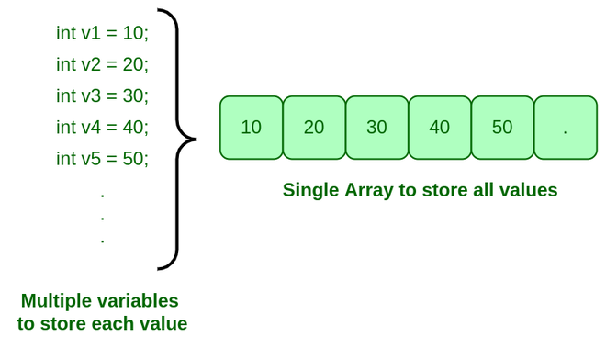
-In order to store same type of values we need to create an Object [Block of Memory]
-Before creating an object, we need to create a block of memory to store the Address of the object.
-To store Homogenous type of values using Array we need create:-
1]Array Reference Variable
2]Array Object

1]Array Reference Variable
-Array reference variable it is used to store the Address of the Array object.
-We can create an Array for both Primitive & NonPrimitive Datatype.
Syntax:-
1] datatype[] VariableName;
2] datatype VariableName [];

class ArrayDemo
{
public static void main(String[] args)
{
int[] a;
byte[] b;
long[] c;
short[] d;
float[] e;
double[] f;
char[] g;
boolean[] h;
String[] i;
}
}

class ArrayDemo1
{
public static void main(String[] args)
{
int a [];
byte b [];
long c [];
short d [];
float e [];
double f [];
char g [];
boolean h [];
String i [];
}
}

2]Array Object
-Array object is consist of Address.
-We can create an Array Reference variable for both Primitive or NonPrimitive datatype.
-We can create an Array object in two ways:-
1]Declaration & Initialization
2]Using New Keyword
1]DECLARATION & INITIALIZATION

Syntax:
Datatype[] VariableName={value1,value2,value3…..value n};

//QNO1:-Creating Array using Array Declaration And Initialization
class ArrayDeclarationAInitialization
{
public static void main(String[] args)
{
int [] arr = {1,2,3,4,5};//Declaration And Initialization Of Array
System.out.println(arr);
System.out.println(arr.length)
}
}
/************************************
--------->>>>>OUTPUT>>>>------------*
*************************************
-->>[I@3fee733d *
*************************************/

Int [] arr = {1,2,3,4};
@123

@123

1
2
3
4
5
Array Object

-If we print the arr then it print the address of the array.
-For accessing the array element you have use the index value.
NOTE:-
-Index value always start from 0.
-Length is always start from 1.
Length Property

-It is used to count the number the units present inside the array object.
-Array always consist of Fixed-Length.
-We can access the length of array with the help of Length variable
Syntax:-
ArrayReferenceVariableName.length;

class ArrayLength
{
public static void main(String[] args)
{
int[] array = {1,2,3,4,5};
System.out.println(array.length);
}
}

Access Array Element

-We can access the units of array object with the help of Index Value.
-Index Value always start with 0[Zero].
-To access index value we need to take the help of array Reference Variable.
Syntax:-
ArrayReferenceVariable [Index Value];

class ArrayDemo
{
public static void main(String[] args)
{
int[] array = {10,20,30};
System.out.println(array[0]);
System.out.println(array[1]);
System.out.println(array[2]);
System.out.println(array.length);
}
}

Int arr = {10,20,30};
@123
10
20
30
0 1 1 2
Count
Length
@123
Index Value
3 2

NOTE:-
-Declaration an Initialization of array cannot be perform in multiple statement. [We get compile Time Error].
//QNO2:-Declaration And Initialization Array In Clone Multiple Statement

class DeclarationAInitializationMultipleStatement
{
public static void main(String[] args)
{
int [] n;
n = {1,2,3,4,5};//Declaration And Initialization Array Cannot Be Clone In Multiple Statement
System.out.println(n);//We get compile Time Error
}
}

DeclarationAInitializationMultipleStatement.java:8: error: illegal start of expression
n={1,2,3,4,5};//Declaration And Initialization Array Cannot Be Clone In Multiple Statement
^
DeclarationAInitializationMultipleStatement.java:8: error: not a statement
n={1,2,3,4,5};//Declaration And Initialization Array Cannot Be Clone In Multiple Statement
^
DeclarationAInitializationMultipleStatement.java:8: error: ';' expected
n={1,2,3,4,5};//Declaration And Initialization Array Cannot Be Clone In Multiple Statement
^
DeclarationAInitializationMultipleStatement.java:9: error: <identifier> expected
System.out.println(n);//WE get compile Time Error

NOTE:-
-Other way to printing the Array element using loops.
-Using for loop we can print easily the array element.
class ArrayAccess
{
public static void main(String[] args)
{
int[] arr = {11,22,33,44,55};
System.out.println(arr);
System.out.println(arr.length);

for(int index=0;index<arr.length;index++)
{
System.out.println(arr[index]);
}
}
}

2]Using New Keyword

Syntax:-
Datatype[] VariableName=new datatype[Size];

New Keyword: -
-New keyword it is used to create an Object [A block of Memory].
class ArrayNewDemo
{
public static void main(String[] args)
{
int[] arr = new int[3];
System.out.println(arr);
System.out.println(arr.length);
}
}

[I@6d06d69c
3
Press any key to continue . . .

class ArrayInsertDemo
{
public static void main(String[] args)
{
int[] arr = new int[3];
System.out.println(arr);
System.out.println(arr.length);
System.out.println(arr[0]);
System.out.println(arr[1]);
System.out.println(arr[2]);
arr[0] = 10;
arr[1] = 20;
arr[2] = 30;
System.out.println(arr[0]);
System.out.println(arr[1]);
System.out.println(arr[2]);

}
}

[I@6d06d69c
3
0
0
0
10
20
30
Press any key to continue . . .

Index Value

Address

int[ ] arr = new[3];
[I@6d06d69c

0 10
0 20
0 30
[I@6d06d69c

0
Array Object
1

2
arr[0]=10;
arr[1]=20;
arr[2]=30;
Default
Value

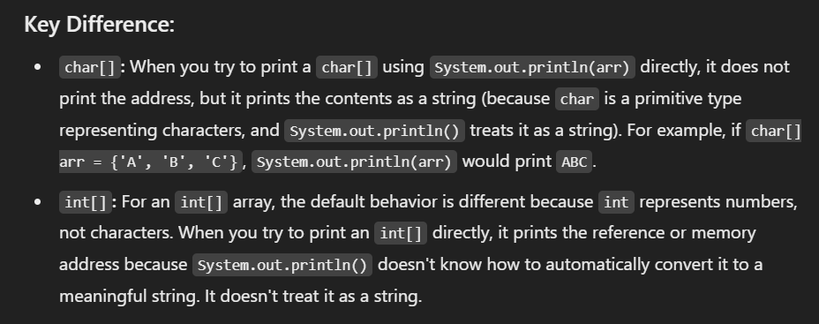
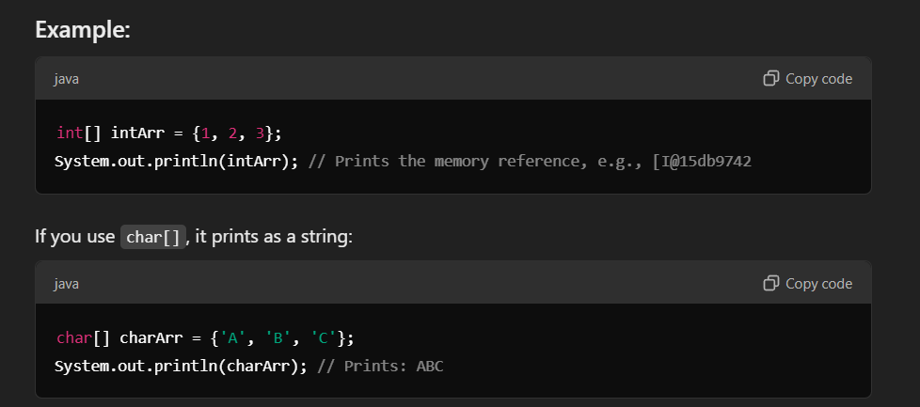
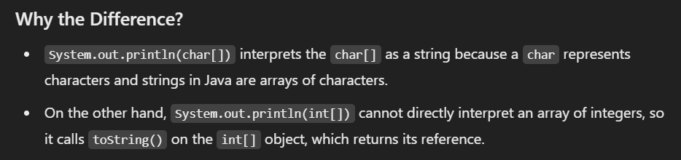
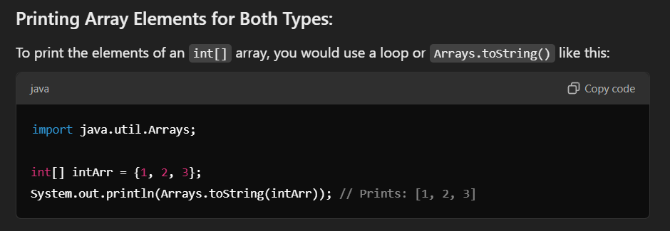
ArrayIndexOutOfBoundsException

-When we try to access Array, units based on its Index Value.
-If the Index Value is Greater or Equal’s to Length of Array Object, we get an
Runtime Exception called as ArrayIndexOutOfBoundsException.
-Whenever an Exception occurs the execution of the program is forcefully Stopped.
class ArrayIndexOutOfBoundsException
{
public static void main(String[] args)
{
System.out.println("Main Starts");
int[] arr = new int[3];
System.out.println(arr[0]);
System.out.println(arr[1]);
System.out.println(arr[2]);
System.out.println(arr[3]);//Exception
System.out.println("Main Ends");
}
}

Main Starts
0
0
0
Exception in thread "main" java.lang.ArrayIndexOutOfBoundsException: 3
at ArrayIndexOutOfBoundsException.main(ArrayIndexOutOfBoundsException.java:10)
Press any key to continue . . .

-In above program we already define the length
-If we trying access the element if the Index value is greater or Equal to the length then we ArrayIndexOutOfBoundsException.
-If this exception occurs then the remaining code of the program is not excuted.

NULL KEYWORD
Note: -Inside the Array Reference variable we can pass two types of elements
1]Address of the Array Object [Object Creation is Mandatory].
2]Null Keyword

Null Keyword: -
-Null is a Keyword in java.
-Null Means Nothing/Empty.
-The Default value of null is Null itself.
-If we pass Null into an Array References variable it does not allow to programmer to point to any of the Array Object.
NullPointerException

NullPointerException: -
-If we pass Null into an Array Reference Variable and If we try to Define the Length of the Array Object since there is no Array Object created, we get a Runtime Exception called as NullPointerException.
class NullPointerException
{
public static void main(String[] args)
{
int[] arr = null;
System.out.println(arr);//null
System.out.println(arr[0]);//NullPointerException
}
}

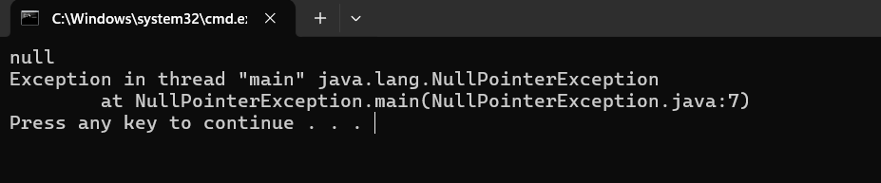

-If you can access the ArrayReference Variable but when you try to access the Array index value then we get NullPointerException.
-Because we set the value of ArrayReference variable is NULL.
-It means you cannot access the Array Index value.
-Even if you try to access the length also we get NullPointerException.
class NullPointerException1
{
public static void main(String[] args)
{
int[] arr = null;
System.out.println(arr);
System.out.println(arr.length);
}
}

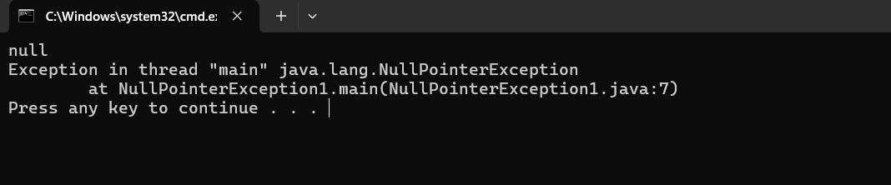

ASSIGNMENT QUESTIONS
QNo1.Write a program to find the summation of an Array.
class SummationFiveNumStoreArray
{
public static void main(String[] args)
{
int num[]={1,2,3,4,5};

int sum=0;
for(int index=0;index<num.length;index++)
{
sum=sum+num[index];
}
System.out.println(sum);

}
}

15
Press any key to continue . . .

QNO2.Write a program to count the number of Even Numbers present inside the Array. int[] n={2,5,10,6,7,12,8,9}
class CountEven
{
public static void main(String[] args)
{
int[] arr={2,5,10,6,7,12,8,9};

System.out.println("Address"+arr);
int count=0;
for (int i=0;i<arr.length;i++)
{
if (arr[i]%2==0)
{
System.out.println(arr[i]);
count++;
}
}
System.out.println("The Number of Even Number In Array:-"+count);
}
}

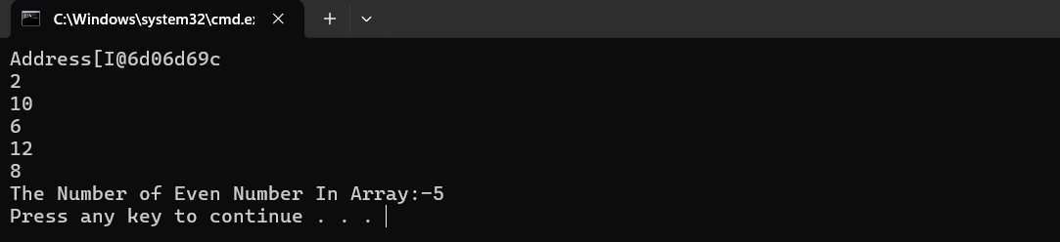

QNO3.Write a program to count the number of Positive numbers inside the array. int[] n={2,-5,10,-6,7,-12,8,-9}
class CountPos
{
public static void main(String[] args)
{
int[] arr={2,-5,10,-6,7,-12,8,-9};
int count=0;

for (int i=0;i<arr.length;i++)
{
if (arr[i]>0)
{
System.out.println(arr[i]);
count++;
}
}
System.out.println("The Number of Positive Number is:-"+" "+count);
}
}

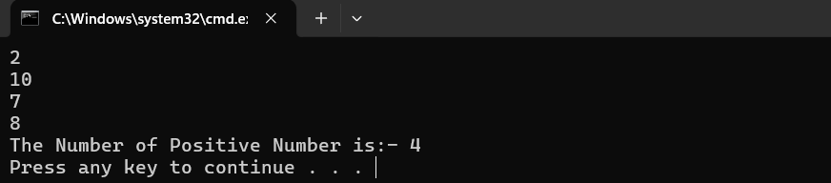

QNO4.Write a program to find he summation of Even numbers present inside the array.
class ArrSummation
{
public static void main(String[] args)
{
int[] arr={2,23,34,141,34,54,234};

int Sum=0;

for (int i=0;i<arr.length;i++)
{
Sum+=arr[i];
}
System.out.println("The Summation Array Is:-"+Sum);
}
}

QNO5.Write a program to count the number of Uppercase and Lowercase Characters present inside the array.Int[] arr={‘A’,’a’,’B’,’b’,’C’,’c’}
class ArrUppLowLetters
{
public static void main(String[] args)
{
char[] arr = {'A','a','B','b','C','c','D'};
char[] Uarr = new char[arr.length];
char[] Larr = new char[arr.length];
int Ucount = 0;
int Lcount = 0;

for (int i=0;i<arr.length;i++)
{
if (arr[i]>='A' && arr[i] <='Z')
{
Uarr[i]+=arr[i];
}
if (arr[i]>='a' && arr[i] <='z')
{
Larr[i]+=arr[i];
}
}
System.out.println(Uarr);
System.out.println(Larr);
}
}

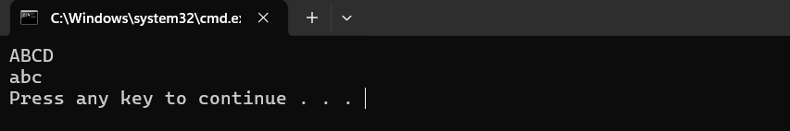

QNO6.Write a program to count the number of Vowels present inside the array.
class CountVowels
{
public static void main(String[] args)
{
char[] ch={'A','a','f','e','h','i'};
int Count=0;

for (int i=0;i<ch.length;i++)
{
if (ch[i]=='a'||ch[i]=='e'||ch[i]=='i'||ch[i]=='o'||ch[i]=='u')
{
Count++;
}
}
System.out.println("The Number of Vowels Is:-"+Count);
}
}

QNO7.Write a program to count the number of Uppercase Vowels present inside the array.
class CountUppercaseVowels
{
public static void main(String[] args)
{
char[] ch={'A','B','c','E','e','I','O','U'};
int Count = 0;

for (int i=0;i<ch.length;i++)
{
if (ch[i]=='A'||ch[i]=='E'||ch[i]=='I'||ch[i]=='O'||ch[i]=='U')
{
Count++;
}
}
System.out.println("The Uppercase Vowels Are:-"+Count);
}
}

PASSING AN ARRAY TO METHOD

-We need to Create the Array Object Reference Variable.
-We Need to call the Method and Pass Address of the Array Object.
class PassingArrayToMethod
{
static public int demo(int arr[])
{
int sum=0;
for(int i=0;i<arr.length;i++)
{
sum=sum+arr[i];
}
return sum;
}
public static void main(String args[])
{
int[] arr1 = {1,21,3,5,6};
int sum = demo(arr1);
System.out.println(sum);
int[] arr2 = {19,18,20,21,22};
System.out.println(demo(arr2));
}
}

ARRAY DISADVANTAGES / LIMITATION OF ARRAY

1]Array is fixed in size.
2]Array can hold only Homogenous Type of elements.
3]Arrays concept is not implemented based on some standard data structure hence there no predefined or readymade method support is not available for array.

GLOBAL VARIABLES

-Global variable are declared inside the Class Block.
-Global variable have default value.
-Global variable are classified into two types: -
1]Static Global Variable
2]Non-Static Global Variable

1]Static Global Variable
-A variable which declared inside the class block and Prefixed with the Static Keyword is called Static Variable.
-We can declare more than one Static variable inside the Class Block but variable name has to be different.
Syntax: -
Static Datatype Variable Name=Value;
Ex: -
Static int n=10;
-Static variable consist of Default Value.
We can Access the Static variable in two ways: -
1]Directly By [Its Variable Name].
2]Class Name as Reference

class AccessStaticVar
{
static int n=10;
public static void main(String[] args)
{
System.out.println(n);//1.Directly
System.out.println(AccessStaticVar.n);//2.ClassName As Refrence
}
}

Note: -We can Access a static variable in two ways for printing the value
Present inside the static variable for Initializing the static variable.
class StoreValueInStaticVar
{
static int n;
public static void main(String[] args)
{
System.out.println(n);//Directly
System.out.println(StoreValueInStaticVar.n);//Class Name As Refernce

//1:-Store Value Directly By Its Name
n=100;
System.out.println(n);

//2:-Store Value By Its Class Name As A Reference
StoreValueInStaticVar.n=200;
System.out.println(StoreValueInStaticVar.n);
}
}

Note: -If a class consist of both Static variable and Local Variable with Same Variable name after declaration of Local variable if we try to access any variable Directly by its Variable name the compiler always gives Priority for Local Variable first.
-On such case to access a static variable we need to take the help of Class Name as Reference.
class Static$LocalVar
{
static int n=10;
public static void main(String[] args)
{
System.out.println(n); //Directly by Its Name
n=20; //Directly by Its Name
System.out.println(n); //Directly by Its Name

int n=30;
System.out.println(n); //Directly by Its Name
System.out.println(n); //Directly by Its Name

n=60;
System.out.println(n); //Directly by Its Name
System.out.println(Static$LocalVar.n); //Class Name as Reference

Static$LocalVar.n=100; //Class Name As Reference
System.out.println(Static$LocalVar.n); //Class Name as Reference
}
}

Note: - We can access the Static variable from one class to another class with help of Class Name As Reference.
class P1
{
static int n=10;
}

class P2
{
static int n=20;
public static void main(String args[])
{
System.out.println(n); //Directly by Its Name
System.out.println(P1.n); //Class Name as Reference
System.out.println(P2.n) ;//Class Name as Reference
}
}

Note: -After declaration of static variable when we declare the local variable inside the main method and if we try to access directly then the compiler searches for the local variable because the local variable has the first priority.
-The compiler searches the local variable Before that Statement.
class StaticSearchingVar
{
static int n=10;
public static void main(String[] args)
{
System.out.println(n); //1.Local==>NP==>2.Static==>NP==>Non-Static
n=20;//1.Local==>NP==>2.Static==>NP==>Non-Static
System.out.println(n);//1.Local==>NP==>2.Static==>NP==>Non-Static

int n=30;//1.Local==>NP==>2.Static==>NP==>Non-Static
System.out.println(n); //1.Local==>NP==>2.Static==>NP==>Non-Static
System.out.println(n); //1.Local==>NP==>2.Static==>NP==>Non-Static
n=60;//1.Local==>NP==>2.Static==>NP==>Non-Static
System.out.println(n);//1.Local==>NP==>2.Static==>NP==>Non-Static
System.out.println(Static$LocalVar.n);//Directly Static

Static$LocalVar.n=100;//Directly Static
System.out.println(Static$LocalVar.n);//Directly Static
}
}

a
0 10
Main
LINK
1.Directly Name Local VarPresentAccess
2.Not PresentStatic Var
{
Sop(a);
Sop(b);
}
0 20
b

gg
1.Directly Name Local VarPresentAccess
2.Not PresentStatic Var
Static Area
Stack Area

LOADING PROCESS OF STATIC VARIABLE

1]Searching
2]Loading
3]Allocates with Default Value
4]Passing Actual Value of Variable

Steps: -
1.First the main method comes for execution
2.Before execution of main method we need to keep Loads the static variable for the execution
3.Before execution of main method compiler Searches for the Static variable inside the class Block. [Searching Is Happens]
4.If its present then it gets loaded one by one inside the Static Area. [Loading Is Happens]. Again, compiler searches for another static variable whether it is present it gets loaded or Not Present.
5.Then compile allocates/assigns the default value to the static variable. [Allocation Default value Is Happens]
6.After that Compiler Assigns Actual value to the Static variable if it actual value is not, they’re then nothing worry about it because the default value is Present. [Passing Actual Value of Variable]
7.Here our static variable is gets ready for execution. Then the main method is coming for the execution of static variable.

STATIC BLOCK

-A block which is prefixed with static keyword and declared inside the class block is called as Static Block
Syntax: -
Static
{
Statements;
}

-Static block always gets executed before the execution of Main Method Begins.
-A programmer cannot call a static block because static block does not consist
of Any Name.
-Static block does not return any value back to programmer because static block does not consist any ReturnType
-We can declare more than one static block inside the class block.
-All the static block gets executed in Top to Bottom order.

class StaticBlockExecution
{
static
{
System.out.println("Static Block-1");
}
public static void main(String args[])
{
System.out.println("Main Method");
}
static
{
System.out.println("Static Block-2");
}
}

Static Initializer Block [SIB]

-With the help of Static Block we can initialize a Static variable before the Execution of Main method Begins.
-Hence Static Block it is also called as Static Initializer Block [SIB].
class StaticVarInitializeFromStaticBlock
{
static int a;

static
{//Static Block
a=100;
System.out.println(a);//Directly Access using Variable Name
StaticVarInitializeFromStaticBlock.a=200;
System.out.println(StaticVarInitializeFromStaticBlock.a);//Accces Static Varible Class Name As a Reference
}
public static void main(String[] args)
{
System.out.println("Hello World!");
}
}

{
a=200;
Sop(a);
}
static

1.Directly Name Local VarPresentAccess
2.Not PresentStatic Var
a
0 200
Main
{
Sop(a);
}
1.Directly Name Local VarPresentAccess
2.Not PresentStatic Var
gg

Static Area

Stack Area
-We can access the static variable from static block in two ways:-
1]Directly By variable Name
2]Class Name As Reference.
class StaticVarAccessFromStaticBlock
{
static int a=100;

static
{//Static Block
System.out.println(a);//Directly Access using Variable Name
System.out.println(StaticVarAccessFromStaticBlock.a);//Accces Static Varible Class Name As a Rreference
}
public static void main(String[] args)
{
System.out.println("Hello World!");
}
}

Static -1
{
Sop(a);
A=10;
Int a=30;
Sop(a)
Sop(P6.a);
}

a
0 30
b
0 50
Static -2
{
B=50
Int b=40;
Sop(P6.b);
Sop(b);
}

Main
{
Sop(a);
Sop(b);
}

Static Method
-A method which is declared inside the class Block and Prefixed with Static keyword is called as Static Method.
-We can declare more than one Static method inside the class Block.
-We can Access the Static Method in Two ways: -
1]Directly by Method Name
2]Class Name as Reference.
-Main Method gets loaded before the execution of Static Block.
Class P1
{
static public void test()
{
System.out.println(“test()”);
}
public static void main(String[] args)
{
test();
P7.test();
}
}

-We can Access the static method from one class to Another class with the help
Of Class Name as Reference.
Class P2
{
Static public void test()
{
System.out.println(“test()”);
}
}

Class P3
{
Public static void main(String args[])
{ //Access the Previous Class Method
System.out.println(P2.test());//Class Name As Reference
}
}

-Inside the class block we can declare the Three types of Static Members
1]Static Variable
2]Static Method
3]Static Block

QNo1.Can we access a static method from a Static Block? [In how many Ways]
#Class P4
{
static public void demo()
{
System.out.println(“Demo()”)
}
static
{
Demo();
P4.demo()
}
public static void main(String args[])
{
System.out.println(“main method”);
}
}

QN02.Can we access the static variable from a Programmer Created Static Method? [In how Many Ways]
Ans: -
QNo3.Can we Initialize a static variable from a Programmer created Parameterized Static Method.
QNo4.Can we access the Static variable from a static block [In how many ways]
QNo5.can, we access a static variable and a static method from One Class to another class with the help Static block?
Class P5
{
Static int a=10;
Static int b=20;

Public static void test()
{
System.out.println(a);
System.out.println(P5.a);
}
Static
{
P9.test();
}
Public static void main(String [] args)
{
Test();
System.out.println(P5.a);
}
}

O/P: -
10
10
10
10
10

static
Frame Created For Execution
a
{
P9.test()//mcs
}

0 10

Frame Deleted After Execution
b
Test()
0 20
{
Sop(a);
Sop(P9.a);
}

Test()

Frame Created For Execution
main
00
test()
{
Sop(a);
Sop(P9.a);
}

Frame Deleted After Execution
Static Area
main
{
test()//mcs
Sop(P9.a);
}

Steps: -
Stack Area
1.Static Variable
2.Static Method
3.Static Block
4.Execution Main Method Begin
Que.Loading Process of The Class [Class Loading Process]
Que.Loading Process of Static Members
During Loading Process of Static members Static Variable gets loaded first.
Once after Loading process of static variable is completed Static Method gets loaded Next.
Once after the loading process of Static Variable and Static Method is completed then all the Static Blocks of the Class get Executed in Top-to-Bottom Order.
Once after the execution of all The Static Blocks Is completed then Execution of Main Method will Begins.

Note: -
Programmer does not create Memory Allocation for Static Members.
Static Members gets Memory Allocated Automatically during the Compile Time.
Loading Execution
Static Variable
Static Block
{
Directly
Class Name Reference
}

Static Method
Main
{
Directly
Class Name Reference
}
{
Directly
Class Name Reference
}

NON-STATIC MEMBERS
-Non-Static Members are classified into three types: -
1]Non-Static Variable
2]Non-Static Method
3]Non-Static Block

-All the Non-Static Members are declared inside the class block and Not Prefixed with Static Keyword.
Class
{
//Non Static Variable
Datatype VariableName;

Modifier ReturnType MethodName (formal Arguments)
{
//Non-Static Method
Statements;
}

{
//Non-Static Block
Statements;
}
}

For all the Non-static members compiler does not allocates /creates memory
Automatically.
-For all the Non static members an object for the Entire Class is created.
-Before creating an object for the entire class, we need to create Object Reference Variable for the class First such that we can store the Address of the Object which is created for the Entire Class.
-In order to create an object for the class we need to take the help Constructor.

CONSTRUCTOR
-Constructor it is used to create an object for the class with help of New Keyword.
Syntax: -
ClassName objectReferenceVariable=new Keyword ClassName ();
Eg: -
P1 var=new P1()
-We can create more than one object for the class.
Ex: -
Class P1
{
Public static void main(String args[])
{
//Object Creation for Class P1
P1 var=new P1();
P1 var1=new P1();
System.out.println(var);
System.out.println(var1);
}
}

Note: - We can create an Object for One class from Another Class.

class P1
{

}

class P2
{
Public static void amin(String args[])
{
//for another class Object Creation
P1 var =new P1();
System.out.println(var);

//for its own class
P2 var1=new P2();
System.out.println(var1);
}
}

O/P:-
P1@123652
P2@367392

NON-STATIC VARIABLE

-The variable which is declared inside the class block and Not Prefixed by Static Keyword is called as Non-Static Variable.
-In order to load the Non-Static variable, we need to create Object for the Class.
-We can access and Initialize a Non-Static variable with the help of object Reference Variable.
-We can declare more than one Non-Static variable inside the class block but different variable names.
-Non-Static variable consist of Default Values.
Class P1
{
Int a;
Int b=20;

Public static void main(String args[])
{
P1var = new P1 ();
System.out.println(var);
System.out.println(var.a);
var.a=10;
System.out.println(var.a);
System.out.println(var.b);
}
}

class P2
{
int a;
public static void main(String args[])
{
P2 var=new P2();
System.out.println(var);
System.out.println(var.a);
var.a=10;
System.out.println(var.a);

P2 obj=new P2();
System.out.println(obj);
System.out.println(obj.a);
obj.a=20;
System.out.println(obj.a);
System.out.println(var.a);
}
}

P4 var
P4@100
P4@100

P4 var=new P4();
Sop(var);
Sop(var.a);
var.a=10;
Sop(var.a);

Instance of class P4

a
0 10
a
0 20

P4@200
P4 obj
Instance of class P4

P4@200
P4 obj=new P4();
Sop(obj);
Sop(obj.a);
obj.a=20;
sop(obj.a);
sop(var.a);

Heap Area

CONSTRUCTORS

-Constructor has a Same Name as Class Name.
-Constructor does not return any value back to programmer because it does not have any ReturnType.
-For Execution of Constructor Calling is Mandatory.
Constructors are classified into two types: -
1]No Argument Constructor
2]Parameterized Constructor

1]No Argument Constructor
-A constructor declare inside the class block and does not any arguments such constructor is called as No Argument Constructor.
Class P1
{
P1 ()
{
System.out.println(“P1 ()”);
}
Public static void main(String args[])
{
P1 var=new P1();
P1 var1=new P1();
}
}

2]Parameterized Constructor
-A constructor which consist of Arguments and declared inside the class block
Is called as Parameterized constructor.
class P2
{
P2 (int a, int b)
{
System.out.println(a);
System.out.println(b);
}
Public static void main(String args[])
{
P2 var=new P2 (20,50);
P2 var1=new P2 (50,100);
}
}

CONSTRUCTOR OVERLOADING

-A class consist of more than one Constructor with Same class Name and different Arguments is called as Constructor Overloading.
Class P1
{
P1 (int a,int b)
{
System.out.println(a+b);
}
P1(char ch)
{
System.out.println(ch);
}
Public static void main(String args[])
{
P1 var=new P1(20,50);
P1 var1=new P1(‘a’);
}
}

DEFAULT CONSTRUCTOR

-If a programmer fails to declare at list one constructor inside the class block
-The compiler Automatically adds the constructor of No Argument Type such constructor are called as Default Constructor.
Note: -There is no concept of default Parameterized Constructor in Java
Reason: -Compiler cannot define a variable name.
Class P4
{
Public static void main(String args[])
{
P4 obj=new P4();
}
}

TO
Class P2
{
//Default Constructor
P2()
{
}
Public static void main(String args[])
{
P2 obj=new P2();
}
}

Note: -inside the class block if a programmer declares at list one constructor
The compiler does not add Default Constructor on such case we get compile Time Error.
Class P3
{
P2(int a)
{
}
Public static void main(String args[])
{
P3 obj = new P3()//CTE
}
}

Class P4
{
P4 ()
{
System.out.println(“P4 ()”);
}
Public static void main(String args[])
{
P4obj=new P4 ();
System.out.println(obj);
}
}

P6 obj
P6@100
P6()
()
P6@100
{
P6 obj=new P6();
Sop(obj);
}
main
{
Sop(“P6”);
}

Heap Area
Class P5
{
int a=10;
P5()
{
Sop(a);//local,static,Non-Static
A=20;
Sop(a);
}
Public static void main(String args[])
{
P5 obj =new P5();
Sop(P5.a);//local,Static,CTE
}
}

Class P8
{
Int a;//20//100
P8()
{
System.out.println(a);//0
A=20;
System.out.println(a);//20
Int a=25;//50
System.out.println(a);//25
A=50;
System.out.println(a);//50
System.out.println(this.a);//20
this.a=100;
System.out.println(this.a);//100
}
Public static void main(String args[])
{
P8 obj=new P8();
System.out.println(obj.a);//100
}
}

Class P8

Int a;
P8@100
0 20
O/P:-
0
20
25
50
20
100
100
P8()
a
{
System.out.println(a);
A=20;
System.out.println(a);
Int a=25;
System.out.println(a);
A=50;
System.out.println(a);
System.out.println(this.a);
this.a=100;
System.out.println(this.a);
}

obj
P8@100
HEAP AREA
main
P8()
Loading Of Non-Static Constructor
1.Non-Static Variable
2.Non-Static Method
3.Non-Static Block

{
P8 obj=new P8();
Sop(obj.a)
}

O/P:-25 2550252525502525100

P8@100
Int a;//25
obj
a
0 25 100
0 25 150
P8()
Obj1
P8@100
P8@200
main
{
a=25;
System.out.println(a);//25
int A=50;
System.out.println(this.a);//25
System.out.println(a);//50
}

P8@200
a
P8()
{
P8 obj=new P8();
Sop(obj.a);//25
P8 obj1=new P8();
Sop(obj1.a);//25
Obj.a=100;
Sop(obj1.a);//100
Obj1.a=150;
Sop(obj.a);//150
}

}
Loading Of Non-Static Constructor
1.Non-Static Variable
2.Non-Static Method
3.Non-Static Block

P8()

Loading Of Non-Static Constructor
1.Non-Static Variable
2.Non-Static Method
3.Non-Static Block

THIS KEYWORD
-This keyword it is used to point the current object based on the object creation.
Class P1
{
P1()
{
System.out.println(this);
}
Public static void main(String args[])
{
P1 ob=new P1();
System.out.println(ob);
}
}

-This keyword it is also point to the address of the class.
-Whenever the name of the instance and local variable both are the same then our runtime environment JVM gets confused that which one is local variable & which one is the instance variable to avoid this problem we use the this keyword.
-It is also used to call the No Argument Constructor of the current class.
-It is also used to the call Parameterized constructor of the current class.

This Keyword
-This keyword can be used only inside the non static members (non static block ,no argument constructor,parameterized constructor and non static method)
-This keyword it is used to point current object.
-We cannot use this keyword inside the static members (static block, static method)

Important Note
-We can access a non static variable a non static method from static block and static method with help of object reference variable.
-In order to access object reference variable object creation for class is mandatory.

Initializing a Non-Static Variable with the Help of Constructor
Class Student
{
String name;
Int rollno;
String Mnumber;

Student(String n, int r,String m)
{
name=n;
this.rollno=r;
this.Mnumber=m;
}
Public static void main(String args[])
{
Student s1=new s1(“Sagar”,05,”3269832896”);
System.out.println(s1.Name);
System.out.println(s1.rollno);
System.out.println(s1.Mnumber);
}
}

String name;
Int rollno;
String Mnumber;
Student

S1@100
S1
S1@100
Name
null Sagar
rollno

S1
0 123
Student(String n,int r,String m)

{
Name=n;
This.rollno=n;
This.Mnumber=m;
}
Mnumber
null 938926257

Main()
Student s1=new Student(“sagar”,123,”9838926257”);
Sop(s1.name);
Sop(s1.rollno);
Sop(s1.Mnumber);

HeapArea
Student(String n,int r,String m)

Loading Of Non-Static Members
1.Non-Static Variable
2.Non-Static Method
3.Non-Static Block

NON-STATIC BLOCK

-A block which is inside the class block and Not Prefixed with Static keyword is called as Non-Static Block.
Syntax: -
{
Statements;
}

-For the execution of the Non-Static Blocks object creation is mandatory for the class.
-A programmer cannot call the Non-Static block because it does not consist any Name.
-A Non-Static block does not return any value back to programmer because it does not consist of any ReturnType.
-Non-Static block gets executed only once for each object creation.
-We can declare the more than one Non-Static block inside the class block and all the Non-Static blocks gets executed in Top-to-Bottom order.
We can initialize a non static variable from non static block during object creation in two ways
1.Directly
2.using this keyword
Hence non static block is also called as instance initializer block(IIB)

Class P1
{
{
System.out.println(“NS-BLOCK-1”);
}
{
System.out.println(“NS-BLOCK-2”);
}
Public static void main(String args[])
{
P1 obj=new P1();
P1 obj1=new P1();
}
}

Class P2
{
Static
{
//Executes Before the execution of the Main Method Begins
System.out.println(“Static Block”);
}

{
//Executes during the object creation
System.out.println(“Non-Static Block”);
}

P2()
{
//Executes after the Object creation
System.out.println(“P2()”);
}
Public static void main(String args[])
{
P7 obj=new P7();
}
}

NON-STATIC METHOD

-A method which is declared inside the class block and not prefixed by Static keyword is called as Non-Static Method.
-We can declare more than Non-Static method inside the class block.
-In order to load Non-Static method Object creation for the Entire is Mandatory.
-We can access the Non-Static method with the help of Object Reference variable.
Class P1
{
Public void test()
{
System.out.println(“test()”);
}
Public static void main(String args[])
{
P1 obj=new P1();
obj.test();
P1 obj1=new P1();
obj1.test();
}
}

Assignment Question

Non-Static Block
QNo1.Can we access the variable from a non-static block.[In two Ways](Directlythis keyword)
QNo2.Can we Initialize a Non-Static variable from a Non-Static Block
[In two Ways](Directlythis keyword).
QNo3.Can we call a No Argument Non-Static method from the Non-Static Method
QNo.4.Can we call Parameterized Non-Static Method from the Non-Static Block.
QNo5.Can we call a No Argument and a Parameterized method of Non-Static from No Argument and Parameterized Constructor.[In How Many Ways]

Non-Static Method
QNo1.Can we Access the and Initialize a Non-Static variable from a No Argument Non-Static Method[in How Many ways]
QNo2.Can we Access and Initialize a Non-Static variable from a Parameterized Non-Static Method.
QN03.Write A Program to find the summation of First 10 Number and Return the result using Non-Static Method.
QNo4.Can we perform method overloading with the help of Non-Static Method.
QNo5.Can we perform the recursive method with the help of Non-Static method
QN06.Can we call One Non-Static Method from Another Non-Static Method
QN07.Can we Access the Static variable from main method.[In how Ways].

Que.Why Non Static block required Object creation.
Que.String[] instead …
Que.what is use of creating object inside the class block.
Que.Can we call main method inside main method
Main(new String[0])

LOADING PROCESS OF NON STATIC METHOD:

-To non static members of the class object creation for the class is mandatory.
-During the object creation non static variables are always gets loaded first.
-Once after all the non static variable gets loaded completely then non static method gets loaded next.
-Once after all the non static variable and non static method gets loaded completely then non static block gets executed in top to bottom order.
-Once after all the non static block gets executed in top to bottom In order then execution of constructor begins.

What is the use of Constructor
1.With help of constructor we can load non static members of the class inside the object.
2.with help of constructor we can initialize the non static variable after object creation.
3.with help of constructor we can access both non static and static members.

OBJECT ORIENTED PROGRAMMING

-Object Oriented programming it is concept of (structure)where we take all the real time examples and convert into a programming language.
Object
-Object it is an real time example object consist of 2 element:
1.properties
2.behaviours
-Properties are converted into a variable.
-Behaviors are converted into a methods.
-Variable and method are the property of the class.
-Hence object (real time example) is converted into a class.

Class:
-Class it is called as blue print of the object.
-Object Oriented Programming consist of following Pilers
1.Encapsulation
2.Inheritence
3.Polymorphism
4.abstraction

1.Encapsulation
-It is process of binding between properties and behaviours of an object.
Advantage
-Data hiding
2.Inheritence
-It is process of acquiring the properties and behaviours of parent class inside the child class is called inheritance.
Advantage
-Reusability
3. Polymorphism
-It is process of an object which exhibit more than one form is called as polymorphism.
4.Abstractions
-It is process of hiding the implementation is called as abstraction.

1.ENCAPSULATION

-It is process of binding between properties and behaviours of an object.
-Encapsulation is process of the achieving the data hiding is called as encapsulation.
Data Hiding:
-Hiding the data (Value) from the outside world is called data hiding.
-We can hide the data with help of private keyword.
Private Keyword:
-Private keyword it is an access modifier. When we prefix any variable with private keyword we can not access the private variable from another class.
(for printing and modifying the value)
-In order to access private variable we need to create two methods
1.getter method
2.setter method

1.Getter method:
-Getter method it is used to access private variable (printing ,reading method header of getter method)
Access modifier return type getMethodName(){
Return private variable;
}

-Return type of getter method depends on the variable which is private.

2.Setter method:
Setter method It is used to modify the private variable.
Method header of setter method
Access modifier void setMethodName(datatype Variablename){
this.private_variable=new variable_name;
}

Class Student
{
//n-s variable
String name;
int rollno;
Private String Mnumber;
Student(String n,int r,String m)
{
This.name=n;
This.rollno=r;
This.Mnumer=m;
}
//getter method
Public String getNumber()
{
Return Mnumber;
}
//setter method
Public void setNumber(String number)
{
This.Mnumber=number;
}
//non static method
Public void details()
{
System.out.println(this.name);
System.out.println(this.rollno);
System.out.println(this.Mnumber);
}
}

Class School
{
Public static void main(String[] args)
{
Student s1=new Student(“Sager”,123, “9876543211”);
System.out.println(s1.Mnumber);//CTE (variable is private)
//calling getter method
System.out.println(s1.getNumber());
//s1.Mnumber=”9874543611” //CTE (variable is private)
//calling setter method
S1.setNumber(“9876543211”);
System.out.println(s1.getNumber());
}

Name
Rollno
Mnumber

Getter and setters
Details(){
}
Null sagar
Private
0 125
Student(String n,int r,String m){
Name=n;
Rollno=r;
Mnumber=m
}

Null 9876

Main(){
Students1=newStudent(“Sager”,123, “9876543211”);
System.out.println(s1.Mnumber);//CTE (variable is private)
//calling getter method
System.out.println(s1.getNumber()); //s1.Mnumber=”9874543611” //CTE (variable is private)
//calling setter method
S1.setNumber(“9876543211”);
System.out.println(s1.getNumber());

}
Student@1

                - 1.Non static variables
                - 2.Non static metho
                - 3.Non static block 4.constructor

Create one program using setter and getter method and private keyword.
Class Gmail
{
Private String gamil;
Private String password;
Gmail(String gamil,String password)
{
This.gamil=gmail;
This.password=password;
}
Public void setGmail(String gamil)
{
This.gamil=gamil;
}
Public void setPassword(String Password)
{
This.password=password;
}
Public String getGamil()
{
Return gmail;
}
Public String getPassword()
{
Return password;
}
}
Class GmailDriver
{
Public static void main(String[] args)
{
Gmail g1=new Gmail(“rushimisal5@gmail.com”, “Rushikesh@9096”);
// System.out.println(g1.gamil); //CTE
System.out.println(g1.getGamil() );
g1.setPassword(“124”);
System.out.println(g1.getPassword());
}
}

Diagram:
Null rushim
gamil
password

Getter and setters methods

Private
Gmail(String gamil,String password){
This.gamil=gmail;
This.password=password;
}

Null 125

Gamil@1
Main(){
Gamil g1=new Gmail(“rushimisal5@gmail.com”, “Rushikesh@9096”);
// System.out.println(g1.gamil); //CTE
System.out.println(g1.getGamil() );
g1.setPassword(“124”);
System.out.println(g1.getPassword());
}

}

                - 1.non static variables
2.Non static method
3.Non static block 4.constructor

RELATIONSHIP

Relationship It is classified into two types
1.has-a-releationship
2.is-a-relationship
1.has-a- relationship:
Has-a-relationship it behaves like a complete whole object and multiple parts of it
Examples:
1.company has a employee
2.bike has a engine
3.youtube has a subscribers
4.grosary store has a customers
5.Aroplane has a passengers
2.is-a-relationship:
Is- a-relationship it behaves like a parent and child.
Examples:
1.flult is a musical instrument
2.facebook is a social media application
3.laptop is a gadget
4.camera is a device
5.bike is a vehicle

Inheritance:
Definition:
-It is process of acquiring the properties and behaviors from parent class to child class is called as Inheritance.
-We can perform inheritance with help of extends keyword.
-Extends keyword represent is-a relationship.
-Parent class it is also called as super class.
-Child class it is also called as sub class.
-It is process of acquiring the properties and behaviors of super class to
-Sub class is called as Inheritance.
Class A{
Static int a=100;
Public static void tets(){
System.out.println(“test()”)
}
Public static void main(String[] args){
//members of its own class
System.out.println(a);
Test();
}
}

Class B extends A{
Static int b=10;
Public static void demo(){
System.out.println(“demo()”);
}
Public static void main(String[] args){
//members of its own class
System.out.println(b);
Demo();
//members of its parent class
System.out.println(a);
Test();
}

Variable -a
Method-tets()

Main(){
Tets()--
}

parent class
or
Incorporated members

extends
Variable -b
Method-demo()
Main(){
B
Demo()

A
Tets()
}

Child class
Or Incorporated
members
Sub
class
Inherited
Members

-Properties are called as variable (static variable,non static variable ,local variable)
-Behaviors are called as method(static and non static)
-In the above program class A it is behaving like super class or parent class of class of B
-Here class B it is behaving like child of parent class A
-Child class B can access the members of its own class such members are called as incorporated members.
-Child class can also access the members of its parent class such members for child class are called as inherited members.

Loading process of static members using inheritance

Class A{
Static int a=100;
Static{
System.out.println(“SIB-A”);
}
Public static void test(){
System.out.println(“test()-A”);
}
}
Class B extends A{
Static int b=20;
Static {
System.out.println(“SIB-B”);
}
Public static void demo(){
System.out.pritnln(“Demo()”);
}
Public static void main(String[] args){
//calling the members directly by its name
System.out.println(b);
Demo();
System.out.println(a);
Test();
}
}

Note-1: calling the members of its own class and its parent class with help of class name as reference
Public static void main(String[] args){
//calling the members Class name as reference
System.out.println(B.b);
B.Demo();
System.out.println(A.a);
A.Test();
}

Note-2:We can access static members with help of object reference variable only when there is no non static members with the particular name.
Public static void main(String[] args){
B obj=new B();
System.out.println(obj.b);
Obj.demo();
//members of the parent class
System.out.println(obj.a);
Obj.test();
}

Note-3
We can access static members in four ways
1.direclty by its name(variable,method).
2.with help of class name as reference.
3.with help of object reference variable
4.with the help of this keyword.(From Non-Static Context)
5.with the help of super keyword.(From Non-Static Context)

Super most class

Object
  - static variable
  - static method
  - static block

constructor invocation A constructor execution

B

Main(){
Sop(b);
Demo();
Sop(a);
Test();
}

Directly --->local --static variable own class-static variable parent clas Directlystatic method of own class
Directly-local-static variable own class -static variable par Directlyown class static method -parent class static method

Stack

Object class static members

A
0 100

A
Test()

B
0 20

B
Demo()

B
Main()

Static area

Loading process of non static members using inheritance
-In order to load non static members we need to crate an object for child class. Such that we can load the members of own class and its parent class

Class A{
Int a=100;
Public void test(){
System.out.println(“test()”);
}
{
System.out.println(“IIB-A”);
}
}
Class B extends A{
Int b=20;
Public void demo(){
System.out.println(“demo() “);
}
{
System.out.println(“IIB -B”);
}
Public static void main(String[] args){
//object creation for child class
B obj=new B();
System.out.println(obj):
System.out.println(obj.a);
System.out.println(obj.b);
Obj.demo();
Obj.test();
}
}

Object(){

}
B@100 address

Object class non static members
Instance of object class
B@100
B Obj=new B();

Sop(obj.a);
Obj.demo();
Obj.test();
A(){
Super();

}
B(){
Super();

}

A
0 100

Instance of class A

Tets(){}

B
0 20

Instance of class B

demo(){}

1.non static variable 1.non static variable
2.non static method heap memory
3.non static block
4.constuctor

CONSTRUCTOR CHAINING
-It is process of one constructor calling another constructor is called constructor Chaining.
-Constructor chaining is classified into two types:
1.Super call statement:
-Super call statement is used to call the constructor of its parent class.
-Super call statement should be always declared as first statement inside the constructor.
A () {
Super ();
}

We can not declare super call statement in between the constructor we get compile time error.
Example:
A(){
System.out.println(“A()”); ------>CTE
Super ();
}

-Super call statement of no-argument type gets added automatically as the first statement inside the constructor.
Example:
A(){
System.out.println(“A()”);
}

To
A(){
Super (); ---->gets added automatically
System.out.println(“A()”);
}

Class A{
Int a=100;
Public void test(){
System.out.println(“test()--A”);
}
{
System.out.println(“IIB--A”);
}
A(){
System.out.println(“A()”);
}

}
Class B extends A{
Int b=20;
Public void demo(){
System.out.println(“Demo()---B”);
}
{
System.out.println(“IIB--B”);
}
B(){
System.out.println(“B()”);
}

}
Class C extends B{
Int c=20;
Public void key(){
System.out.println(“key()--B”);
}
{
System.out.println(“IIB--C”);
}
C(){
System.out.println(“c()”);
}
Public static void main(String[] args){
C c=new C();

}}

C@100 address

Object class non static members
Instance of object class
Object(){

}

Instance of class A
A
0 100
Tets(){}

B(){
Super();

}
B
0 20

Instance of class B

demo(){}

B(){
Super();

}
B
0 20

Instance of class C
Key(){}

C(){
Super();

}

1.non static variable 1.non static variable
2.non static method heap memory
3.non static block T
4.constuctor b
C Obj=new C();

C @100
Super Most Class
Object

- static variable
- static method
- static block

constructor invocation A constructor execution

B

C

Class A{
Int a=100;
Public void test(){
System.out.println(“test()”);
}
{
System.out.println(“IIB-A”);
}
}
Class B extends A{
Int b=20;
Public void demo(){
System.out.println(“demo() “);
}
{
System.out.println(“IIB -B”);
}
Public static void main(String[] args){

//object creation for child class
B obj=new B();
System.out.println(obj):
System.out.println(obj.a);
System.out.println(obj.b);
Obj.demo();
Obj.test();
}
}

Note 1: -If a parent class consist of parameterized constructor and to call this constructor from child class writing the super() call statement and passing value is Mandatory inside the child class constructor.
Ex:-
#program
OBJECT CLASS

Class A
{
Super();
A(int a)
{
System.out.println(“A(int)”);
}
Constructor Invocation
}

Class B extends A
Constructor Execution
{
B()
{
Super(12);//Mandatory
System.out.println(“B()”);
}
Public static void main(String args[])
{
B obj=new B();
}
}
Constructor Invocation[Calling]:-
B()B(12)A()Object Class()

Constructor Execution:-
Object class()A()B()

OBJECT CLASS

Class A
{
A(int a)
{
Super();
System.out.println(“A(int)”);
}
A(double a)
{
Constructor Invocation
Super();
Constructor Execution
System.out.println(“A(double)”);
}
}
Class B extends A
{
B()
{
Super(‘a’);
System.out.println(“B()”);
}
Public static void main(String args[])
{
B obj=new B();
}
}

Scanner Class

Scanner is a In build class in java it is used to take obtain the input of primitive types like int,double,char,string.
-It is easiest way to read the input from the user.
-Scanner class present inside java.util package we need to import it.
-Using Scanner class we take input from user during Runtime.

Syntax: -import packageName Member To Imported
Syntax: - import java.util.Scanner

Scanner Classes Method
Byte ======> nextByte()
Short ======> nextShort()
Int ======> nextInt()
Long ======> nextLong()
Float ======> nextFloat()
Double ======> nextDouble()
Char ======> next()
charAt(0)
Boolean ======> nextBoolean()
String ======> next()
nextLine()

next():-next method is takes input as a Word
nextLine() :-nextLine method is takes input as a Line

STRING

-String is a Non-Primitive Datatype.
-String it is an Inbuild Class Which is Present java.lang Package.
-The Fully Qualified Name Of String Class java.lang.String.
-String class is a final.
-String Class Extends Object Class and Implements Two Interfaces
1]Comparable Interface
2]Serializable Interface
3]Char Sequence Interface

Char Sequence Interface
Serializable Interface
Comparable Interface
OBJECT
CLASS

EXTENDS IMPLEMENTS

STRING

-String is a Concrete Class in java.
-We can create the Object for the String Class in two ways
1]Using Assignment Operator[Literal Way]
2]Using New Keyword.

#Program
Class P1
{
Public static void main(String args[])
{
String s1=”java”;
System.out.println(s1);

String s2=new String(“Java”);
System.out.println(s2);
}
}

STRING CONSTANT POOL AREA
Java.lang.String@123

“JAVA”
String s1 = ”java”;
Java.lang.String@123

-The Created Object using the Assignment operator for the String it will be Store Inside the String Constant Pool Area.

-We Cannot modify The Value Of the String Object Because it is final in Nature

-String Constant Pool Does Not Allow To Store Duplicate Object.

STRING CONSTANT POOL AREA
Java.lang.String@123

“JAVA”
String s1 = ”java”;
Java.lang.String@123
Java.lang.String@123

“JAVA”

String s2 = ”java”;
Java.lang.String@123

-If the Value of the String Object Is Same it does not created Object for the New String Object inside String Constant Pool Area.

STRING CONSTANT POOL AREA
Java.lang.String@123

“JAVA”
String s1 = ”java”;
Java.lang.String@123

HEAP AREA
Java.lang.String@123

“JAVA”
String s2 = new String(”java”;)
Java.lang.String@123

-If The We Creating Object for String Using Assignment then the
Object will be Created Inside the String Constant Pool Area.

-If the Object Created String using The New Keyword then the Object will be Created inside the Heap Area.
#Program
Class P2
{
Public static void main(String args[])
{
String s1=”java”;
String s2=”java”;
String s3=new String(“java”);
String s4=new String(“java”);

System.out.println(s1==s2);//true
System.out.println(s1==s3);//false
System.out.println(s2==s4);//false
System.out.println(s3==s4);//false
}
}

-Heap Area Allow To Create the Duplicate Object of the String.

STRING CONSTANT POOL AREA

Java.lang.String@123

“JAVA”

String s1 = ”java”;
Java.lang.String@123

Java.lang.String@123
“JAVA”

String s2 = ”java”;
Java.lang.String@123

HEAP AREA
Java.lang. String@123

“JAVA”

String s3 = new String(”java”;)
Java.lang.String@1234
“JAVA”
Java.lang.String@1234545

String s4 = new String(”java”;)
Java.lang.String@12345

-The object Class Method Overridden from String Class such that it won’t return the Address instead it will return the Value Present Object.
#Program
Class P3
{
String s1=”java”;
String s2=new String(“java”);

//Compare the Address Of the Object
System.out.println(s1==s2);

//Compare The Value Present Inside the Object
System.out.println(s1.equals(s2));

}
}

STRING CONSTANT POOL AREA
Java.lang.String@123
“JAVA”
String s1 = ”java”;
Java.lang.String@123

//Compare Address
S1==s2(Address)

HEAP AREA

Java.lang.String@1234
“JAVA”
String s2 = new String(”java”;)
Java.lang.String@1234

//Compare The Value Present Inside the Objects
s1.equals(s2);

#Program
Class P4
{
Public static void main(String args[]
{
String s1=”java”;
String s2=”java”;

System.out.println(s1==s2);
System.out.println(s1.equals(s2));
System.out.println(s1.equalsIgnoreCase(s2));

System.out.println(s2.charAt(0));
System.out.println(s2.length());

String s3=”mango”;
System.out.println(s3.toUppercase());

String s4=”MANGO”;
System.out.println(s4.toLowerCase());

String s5=”JUICE”;
System.out.println(s4.concat(s5));
}
}

equalsIgnoreCase()
-It is Used to Compare the Value the Two Different String Object by ignoring the Case Sensitive.
-The Return Type IS Boolean Condition

charAt()
-It is Used to Extract the Character a given String based on its Index Value.
Syntax:
charAt(0);

length()
-It is used to Calculate or Count the Number Of Elements which is Present inside the Given String.
-The ReturnType Integer Value.

toUpperCase()
-It is used to convert Lowercase String to Uppercase String.

toLowerCase()
-It is used to convert Uppercase String to Lowercase String.

concat()
-It is Used to Merge the Values of two different String Objects.

compareTo()
-It used to compare the Two Different String and Return the Output
In Integer Format.
#Program P2
Class P1
{
Public static void main(String args[])
{
String s1=”java”;
String s2=”java”;

System.out.println(s1.compareTo(s2));//0
System.out.println(“a”.compareTo(“A”));//32
System.out.println(“A”.compareTo(“a”));//-32
}
}

Case 1: String 1 == String 2 Output: 0(Zero)
Case 2:String1 > String 2 Output :Positive
Case 3: String1 < String 2 Output :Negative

indexOf()
-It is used to return Index Value of a given Character or String.
-Index Value Always Will be in Integer Format.
-If the Given Character or String is Not Present then it will Return A Negative value (-1).
-If we Pass the String Inside the Index Of Method it will Return Index value of the First Character of the given String.
Syntax:
1]indexOf
2]indexOf(character,index_value)
3]indexOf(String)
4]indexOf(String,index_value)

#Programs
Class P2
{
Public static void main(String args[])
{
String s1=”Maharashtra”;
System.out.println(s1);
System.out.println(s1.charAt(1));
System.out.println(s1.indexOf(‘a’));
System.out.println(s1.indexOf(‘c’));
System.out.println(s1.indexOf(‘a’,2));

System.out.println(s1.indexOf(“tra”));
System.out.println(s1.indexOf(“ras”));
System.out.println(s1.indexOf(“ras”,5));//-1
}
}

substring()
-It is used to Extract a character or a String From a Given String.
Syntax:
substring(index_value)

substring(Start Index_Value,End Index_Value)

#Program
Class P4
{
Public static void main(String args[])
{
String s1=”corejava”;
System.out.println(s1);
System.out.println(s1.substring(4));
//0<4
System.out.println(s1.substring(0,4));
//4<5
System.out.println(s1.substring(4,5));

System.out.println(substring(0));
System.out.println(substring(8));
}
}
-For the substring we Pass Greater Index Value we cannot get StringIndexOutBoundsException it prints the Empty Space.

#Program
Class P5
{
Public static void main(String args[])
{
String s1=”Maharashtra”;
For(int r=0;r<s1.length();r++)
{
char m=s1.charAt(r);
System.out.println();
}
}
}

ASSIGNMENT QUESTIONS
QNo1.Write A Program to Print the Uppercase Characters Which is Present inside the Given String.
Ans:-
class PrintUppercase
{
public static void main(String[] args)
{
String str="MaHaraStra";

System.out.println(str.length());

for (int i=0;i<str.length();i++)
{
if (str.charAt(i)>='A' && str.charAt(i)<='Z')
{
System.out.println(str.charAt(i));
}
}
}
}

QNo2.Write A Program to Count Number Of Lowercase Character Present in Given String.
Ans:-
class CountLowerCase
{
public static void main(String[] args)
{
String str="JavaClass";

System.out.println(str);

int count=0;

for (int r=0;r<str.length();r++)
{
if (str.charAt(r)>='a' && str.charAt(r)<='z')
{
System.out.println(str.charAt(r));
count++;
}
}
System.out.println("The Number Of Lowercase Letteres :"+count);
}
}

QNo3.Write the Program to Count Number of Vowels Present in a Given String.
Ans:
class CheckVowels
{
public static void main(String[] args)
{
String str="i love Maharastra";

System.out.println(str);

for (int r=0;r<str.length();r++)
{
if (str.charAt(r)=='a' || str.charAt(r)=='e' || str.charAt(r)=='i' ||str.charAt(r)=='o' || str.charAt(r)=='u')
{
System.out.println("The Vowels Are:"+str.charAt(r));
}
}
}
}

QNo4.Write A Program To Count the Number of Uppercase Vowels and Lowercase Vowels Present in a Given String.
Ans:-
class CountUppLowVowels
{
public static void main(String[] args)
{
String str="I Love Pune.It BeautifAEul Place";

System.out.println(str);
int count=0;

for (int r=0;r<str.length();r++)
{
if (str.charAt(r)=='a' || str.charAt(r)=='e' || str.charAt(r)=='o' || str.charAt(r)=='i' || str.charAt(r)=='u')
{
System.out.println("The Lowercase Vowels Count Is :"+str.charAt(r));
count++;
}

}
System.out.println("The Lowercase Vowels Are: "+count);
if (count!=0)
{
count=0;
for (int r=0;r<str.length();r++)
{
if (str.charAt(r)=='A' || str.charAt(r)=='E' || str.charAt(r)=='I' || str.charAt(r)=='O' || str.charAt(r)=='U')
{
System.out.println("The Uppercase Vowels Are :"+str.charAt(r));
count++;
}
}
}
System.out.println("The Upperacse Vowels Count Is : "+count);
}
}

QNo5.Write A Program to Count the Number Of Digit in Given String.
Ans:-
class CountDigit
{
public static void main(String[] args)
{
String str="WWC13";

System.out.println(str);

int Digit=0;

for (int r=0;r<str.length();r++)
{
if (str.charAt(r)>='0' && str.charAt(r)<='9')
{
System.out.println(str.charAt(r));
Digit++;
}
}
System.out.println("The Number Of Digit :"+Digit);
}
}
QNo6.Write a Program to Reverse a String.
class ReverseString
{
public static void main(String[] args)
{
String str="java";

String Rev= "";

for (int r=0;r<str.length();r++)
{
Rev=str.charAt(r) + Rev;
}

System.out.println("Reverse String Is :"+Rev);
}
}
Note : We cannot modify the value which is Present inside the String Object.Hence the Object of the String it is also called as
Immutable [Modification Not Allowed].

#Program
Class P1
{
Public static void main(String args[])
{
String s1=”sam”;
System.out.println(s1);

String s2=”sung”;
System.out.println(s2);

String s3=s1.concat(s2));

System.out.println((s1));
System.out.println((s2));
System.out.println(s3));
}
}

@100
“Sam”
String s1
@100

@200
“sung”
String s2
@200
Concat()

@300
“Samsung”
String s3=s1.concat(s3)
@300

-With the help of concat() we can Merge value of two different object and create New Object.

CONVERTING AN ARRAY TO STRING
Program
Class P2
{
Public static void main(String args[])
{
char[] ch={‘c’,’a’,’t’};
int[] n={1,2,3};

String s1=new String(ch);
System.out.println(s1);

String s2=String .valueOf(ch);//boxing
System.out.println(s2);

System.out.println(n);
System.out.println(ch);
System.out.println(ch.toString());
}
}
O/P
cat
cat
[I@39ed]
cat
[C@123]
toCharArray()
-It is used to convert String into Array of characters.
#Program
Class P3
{
Public static void main(String args[])
{
String s1=”JavaClass”;
System.out.println(s1);
//Converting String to Array
Char ch[]=s1.toCharArray();
for(int n=0;n<ch.length;n++)
{
System.out.println(ch[n]);
}
}
}
O/P
JavaClass
J
a
v
a
C
l
a
s
s

trim()
-It is used to delete the Space of Starting and end of the given String.

#program
Class P4
{
Public static void main(String args[])
{
String s1=” ABCDE “;
System.out.println(s1);
System.out.println(s1.length());

String s2=s1.trim();
System.out.println(s2);
System.out.println(s2.length());
}
}
o/p
___ABCDE_____
13
ABCDE
5

spilt()
-It is used to divide the Multiple String.
#Program
Class P5
{
Public static void main(String args[])
{
String s1=”pug husky elephant”;
System.out.println(s1);
System.out.println(s1.contais(“husky”));
//Array
String[] s2=s1.spilt(“”);

for(int n=0;n<s2.length;n++)
{
System.out.println(s2[n]);
}
}
}

String s2
@A500

STRING CONSTATANT POOL AREA
@100
@A500
@100
pug

@300
@200
@300
elephant
husky
@200

STRING BUFFER
-The Java StringBuffer class is mutable sequence of characters. StringBuffer can be used to modify the content of a String with ease.
-It provides many utility functions to manipulate a string. A StringBuffer operations are synchronized in nature and it is recommended to be used in multi-threading environment. In case, synchronization is not needed, we can go for an alternate API StringBuffer.
-StringBuffer is a inbuild Class In Java which helps programmer to create Mutable Objects.
-StringBuffer don’t have concepts called String Constant Pool.
-StringBuffer is Thread Safe class mean Multithreading is Not possible in StringBuffer.
-We can create object for StringBuffer in only one-way i.e
With the help of New keyword.
-There are some inbuild Non-Static Methods which are Present inside the StringBuffer class.

Key features of StringBuffer:
- Mutable: You can modify the string in place without creating a new object.
- Thread-safe: StringBuffer methods are synchronized, meaning it's safe to use in a multithreaded environment.
- Performance: Since it's synchronized, StringBuffer is slower compared to StringBuilder (which is not thread-safe but faster for single-threaded programs).

STRINGBUFFER CLASS CONSTRUCTORS
Following is the list of constructors of the StringBuffer class.
Sr.No. | Constructor & Description
1 | StringBuffer()  This constructs a string builder with no characters in it and an initial capacity of 16 characters.
2 | StringBuffer(CharSequence seq)  This constructs a string builder that contains the same characters as the specified CharSequence.
3 | StringBuffer(int capacity)  This constructs a string builder with no characters in it and an initial capacity specified by the capacity argument.
4 | StringBuffer(String str)  This constructs a string builder initialized to the contents of the specified string.

STRINGBUFFER CLASS METHODS

-Following is the list of methods of the StringBuffer class.
Sr.No. | Method & Description
1 | StringBuffer append()  This method appends the given string argument to the sequence.
2 | StringBuffer appendCodePoint(int codePoint)  This method appends the string representation of the codePoint argument to this sequence.
3 | int capacity()  This method returns the current capacity.
4 | char charAt(int index)  This method returns the char value in this sequence at the specified index.
5 | int codePointAt(int index)  This method returns the character (Unicode code point) at the specified index.
6 | int codePointBefore(int index)  This method returns the character (Unicode code point) before the specified index.
7 | int codePointCount(int beginIndex, int endIndex)  This method returns the number of Unicode code points in the specified text range of this sequence.
8 | StringBuffer delete(int start, int end)  This method removes the characters in a substring of this sequence.
9 | StringBuffer deleteCharAt(int index)  This method removes the char at the specified position in this sequence.
10 | void ensureCapacity(int minimumCapacity)  This method ensures that the capacity is at least equal to the specified minimum.
11 | void getChars(int srcBegin, int srcEnd, char[] dst, int dstBegin)  Characters are copied from this sequence into the destination character array dst.
12 | int indexOf(String str)  This method returns the index within this string of the first occurrence of the specified substring.
13 | StringBuffer insert()  This method inserts the string representation of the given argument into this sequence.
14 | int lastIndexOf(String str)  This method returns the index within this string of the rightmost occurrence of the specified substring.
15 | int length()  This method returns the length (character count).
16 | int offsetByCodePoints(int index, int codePointOffset)  This method returns the index within this sequence that is offset from the given index by codePointOffset code points.
17 | StringBuffer replace(int start, int end, String str)  This method replaces the characters in a substring of this sequence with characters in the specified String.
18 | StringBuffer reverse()  This method causes this character sequence to be replaced by the reverse of the sequence.
19 | void setCharAt(int index, char ch)  Character at the specified index is set to ch.
20 | void setLength(int newLength)  This method sets the length of the character sequence.
21 | CharSequence subSequence(int start, int end)  This method returns a new character sequence that is a subsequence of this sequence.
22 | String substring(int start)  This method returns a new String that contains a subsequence of characters currently contained in this character sequence.
23 | String toString()  This method returns a string representing the data in this sequence.
24 | void trimToSize()  This method attempts to reduce storage used for the character sequence.

Common methods:
1]append(String s): Adds the specified string to the end of the current string.
2]insert(int offset, String s): Inserts the specified string at the specified position.
3]delete(int start, int end): Removes characters from the specified start to end indices.
4]reverse(): Reverses the sequence of characters.
5]toString(): Converts the StringBuffer to a String.

Program For Creating Mutable String using StringBuffer.
public class StringBuffer
{
public static void main(String[] args) {
java.lang.StringBuffer sb = new java.lang.StringBuffer("Hello");

// Append
sb.append(" World");
System.out.println(sb); // Output: Hello World

// Insert
sb.insert(5, ",");
System.out.println(sb); // Output: Hello, World

// Delete
sb.delete(5, 6);
System.out.println(sb); // Output: Hello World

// Reverse
sb.reverse();
System.out.println(sb); // Output: dlroW olleH
}
}

STRINGBUILDER CLASS METHODS

-The Java StringBuilder class is mutable sequence of characters. This provides an API compatible with StringBuffer, but with no guarantee of synchronization.
-StringBuilder class can be used to replace StringBuffer where single threaded operations are in use. As StringBuffer has overhead of synchronization, StringBuilder acts as a faster alternative of StringBuffer.
-In case of multi-threaded environment, where we need to synchronized string manipulation operations, StringBuffer is recommanded, otherwise StringBuilder is to be used to improve performance.
Key Features of StringBuilder:
- Mutable: You can modify the string in place.
- Not Thread-Safe: Unlike StringBuffer, StringBuilder is not synchronized, making it unsafe to use in multi-threaded environments.
- Better Performance: Since it's not synchronized, StringBuilder is faster for single-threaded operations than StringBuffer.

STRINGBUILDER CLASS CONSTRUCTORS
Following is the list of constructors of the StringBuilder class.
Sr.No. | Constructor & Description
1 | StringBuilder()  This constructs a string builder with no characters in it and an initial capacity of 16 characters.
2 | StringBuilder(CharSequence seq)  This constructs a string builder that contains the same characters as the specified CharSequence.
3 | StringBuilder(int capacity)  This constructs a string builder with no characters in it and an initial capacity specified by the capacity argument.
4 | StringBuilder(String str)  This constructs a string builder initialized to the contents of the specified string.

STRINGBUILDER CLASS METHODS
-Following is the list of methods of the StringBuilder class.
Sr.No. | Method & Description
1 | StringBuilder append()  This method appends the given string argument to the sequence.
2 | StringBuilder appendCodePoint(int codePoint)  This method appends the string representation of the codePoint argument to this sequence.
3 | int capacity()  This method returns the current capacity.
4 | char charAt(int index)  This method returns the char value in this sequence at the specified index.
5 | int codePointAt(int index)  This method returns the character (Unicode code point) at the specified index.
6 | int codePointBefore(int index)  This method returns the character (Unicode code point) before the specified index.
7 | int codePointCount(int beginIndex, int endIndex)  This method returns the number of Unicode code points in the specified text range of this sequence.
8 | StringBuilder delete(int start, int end)  This method removes the characters in a substring of this sequence.
9 | StringBuilder deleteCharAt(int index)  This method removes the char at the specified position in this sequence.
10 | void ensureCapacity(int minimumCapacity)  This method ensures that the capacity is at least equal to the specified minimum.
11 | void getChars(int srcBegin, int srcEnd, char[] dst, int dstBegin)  Characters are copied from this sequence into the destination character array dst.
12 | int indexOf(String str)  This method returns the index within this string of the first occurrence of the specified substring.
13 | StringBuilder insert()  This method inserts the string representation of the given argument into this sequence.
14 | int lastIndexOf(String str)  This method returns the index within this string of the rightmost occurrence of the specified substring.
15 | int length()  This method returns the length (character count).
16 | int offsetByCodePoints(int index, int codePointOffset)  This method returns the index within this sequence that is offset from the given index by codePointOffset code points.
17 | StringBuilder replace(int start, int end, String str)  This method replaces the characters in a substring of this sequence with characters in the specified String.
18 | StringBuilder reverse()  This method causes this character sequence to be replaced by the reverse of the sequence.
19 | void setCharAt(int index, char ch)  Character at the specified index is set to ch.
20 | void setLength(int newLength)  This method sets the length of the character sequence.
21 | CharSequence subSequence(int start, int end)  This method returns a new character sequence that is a subsequence of this sequence.
22 | String substring(int start)  This method returns a new String that contains a subsequence of characters currently contained in this character sequence.
23 | String toString()  This method returns a string representing the data in this sequence.
24 | void trimToSize()  This method attempts to reduce storage used for the character sequence.

Program For Creating Mutable String Using StringBuilder.
public class StringBuilder
{
public static void main(String[] args) {
// Create a mutable string using StringBuilder
java.lang.StringBuilder sb = new java.lang.StringBuilder("Hello");

// Append text to the StringBuilder
sb.append(" World");
System.out.println(sb); // Output: Hello World

// Insert a comma at index 5
sb.insert(5, ",");
System.out.println(sb); // Output: Hello, World

// Replace a part of the string (replace "World" with "Java")
sb.replace(7, 12, "Java");
System.out.println(sb); // Output: Hello, Java

// Delete a portion of the string (remove "Java")
sb.delete(7, 11);
System.out.println(sb); // Output: Hello,

// Reverse the string
sb.reverse();
System.out.println(sb); // Output: ,olleH
}
}

QNO1.Write down the Difference between String and StringBuffer?
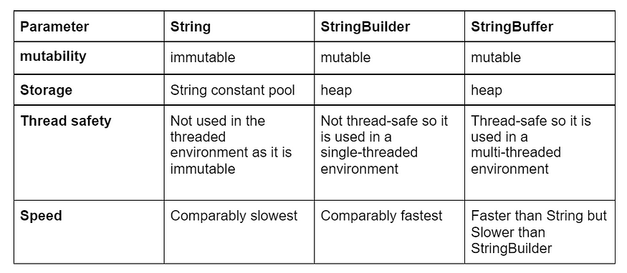
StringBuffer | StringBuilder
StringBuffer is present since early versions of Java. | StringBuilder was introduced in Java 5 (JDK 1.5).
StringBuffer is synchronized. This means that multiple threads cannot call the methods of StringBuffer simultaneously. | StringBuilder is asynchronized. This means that multiple threads can call the methods of StringBuilder simultaneously.
Due to synchronization, StringBuffer is called a thread safe class. | Due to its asynchronous nature, StringBuilder is not a thread safe class.
Due to synchronization, StringBuffer is lot slower than StringBuilder. | Since there is no preliminary check for multiple threads, StringBuilder is a lot faster than StringBuffer.
Use in multi-threaded environments. | Use in single-threaded or non-concurrent environments.

QNo2.Create class and declare a String variable and print first three character of the given String in Uppercase and rest String into Lowercase.
QNo3. Create class and declare a String variable and print Last three character of the given String in Uppercase and rest String into Lowercase.
QNo4.Create class and declare the String Variable and print the first letter in Uppercase for Every Word without using Inbuild Method.

COLLECTION FRAMEWORK
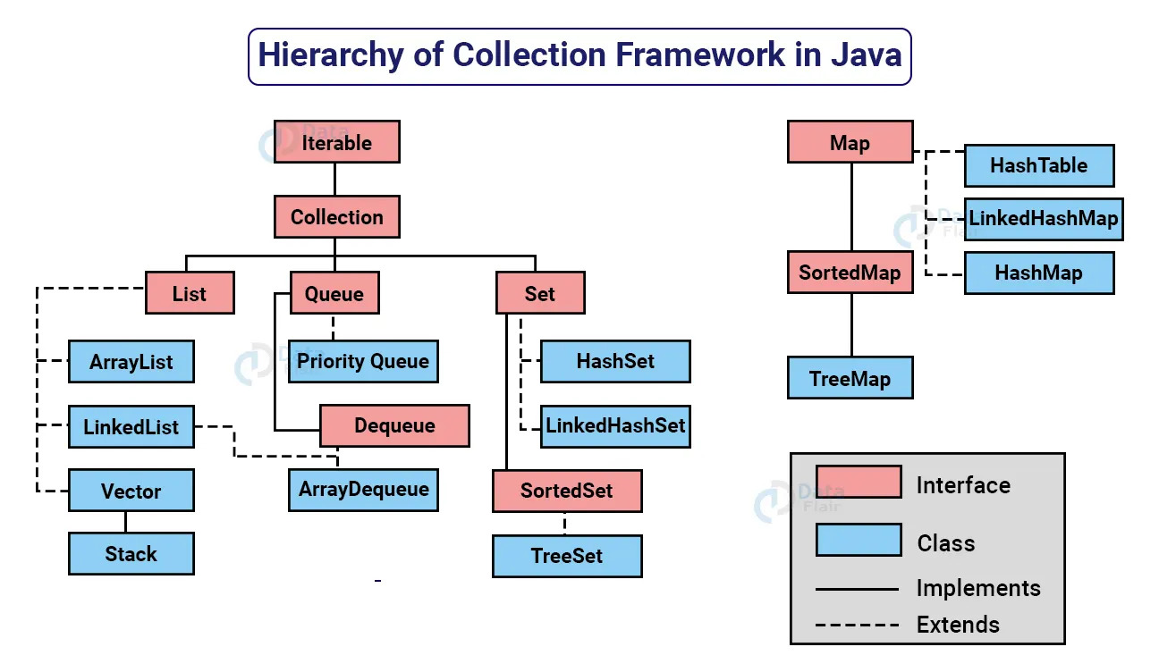
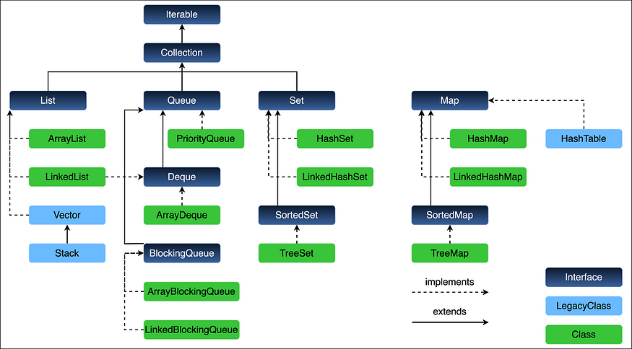

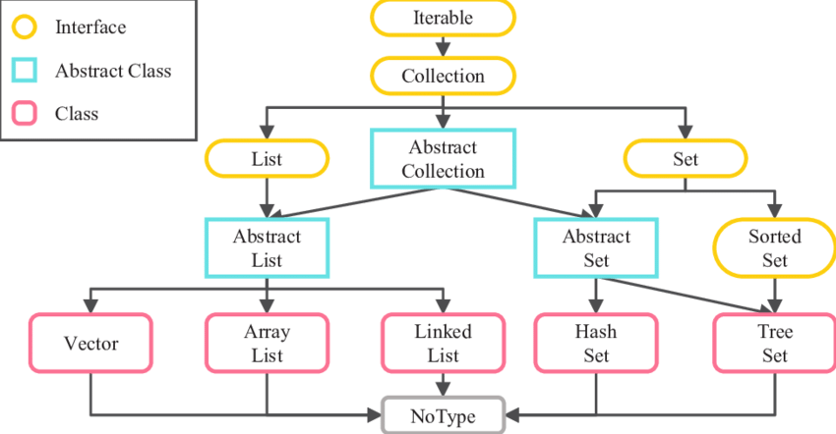

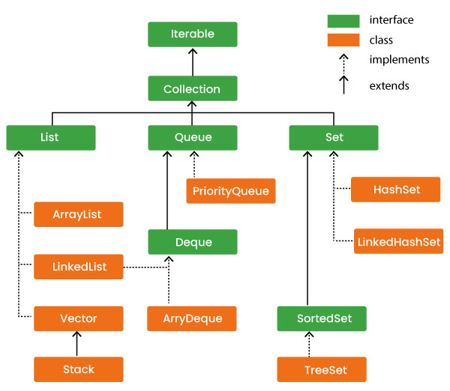

-With the help of Collection framework, we can store the Objects and maintain in organized way.
-The Collection framework it is Present inside the java.util Package.-
-The Fully Qualified Name For All the Collection class is java.util.ClassName.

Java Collection Interfaces
The collections framework defines several interfaces. This section provides an overview of each interface −
Sr.No. | Interface & Description
1 | The Collection Interface  This enables you to work with groups of objects; it is at the top of the collections hierarchy.
2 | The List Interface  This extends Collection and an instance of List stores an ordered collection of elements.
3 | The Set  This extends Collection to handle sets, which must contain unique elements.
4 | The SortedSet  This extends Set to handle sorted sets.
5 | The Map  This maps unique keys to values.
6 | The Map.Entry  This describes an element (a key/value pair) in a map. This is an inner class of Map.
7 | The SortedMap  This extends Map so that the keys are maintained in an ascending order.
8 | The Enumeration  This is legacy interface defines the methods by which you can enumerate (obtain one at a time) the elements in a collection of objects. This legacy interface has been superceded by Iterator.

JAVA COLLECTION CLASSES

-Java provides a set of standard collection classes that implement Collection interfaces. Some of the classes provide full implementations that can be used as-is and others are abstract class, providing skeletal implementations that are used as starting points for creating concrete collections.
-The standard collection classes are summarized in the following table −
Sr.No. | Class & Description
1 | AbstractCollection  Implements most of the Collection interface.
2 | AbstractList  Extends AbstractCollection and implements most of the List interface.
3 | AbstractSequentialList  Extends AbstractList for use by a collection that uses sequential rather than random access of its elements.
4 | LinkedList  Implements a linked list by extending AbstractSequentialList.
5 | ArrayList  Implements a dynamic array by extending AbstractList.
6 | AbstractSet  Extends AbstractCollection and implements most of the Set interface.
7 | HashSet  Extends AbstractSet for use with a hash table.
8 | LinkedHashSet  Extends HashSet to allow insertion-order iterations.
9 | TreeSet  Implements a set stored in a tree. Extends AbstractSet.
10 | AbstractMap  Implements most of the Map interface.
11 | HashMap  Extends AbstractMap to use a hash table.
12 | TreeMap  Extends AbstractMap to use a tree.
13 | WeakHashMap  Extends AbstractMap to use a hash table with weak keys.
14 | LinkedHashMap  Extends HashMap to allow insertion-order iterations.
15 | IdentityHashMap  Extends AbstractMap and uses reference equality when comparing documents.

-The AbstractCollection, AbstractSet, AbstractList, AbstractSequentialList and AbstractMap classes provide skeletal implementations of the core collection interfaces, to minimize the effort required to implement them.
-The following legacy classes defined by java.util have been discussed in the previous chapter −
Sr.No. | Class & Description
1 | Vector  This implements a dynamic array. It is similar to ArrayList, but with some differences.
2 | Stack  Stack is a subclass of Vector that implements a standard last-in, first-out stack.
3 | Dictionary  Dictionary is an abstract class that represents a key/value storage repository and operates much like Map.
4 | Hashtable  Hashtable was part of the original java.util and is a concrete implementation of a Dictionary.
5 | Properties  Properties is a subclass of Hashtable. It is used to maintain lists of values in which the key is a String and the value is also a String.
6 | PriorityQueue  PriorityQueue class is an unbounded priority queue based on a priority heap. A priority queue relying on natural ordering also does not permit insertion of non-comparable objects.
7 | BitSet  A BitSet class creates a special type of array that holds bit values. This array can increase in size as needed.
8 | ArrayDeque  ArrayDeque class provides resizable-array and implements the Deque interface. Array deques have no capacity restrictions so they grow as necessary to support usage.
9 | EnumMap  EnumMap class is a specialized Map implementation for use with enum keys. All of the keys in an enum map must come from a single enum type that is specified, explicitly or implicitly, when the map is created.
10 | Queue  The queue interface is provided in java.util package and it implements the Collection interface. The queue implements FIFO i.e. First In First Out. This means that the elements entered first are the ones that are deleted first.
11 | Deque  EnumMap class is a specialized Map implementation for use with enum keys. All of the keys in an enum map must come from a single enum type that is specified, explicitly or implicitly, when the map is created.

ITERABLE
-In simple words, the iterable interface is a common interface that allows us to iterate over a collection of objects. It was first introduced with the release of JDK 1.5 and made available in 'java.lang' package.
-The Java Collection Framework extends this interface, hence all the classes available in this collection framework by default implement the iterable interface.
-In other words, the classes of collection framework such as ArrayList, TreeSet, TreeMap and HashMap are iterable.

General Syntax of Iterable Interface
public interface Iterable<TypeOfElement> { }

General Syntax of Iterator()
Iterator<TypeOfCollection> instanceOfIterator = nameOfCollection.iterator();

The Iterator interface provides the following methods
- hasNext() − It returns true if there are more elements to iterate over.
- next() − It returns the next element in the iteration if hasNext() returns true.
- remove() − It removes the current element from the collection.

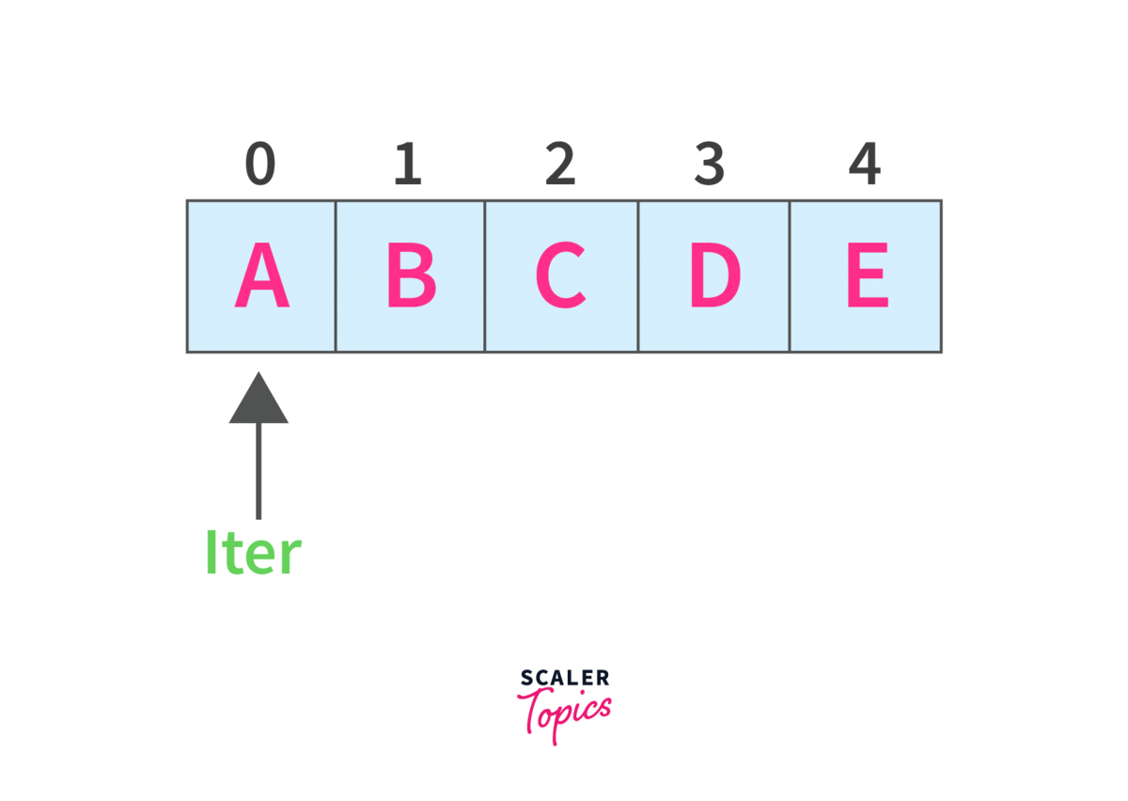

COLLECTIONS

-The Collection interface is the root interface of the collections framework hierarchy.
-If we want to represent a group of individual objects as a single entity then we should go for collection.
-A Collection is an interface allowing items to be grouped within a single container object. It is found in the java.util package and is implemented by List, Set, and Queue.
-There are many varied Collection types in Java, and the special Collections class is provided to manipulate them.
Syntax
import java.util;
Collection<DataType> c = new CollectionClass<DataType>();

-Where DataType is the data type to be stored in the collection and CollectionClass is some class implementing the Collection interface.
Methods
The Collection interface utilizes the following methods:
Method | Syntax | Description
.add() | .add(item) | Adds item to the collection if it wasn’t a member already.
.addAll() | .addAll(collection) | Adds the elements in collection to the collection.
.clear() | .clear() | Removes all the items in the collection.
.contains() | .contains(item) | Returns true if item is a member of the collection.
.containsAll() | .contains(collection) | Returns true if all the items in collection are contained in the collection.
.isEmpty() | .isEmpty() | Returns true if the collection contains no elements.
.remove() | .remove(item) | Removes item from the collection.
.removeAll() | .removeAll(collection) | Removes all items in collection from the collection.
.size() | .size() | Returns the number of elements in the collection.
.toArray() | .toArray() | Returns an array containing all the elements in the collection.
 | .toArray(array) | Returns an array whose data type is the same as array.

1.LIST
-List it is an Interface in java.
-List it is present inside the java.util package.
-The Fully Qualified Name of List is java.util.list.
-List interface it is a child of Iterator Interface.
-We cannot create the object for the List Interface[Because it does not support Constructor] but we can create the Object for its Child Classes[ArrayList,Vector].
-With the help of List we can Add or Remove and Use and Object[Read] from Anywhere but we cannot Modify the Object.
-List is classified Into Two Types
- ArrayList
- LinkedList
-Since List is an interface, we cannot create objects from it.
In order to use the functionalities of the List interface, we can use these classes:
- ArrayList
- LinkedList
- Vector
- Stack

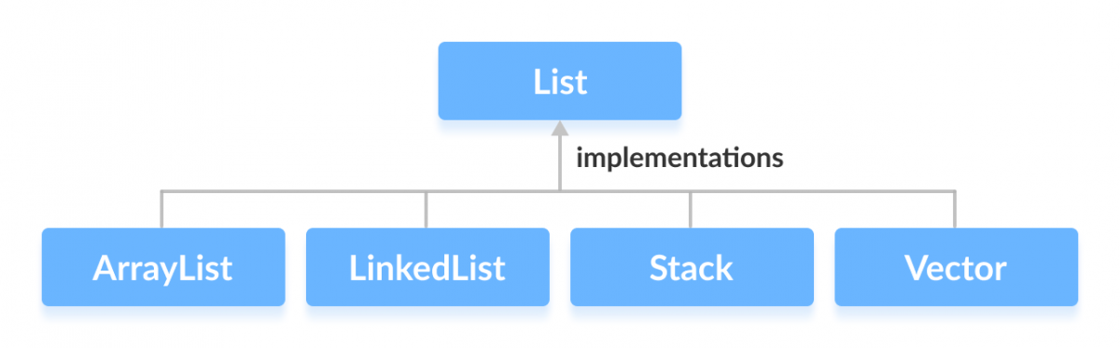

===================IMPORTANT =================
- Java List interface is a member of the Java Collections Framework.
- List allows you to add duplicate elements.
- List allows you to have ‘null’ elements.
- List interface got many default methods in Java 8, for example replaceAll, sort and spliterator.
- List indexes start from 0, just like arrays.
- List supports Generics and we should use it whenever possible. Using Generics with List will avoid ClassCastException at runtime.

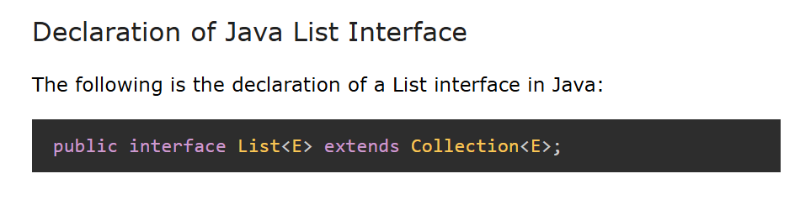
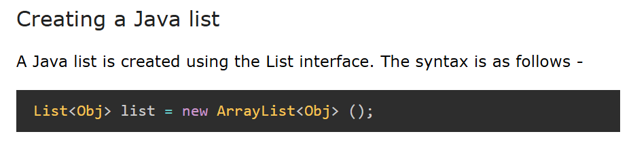

Some of the commonly used methods of the Collection interface that's also available in the List interface are:
Methods | Description
add() | adds an element to a list
addAll() | adds all elements of one list to another
get() | helps to randomly access elements from lists
iterator() | returns iterator object that can be used to sequentially access elements of lists
set() | changes elements of lists
remove() | removes an element from the list
removeAll() | removes all the elements from the list
clear() | removes all the elements from the list (more efficient than removeAll())
size() | returns the length of lists
toArray() | converts a list into an array
contains() | returns true if a list contains specific element

Java - The LinkedList Class
1.LINKEDLIST

-The LinkedList class extends AbstractSequentialList and implements the List interface. It provides a linked-list data structure.
1]Linked List
1]Single Linked List
2]Double Linked List
The important points about Java LinkedList are:
- Java LinkedList class can contain duplicate elements.
- Java LinkedList class maintains insertion order.
- Java LinkedList class is non synchronized.
- In Java LinkedList class, manipulation is fast because no shifting needs to occur.
- Java LinkedList class can be used as a list, stack or queue.
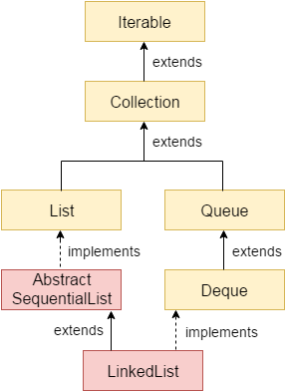
Hierarchy of LinkedList class
-As shown in the above diagram, Java LinkedList class extends AbstractSequentialList class and implements List and Deque interfaces.
Following are the constructors supported by the LinkedList class.
Sr.No. | Constructor & Description
1 | LinkedList( )  This constructor builds an empty linked list.
2 | LinkedList(Collection c)  This constructor builds a linked list that is initialized with the elements of the collection c.
Apart from the methods inherited from its parent classes, LinkedList defines following methods −
Sr.No. | Method & Description
1 | void add(int index, Object element)  Inserts the specified element at the specified position index in this list. Throws IndexOutOfBoundsException if the specified index is out of range (index < 0 || index > size()).
2 | boolean add(Object o)  Appends the specified element to the end of this list.
3 | boolean addAll(Collection c)  Appends all of the elements in the specified collection to the end of this list, in the order that they are returned by the specified collection's iterator. Throws NullPointerException if the specified collection is null.
4 | boolean addAll(int index, Collection c)  Inserts all of the elements in the specified collection into this list, starting at the specified position. Throws NullPointerException if the specified collection is null.
5 | void addFirst(Object o)  Inserts the given element at the beginning of this list.
6 | void addLast(Object o)  Appends the given element to the end of this list.
7 | void clear()  Removes all of the elements from this list.
8 | Object clone()  Returns a shallow copy of this LinkedList.
9 | boolean contains(Object o)  Returns true if this list contains the specified element. More formally, returns true if and only if this list contains at least one element e such that (o==null ? e==null : o.equals(e)).
10 | Object get(int index)  Returns the element at the specified position in this list. Throws IndexOutOfBoundsException if the specified index is out of range (index < 0 || index >= size()).
11 | Object getFirst()  Returns the first element in this list. Throws NoSuchElementException if this list is empty.
12 | Object getLast()  Returns the last element in this list. Throws NoSuchElementException if this list is empty.
13 | int indexOf(Object o)  Returns the index in this list of the first occurrence of the specified element, or -1 if the list does not contain this element.
14 | int lastIndexOf(Object o)  Returns the index in this list of the last occurrence of the specified element, or -1 if the list does not contain this element.
15 | ListIterator listIterator(int index)  Returns a list-iterator of the elements in this list (in proper sequence), starting at the specified position in the list. Throws IndexOutOfBoundsException if the specified index is out of range (index < 0 || index >= size()).
16 | Object remove(int index)  Removes the element at the specified position in this list. Throws NoSuchElementException if this list is empty.
17 | boolean remove(Object o)  Removes the first occurrence of the specified element in this list. Throws NoSuchElementException if this list is empty. Throws IndexOutOfBoundsException if the specified index is out of range (index < 0 || index >= size()).
18 | Object removeFirst()  Removes and returns the first element from this list. Throws NoSuchElementException if this list is empty.
19 | Object removeLast()  Removes and returns the last element from this list. Throws NoSuchElementException if this list is empty.
20 | Object set(int index, Object element)  Replaces the element at the specified position in this list with the specified element. Throws IndexOutOfBoundsException if the specified index is out of range (index < 0 || index >= size()).
21 | int size()  Returns the number of elements in this list.
22 | Object[] toArray()  Returns an array containing all of the elements in this list in the correct order. Throws NullPointerException if the specified array is null.
23 | Object[] toArray(Object[] a)  Returns an array containing all of the elements in this list in the correct order; the runtime type of the returned array is that of the specified array.

LinkedList as Deque and Queue
-Since the LinkedList class also implements the Queue and the Deque interface, it can implement methods of these interfaces as well. Here are some of the commonly used methods:
Methods | Descriptions
addFirst() | adds the specified element at the beginning of the linked list
addLast() | adds the specified element at the end of the linked list
getFirst() | returns the first element
getLast() | returns the last element
removeFirst() | removes the first element
removeLast() | removes the last element
peek() | returns the first element (head) of the linked list
poll() | returns and removes the first element from the linked list
offer() | adds the specified element at the end of the linked list

1.Single Linked List
-A singly linked list is a data structure consisting of a sequence of nodes, where each node contains data and a reference (or link) to the next node in the sequence. Unlike arrays, linked lists can grow and shrink dynamically, allowing for efficient insertions and deletions.
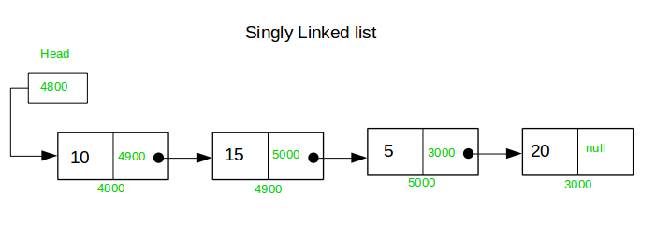

Key Characteristics of Singly Linked Lists:
- Dynamic Size: The size of a linked list can grow or shrink as needed, without the need for resizing.
- Single Direction: Each node points to the next node, allowing traversal in one direction (from head to tail).
- Node Structure: Each node typically consists of two parts: the data and a reference to the next node.
Algorithm
-Create a class Node which has two attributes: data and next. Next is a pointer to the next node.
-Create another class which has two attributes: head and tail.
-addNode() will add a new node to the list:
-Create a new node.
-It first checks, whether the head is equal to null which means the list is empty.
-If the list is empty, both head and tail will point to the newly added node.
-If the list is not empty, the new node will be added to end of the list such that tail's next will point to the newly added node. This new node will become the new tail of the list.

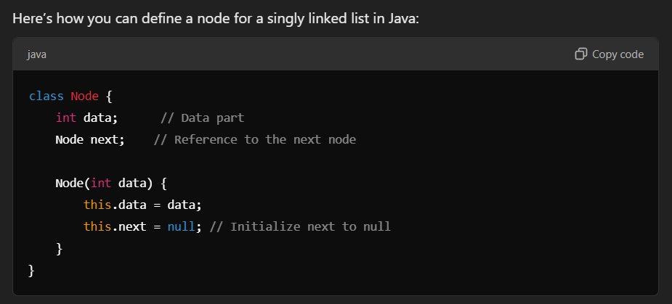

2.Doubly Linked List

A doubly linked list is a type of linked list in which each node consists of 3 components:
- *prev - address of the previous node
- data - data item
- *next - address of next node
data − Each link of a linked list can store a data called an element.
Next − Each link of a linked list contains a link to the next link called Next.
Prev − Each link of a linked list contains a link to the previous link called Prev.
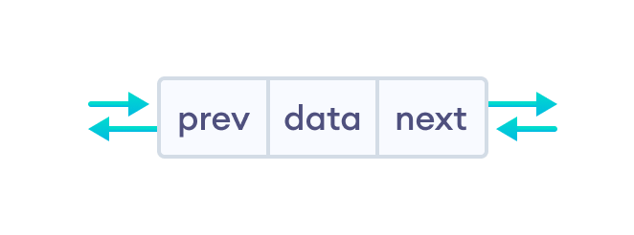
Representation of Doubly Linked List
Let's see how we can represent a doubly linked list on an algorithm/code. Suppose we have a doubly linked list:
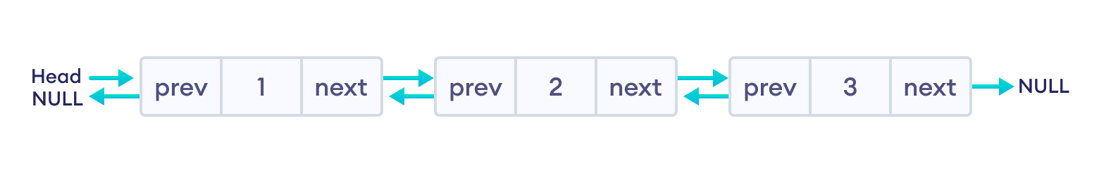Key Characteristics of a Doubly Linked List:
- Bidirectional Traversal: Each node can be accessed from both the previous and next nodes.
- Dynamic Size: The size of the list can grow and shrink dynamically.
- Node Structure: Each node typically consists of three parts: the data, a reference to the next node, and a reference to the previous node.

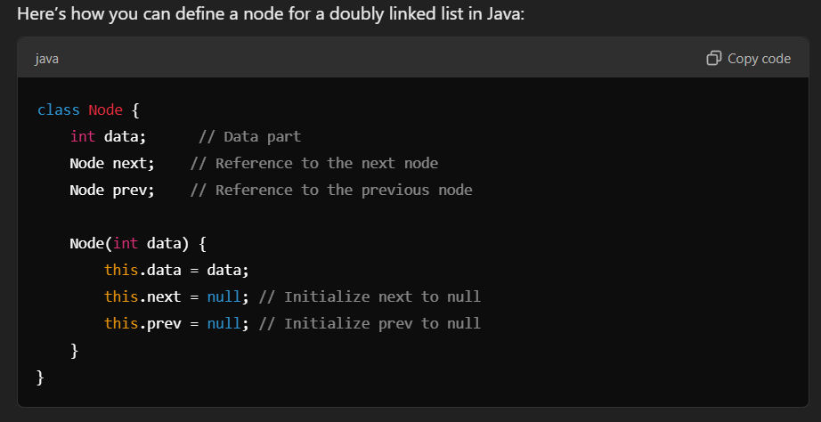

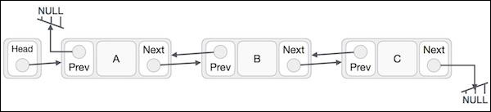
- Doubly Linked List contains a link element called first and last.
- Each link carries a data field(s) and two link fields called next and prev.
- Each link is linked with its next link using its next link.
- Each link is linked with its previous link using its previous link.
- The last link carries a link as null to mark the end of the list.

2.ARRYLIST

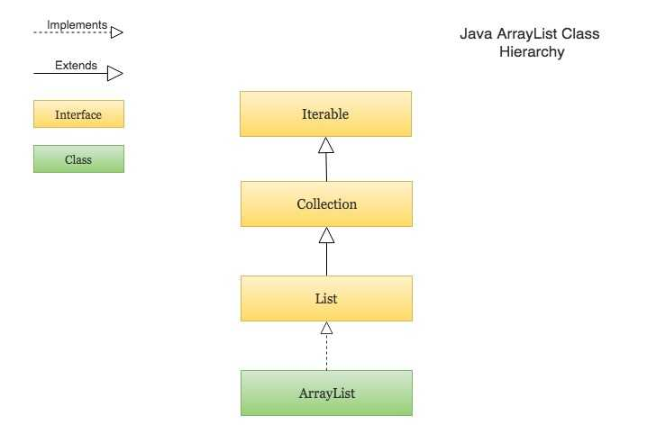

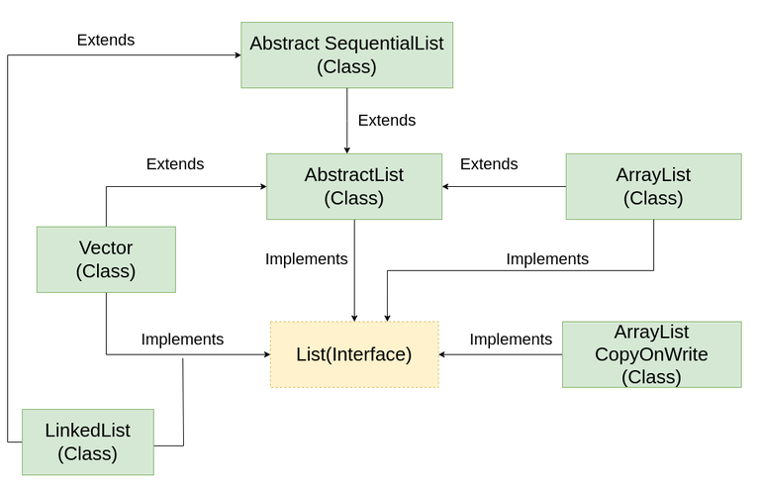
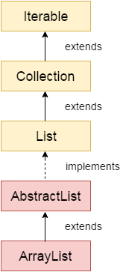
-The ArrayList class is a resizable array, which can be found in the java.util package.
-The difference between a built-in array and an ArrayList in Java, is that the size of an array cannot be modified (if you want to add or remove elements to/from an array, you have to create a new one).
-While elements can be added and removed from an ArrayList whenever you want
- Java ArrayList class can contain duplicate elements.
- Java ArrayList class maintains insertion order.
- Java ArrayList class is non synchronized.
- Java ArrayList allows random access because the array works on an index basis.
- In ArrayList, manipulation is a little bit slower than the LinkedList in Java because a lot of shifting needs to occur if any element is removed from the array list.
-ArrayList in Java maintains the insertion order of elements. This means that when you add elements to an ArrayList, they are stored in the order in which they were added.
-ArrayList it is an Concreate Class In Java.
ArrayList it is Inbuild Class which is Present inside java.util Package.
-The Fully Qualified name of ArrayList is java.util.Arraylist.
-With the Help of ArrayList we can Add ,Remove, Read an Object.
-With the help of ArrayList we can Store Heterogenous type of objects.
-We can create an Object for ArrayList because it is an Concreate Class.
-We can create More than one Objects for the ArrayList but we need to import ArrayList Class from util package first.

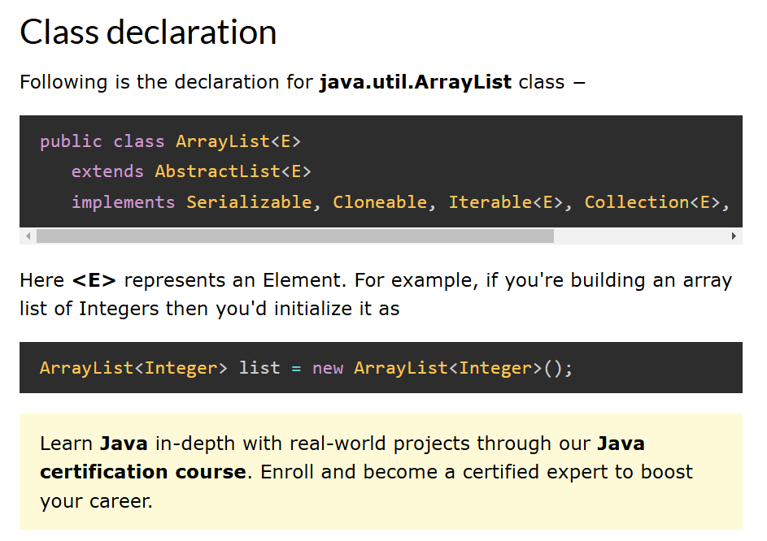

Class constructors
Sr.No. | Constructor & Description
1 | ArrayList()  This constructor is used to create an empty list with an initial capacity sufficient to hold 10 elements.
2 | ArrayList(Collection<? extends E> c)  This constructor is used to create a list containing the elements of the specified collection.
3 | ArrayList(int initialCapacity)  This constructor is used to create an empty list with an initial capacity.

Class methods
Sr.No. | Method & Description
1 | boolean add(E e)  This method appends the specified element to the end of this list.
2 | boolean addAll(Collection<? extends E> c)  This method appends all of the elements in the specified collection to the end of this list, in the order that they are returned by the specified collection's Iterator
3 | void clear()  This method removes all of the elements from this list.
4 | Object clone()  This method returns a shallow copy of this ArrayList instance.
5 | boolean contains(Object o)  This method returns true if this list contains the specified element.
6 | void ensureCapacity(int minCapacity)  This increases the capacity of this ArrayList.
7 | E get(int index)  This method returns the element at the specified position in this list.
8 | int indexOf(Object o)  This method returns the index of the first occurrence of the specified element in this list, or -1 if this list does not contain the element.
9 | boolean isEmpty()  This method returns true if this list contains no elements.
10 | Iterator<E> iterator()  This method returns an iterator over the elements in this list in proper sequence.
11 | int lastIndexOf(Object o)  This method returns the index of the last occurrence of the specified element in this list, or -1 if this list does not contain the element.
12 | ListIterator<E> listIterator()  This method returns an list iterator over the elements in this list in proper sequence.
13 | E remove(int index)  This method removes the element at the specified position in this list.
14 | boolean removeAll(Collection<?> c)  Removes from this list all of its elements that are contained in the specified collection.
15 | protected void removeIf(int fromIndex, int toIndex)  This method Removes all of the elements of this collection that satisfy the given predicate.
16 | boolean retainAll(Collection<?> c)  Retains from this list all of its elements that are contained in the specified collection.
17 | E set(int index, E element)  This method replaces the element at the specified position in this list with the specified element.
18 | int size()  This method returns the number of elements in this list.
19 | Spliterator<E> spliterator()  This method creates a late-binding and fail-fast Spliterator over the elements in this list.
20 | List<E> subList(int fromIndex, int toIndex)  This method returns a view of the portion of this list between the specified fromIndex, inclusive, and toIndex, exclusive.
21 | Object[] toArray()  This method returns an array containing all of the elements in this list in proper sequence (from first to last element).
22 | void trimToSize()  This method trims the capacity of this ArrayList instance to be the list's current size.

Key Points about Insertion Order in ArrayList:
- Sequential Access: When you iterate over an ArrayList, elements are accessed in the same order they were inserted.
- Index-Based Access: You can retrieve elements based on their index, which reflects their position at the time of insertion. For example, the first element added can be accessed at index 0, the second at index 1, and so on.
- Preservation of Order: If you add elements and later remove some, the remaining elements will still maintain their order based on the original insertion sequence.

IndexOutOfBoundsException
-When we try to Access an object which is Present inside the ArrayList based on its index value
-If the Index value is Greater or Equals to the Size of ArrayList we get an Unchecked Exception called as IndexOutBoundsException.
#Program3
Import java.util.ArrayList;
Class P3
{
Public static void main(String args[])
{
ArrayList obj=new ArrayList();
Obj.add(“Amar”);
Obj.add(Akbar”);
System.out.println(obj.get(0));
System.out.println(obj.get(1));
System.out.println(obj.get(2))//Exception
}
}

Difference Between ArrayList and LinkedList
ArrayList and LinkedList both implement the List interface and maintain insertion order. Both are non-synchronized classes.
However, there are many differences between the ArrayList and LinkedList classes that are given below.

ArrayList | LinkedList
1) ArrayList internally uses a dynamic array to store the elements. | LinkedList internally uses a doubly linked list to store the elements.
2) Manipulation with ArrayList is slow because it internally uses an array. If any element is removed from the array, all the other elements are shifted in memory. | Manipulation with LinkedList is faster than ArrayList because it uses a doubly linked list, so no bit shifting is required in memory.
3) An ArrayList class can act as a list only because it implements List only. | LinkedList class can act as a list and queue both because it implements List and Deque interfaces.
4) ArrayList is better for storing and accessing data. | LinkedList is better for manipulating data.
5) The memory location for the elements of an ArrayList is contiguous. | The location for the elements of a linked list is not contagious.
6) Generally, when an ArrayList is initialized, a default capacity of 10 is assigned to the ArrayList. | There is no case of default capacity in a LinkedList. In LinkedList, an empty list is created when a LinkedList is initialized.
7) To be precise, an ArrayList is a resizable array. | LinkedList implements the doubly linked list of the list interface.

3.VECTOR

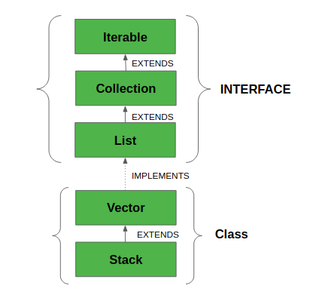

-Vector implements a dynamic array. It is similar to ArrayList, but with two differences −
- Vector is synchronized.
- Vector contains many legacy methods that are not part of the collections framework.
-The Vector class synchronizes each individual operation. This means whenever we want to perform some operation on vectors, the Vector class automatically applies a lock to that operation.
-It is because when one thread is accessing a vector, and at the same time another thread tries to access it, an exception called ConcurrentModificationException is generated.
-Hence, this continuous use of lock for each operation makes vectors less efficient.

-However, in array lists, methods are not synchronized. Instead, it uses the Collections.synchronizedList() method that synchronizes the list as a whole.
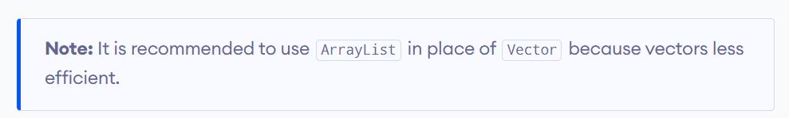
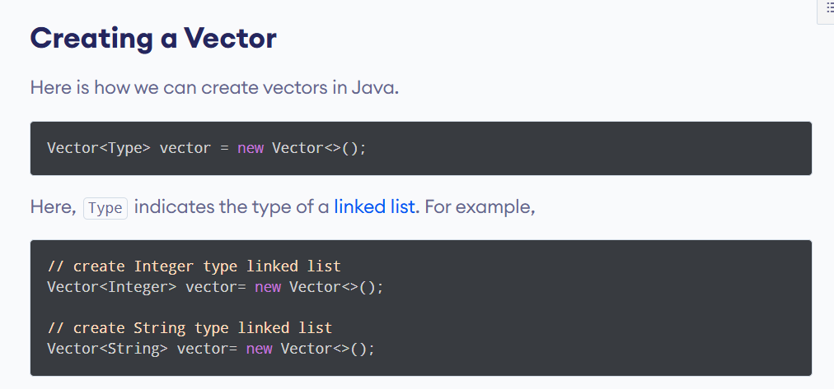

Following is the list of constructors provided by the vector class.
Sr.No. | Constructor & Description
1 | Vector( )  This constructor creates a default vector, which has an initial size of 10.
2 | Vector(int size)  This constructor accepts an argument that equals to the required size, and creates a vector whose initial capacity is specified by size.
3 | Vector(int size, int incr)  This constructor creates a vector whose initial capacity is specified by size and whose increment is specified by incr. The increment specifies the number of elements to allocate each time that a vector is resized upward.
4 | Vector(Collection c)  This constructor creates a vector that contains the elements of collection c.
Apart from the methods inherited from its parent classes, Vector defines the following methods −
Sr.No. | Method & Description
1 | boolean add(E e)  This method appends the specified element to the end of this Vector.
2 | boolean addAll(Collection<? extends E> c)  This method appends all of the elements in the specified Collection to the end of this Vector.
3 | void addElement(E obj)  This method adds the specified component to the end of this vector, increasing its size by one.
4 | int capacity()  This method returns the current capacity of this vector.
5 | void clear()  This method removes all of the elements from this vector.
6 | clone clone()  This method returns a clone of this vector.
7 | boolean contains(Object o)  This method returns true if this vector contains the specified element.
8 | boolean containsAll(Collection<?> c)  This method returns true if this Vector contains all of the elements in the specified Collection.
9 | void copyInto(Object[ ] anArray)  This method copies the components of this vector into the specified array.
10 | E elementAt(int index)  This method returns the component at the specified index.
11 | Enumeration<E> elements()  This method returns an enumeration of the components of this vector.
12 | void ensureCapacity(int minCapacity)  This method increases the capacity of this vector, if necessary, to ensure that it can hold at least the number of components specified by the minimum capacity argument.
13 | boolean equals(Object o)  This method compares the specified Object with this Vector for equality.
14 | E firstElement()  This method returns the first component (the item at index 0) of this vector.
15 | void forEach​(Consumer<? super E> action)  This method performs the given action for each element of the Iterable until all elements have been processed or the action throws an exception.
16 | E get(int index)  This method returns the element at the specified position in this Vector.
17 | int hashCode()  This method returns the hash code value for this Vector.
18 | int indexOf(Object o)  This method returns the index of the first occurrence of the specified element in this vector, or -1 if this vector does not contain the element.
19 | void insertElementAt(E obj, int index)  This method inserts the specified object as a component in this vector at the specified index.
20 | boolean isEmpty()  This method tests if this vector has no components.
21 | Iterator<E&t; iterator()  This method returns an iterator over the elements in this list in proper sequence.
22 | E lastElement()  This method returns the last component of the vector.
23 | int lastIndexOf​(Object o)  This method returns the index of the last occurrence of the specified element in this vector, or -1 if this vector does not contain the element.
24 | ListIterator<E> listIterator()  This method returns a list iterator over the elements in this list (in proper sequence).
25 | E remove(int index)  This method removes the element at the specified position in this Vector.
26 | boolean removeAll(Collection<?> c)  This method removes from this Vector all of its elements that are contained in the specified Collection.
27 | void removeAllElements()  This method removes all components from this vector and sets its size to zero.
28 | boolean removeElement(Object obj)  This method removes the first occurrence of the argument from this vector.
29 | void removeElementAt(int index)  This method deletes the component at the specified index.
30 | boolean removeIf​(Predicate<? super E> filter)  Removes all of the elements of this collection that satisfy the given predicate.
31 | boolean retainAll(Collection<?> c)  This method retains only the elements in this Vector that are contained in the specified Collection.
32 | E set(int index, E element)  This method replaces the element at the specified position in this Vector with the specified element.
33 | void setElementAt(E obj, int index)  This method sets the component at the specified index of this vector to be the specified object.
34 | void setSize(int newSize)  This method sets the size of this vector.
35 | int size()  This method returns the number of components in this vector.
36 | Spliterator<E&t; spliterator()  Creates a late-binding and fail-fast Spliterator over the elements in this list.
37 | List <E> subList(int fromIndex, int toIndex)  This method returns a view of the portion of this List between fromIndex, inclusive, and toIndex, exclusive.
38 | object[] toArray()  This method returns an array containing all of the elements in this Vector in the correct order.
39 | String toString()  This method returns a string representation of this Vector, containing the String representation of each element.
40 | void trimToSize()  This method trims the capacity of this vector to be the vector's current size.

GENERICS IN JAVA

Generics means parameterized types. The idea is to allow a type (like Integer, String, etc., or user-defined types) to be a parameter to methods, classes, and interfaces.
-Using Generics, it is possible to create classes that work with different data types. An entity such as a class, interface, or method that operates on a parameterized type is a generic entity.
<> Operator Name:-
1]Angular Bracket
2]Diamond Bracket
3]Generics

Key Features of Generics
- Type Safety: Generics allow you to specify the data types of the elements that a class or method can operate on, reducing the risk of ClassCastException at runtime.
- Code Reusability: You can write a single class or method that can work with different types, making your code more reusable and easier to maintain.
- Elimination of Casting: When you use generics, you don't need to cast the objects explicitly when retrieving them from a collection.

import java.util.ArrayList;
public class GenericArrayListExample {
public static void main(String[] args) {
// Create a generic ArrayList for Strings
ArrayList<String> stringList = new ArrayList<>();

// Adding elements
stringList.add("Hello");
stringList.add("World");
stringList.add("Generics");

// Displaying the ArrayList
System.out.println("String ArrayList: " + stringList); // Output: [Hello, World, Generics]

// Creating a generic ArrayList for Integers
ArrayList<Integer> integerList = new ArrayList<>();

// Adding elements
integerList.add(1);
integerList.add(2);
integerList.add(3);

// Displaying the Integer ArrayList
System.out.println("Integer ArrayList: " + integerList); // Output: [1, 2, 3]
}
}

Explanation of the Code:
- Import Statement: The ArrayList class is imported from the java.util package.
- Creating an ArrayList:
  - ArrayList<String> stringList = new ArrayList<>(); creates a generic ArrayList that can hold String objects.
  - ArrayList<Integer> integerList = new ArrayList<>(); creates a generic ArrayList that can hold Integer objects.
- Adding Elements: Use the add() method to insert elements into the list.
- Displaying the ArrayList: Simply printing the ArrayList will show its contents.
- Accessing Elements: You can retrieve an element using the get(index) method.
- Removing Elements: Use the remove(element) method to delete a specific element from the list.
Benefits of Using Generics with ArrayList
- Type Safety: The compiler checks the type of elements during compile time, reducing runtime errors.
- Elimination of Casting: You don't need to cast elements when retrieving them from the list.
- Flexibility: You can create ArrayList instances for any type (e.g., String, Integer, or even custom classes).

2.SET
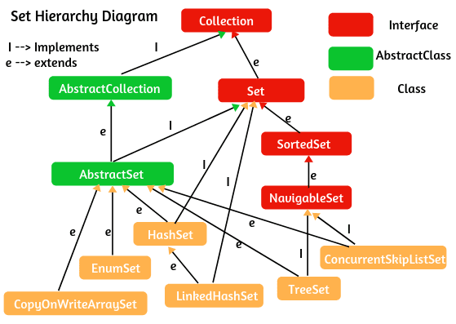

-Set it is an Interface In java
-It is Present inside the java.util package.
-The Fully Qualified Name java.util.Set.
-We cannot create object for Set Interface but we can create Object for its child Classes[HashSet,TreeSet]
-The set interface extends the Collection interface.
- A Set is a Collection that cannot contain duplicate elements. It provides the features of the mathematical set in Java.

Classes that implement Set
Since Set is an interface, we cannot create objects from it.
In order to use functionalities of the Set interface, we can use these classes:
- HashSet
- LinkedHashSet
- EnumSet
- TreeSet
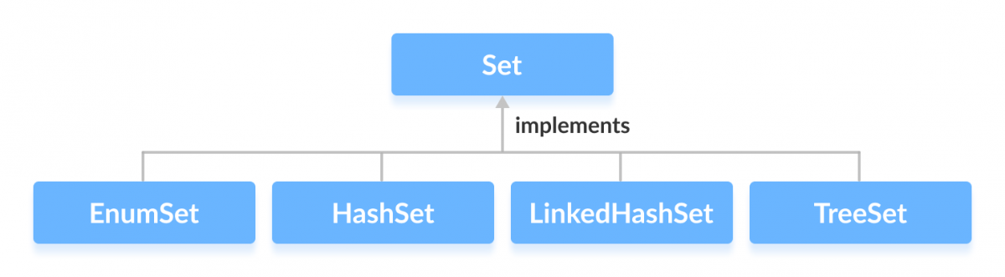

Methods of Set
The Set interface includes all the methods of the Collection interface. It's because Collection is a super interface of Set.
Some of the commonly used methods of the Collection interface that's also available in the Set interface are:
- add() - adds the specified element to the set
- addAll() - adds all the elements of the specified collection to the set
- iterator() - returns an iterator that can be used to access elements of the set sequentially
- remove() - removes the specified element from the set
- removeAll() - removes all the elements from the set that is present in another specified set
- retainAll() - retains all the elements in the set that are also present in another specified set
- clear() - removes all the elements from the set
- size() - returns the length (number of elements) of the set
- toArray() - returns an array containing all the elements of the set
- contains() - returns true if the set contains the specified element
- containsAll() - returns true if the set contains all the elements of the specified collection
- hashCode() - returns a hash code value (address of the element in the set)

1.HASHSET

-HashSet is a Concreate Class in Set.
-HashSet Present inside the java.util Package.
-The Fully Qualified Name oh HashSet is java.util.HashSet
-We can store the Heterogenous Type objects inside the HashSet.
-HashSet Does Not maintain insertion order.
-HashSet it will remove Duplicate Objects Automatically.
-We can create an object for HashSet but we need to import HashSet from java.util package.
- This class makes no guarantees as to the iteration order of the set; in particular, it does not guarantee that the order will remain constant over time.
- This class permits the null element.
Class constructors
Sr.No. | Constructor & Description
1 | HashSet( )  This constructor constructs a default HashSet.
2 | HashSet(Collection c)  This constructor initializes the hash set by using the elements of the collection c.
3 | HashSet(int capacity)  This constructor initializes the capacity of the hash set to the given integer value capacity. The capacity grows automatically as elements are added to the HashSet.
4 | HashSet(int capacity, float fillRatio)  This constructor initializes both the capacity and the fill ratio (also called load capacity) of the hash set from its arguments.  Here the fill ratio must be between 0.0 and 1.0, and it determines how full the hash set can be before it is resized upward. Specifically, when the number of elements is greater than the capacity of the hash set multiplied by its fill ratio, the hash set is expanded.
-Apart from the methods inherited from its parent classes, HashSet defines following methods −
Sr.No. | Method & Description
1 | boolean add(E e)  This method adds the specified element to this set if it is not already present.
2 | void clear()  This method removes all of the elements from this set.
3 | Object clone()  This method returns a shallow copy of this HashSet instance, the elements themselves are not cloned.
4 | boolean contains(Object o)  This method returns true if this set contains the specified element.
5 | boolean isEmpty()  This method returns true if this set contains no elements.
6 | Iterator<E> iterator()  This method returns an iterator over the elements in this set.
7 | boolean remove(Object o)  This method removes the specified element from this set if it is present.
8 | int size()  This method returns returns the number of elements in this set(its cardinality).
9 | Spliterator<E> spliterator()  This method returns a late-binding and fail-fast Spliterator over the elements in this set.
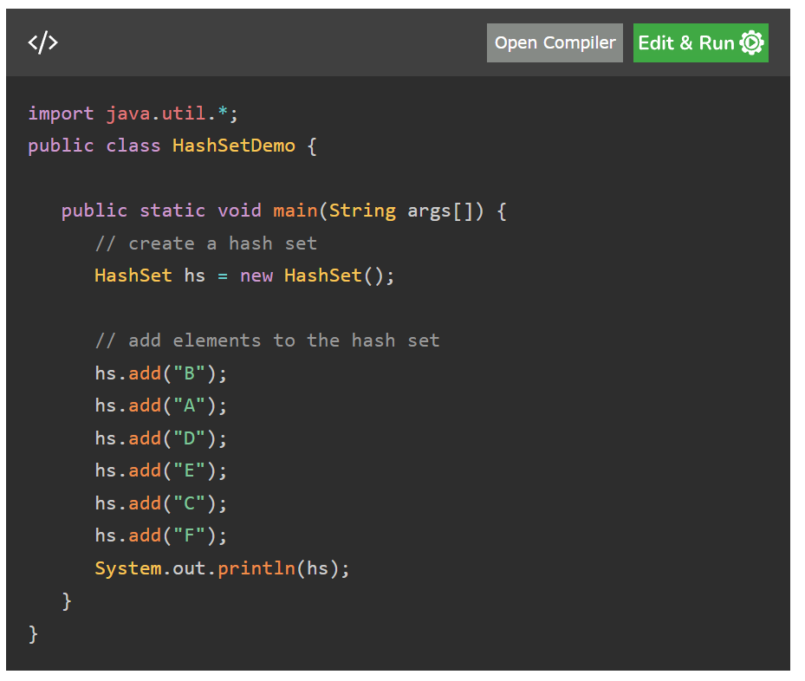

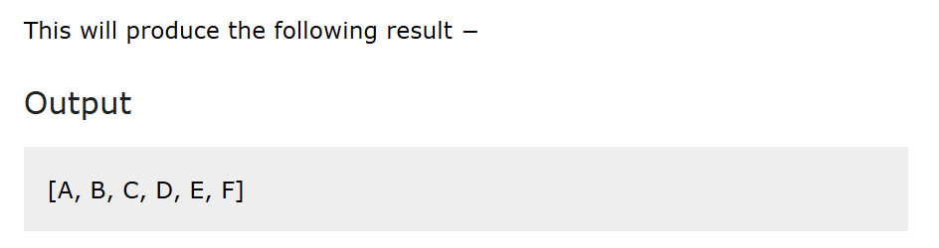

2.TREESET

-The TreeSet class of the Java collections framework provides the functionality of a tree data structure.
-It extends the NavigableSet interface.

TreeSet is an Concreate class.
-TreeSet it is Present inside java.util Package
-We can Store Homogeneous Type of objects inside TreeSet.
-TreeSet does not Allow Duplicate Object
-TreeSet it will Automatically Sort the object in Ascending Order.
-We can create an Object for TreeSet but we need to import TreeSet from
Util package first.
The important points about the Java TreeSet class are:
- Java TreeSet class contains unique elements only like HashSet.
- Java TreeSet class access and retrieval times are quiet fast.
- Java TreeSet class doesn't allow null element.
- Java TreeSet class is non synchronized.
- Java TreeSet class maintains ascending order.
- Java TreeSet class contains unique elements only like HashSet.
- Java TreeSet class access and retrieval times are quite fast.
- Java TreeSet class doesn't allow null elements.
- Java TreeSet class is non-synchronized.
- Java TreeSet class maintains ascending order.
- The TreeSet can only allow those generic types that are comparable. For example The Comparable interface is being implemented by the StringBuffer class.
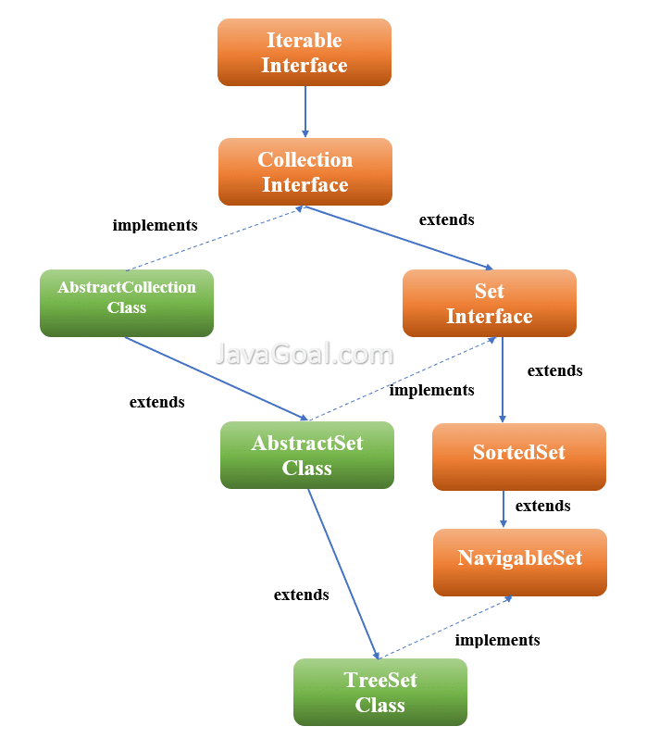

Following is the list of the constructors supported by the TreeSet class.
Sr.No. | Constructor & Description
1 | TreeSet( )  This constructor constructs an empty tree set that will be sorted in an ascending order according to the natural order of its elements.
2 | TreeSet(Collection c)  This constructor builds a tree set that contains the elements of the collection c.
3 | TreeSet(Comparator comp)  This constructor constructs an empty tree set that will be sorted according to the given comparator.
4 | TreeSet(SortedSet ss)  This constructor builds a TreeSet that contains the elements of the given SortedSet.
Apart from the methods inherited from its parent classes, TreeSet defines the following methods −
Sr.No. | Method & Description
1 | void add(Object o)  Adds the specified element to this set if it is not already present.
2 | boolean addAll(Collection c)  Adds all of the elements in the specified collection to this set.
3 | void clear()  Removes all of the elements from this set.
4 | Object clone()  Returns a shallow copy of this TreeSet instance.
5 | Comparator comparator()  Returns the comparator used to order this sorted set, or null if this tree set uses its elements natural ordering.
6 | boolean contains(Object o)  Returns true if this set contains the specified element.
7 | Object first()  Returns the first (lowest) element currently in this sorted set.
8 | SortedSet headSet(Object toElement)  Returns a view of the portion of this set whose elements are strictly less than toElement.
9 | boolean isEmpty()  Returns true if this set contains no elements.
10 | Iterator iterator()  Returns an iterator over the elements in this set.
11 | Object last()  Returns the last (highest) element currently in this sorted set.
12 | boolean remove(Object o)  Removes the specified element from this set if it is present.
13 | int size()  Returns the number of elements in this set (its cardinality).
14 | SortedSet subSet(Object fromElement, Object toElement)  Returns a view of the portion of this set whose elements range from fromElement, inclusive, to toElement, exclusive.
15 | SortedSet tailSet(Object fromElement)  Returns a view of the portion of this set whose elements are greater than or equal to fromElement.

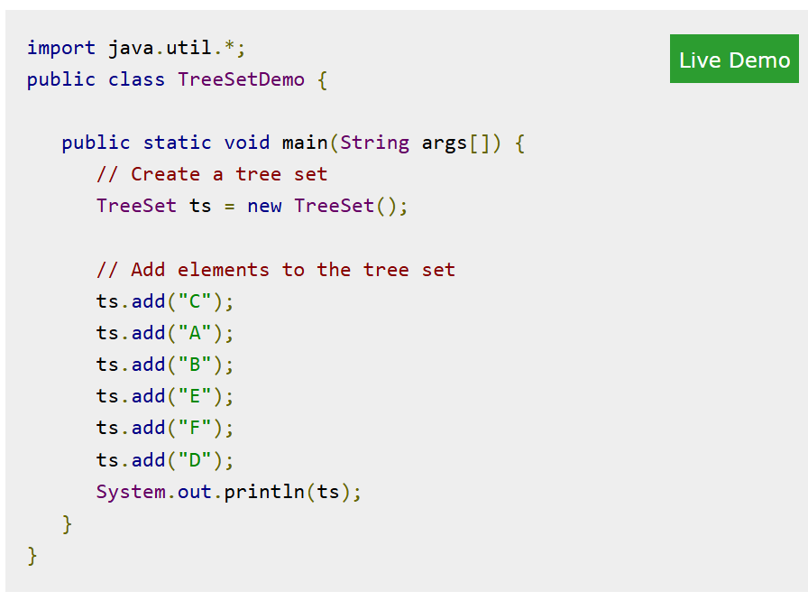

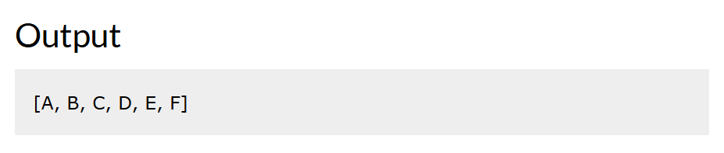

MAP

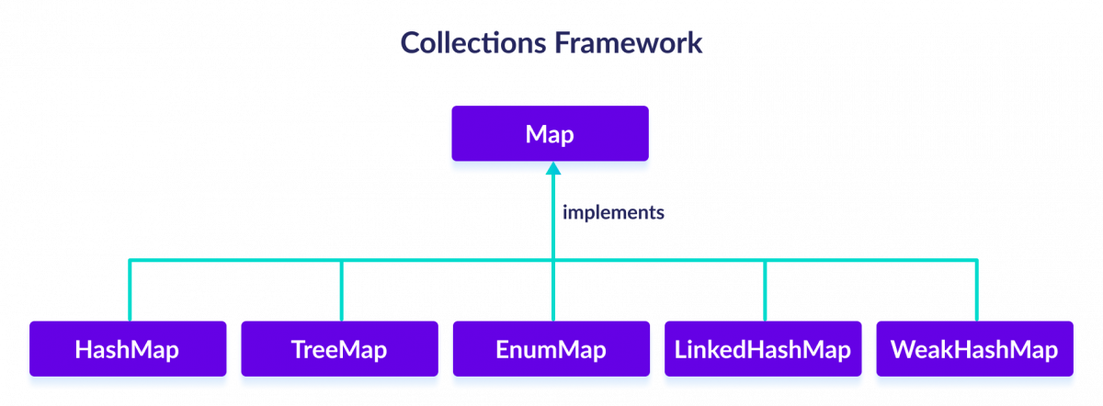

Classes that implement Map
Since Map is an interface, we cannot create objects from it.
In order to use the functionalities of the Map interface, we can use these classes:
- HashMap
- EnumMap
- LinkedHashMap
- WeakHashMap
- TreeMap
Working of Map
-In Java, elements of Map are stored in key/value pairs. Keys are unique values associated with individual Values.
-A map cannot contain duplicate keys. And, each key is associated with a single value

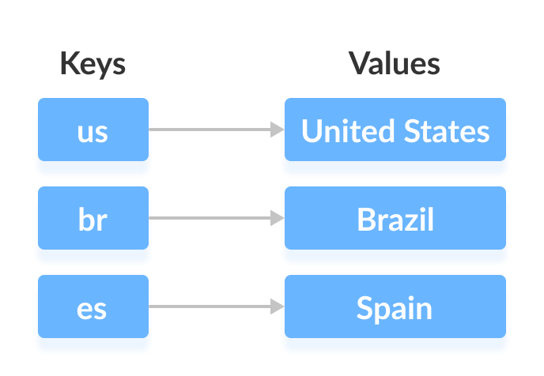
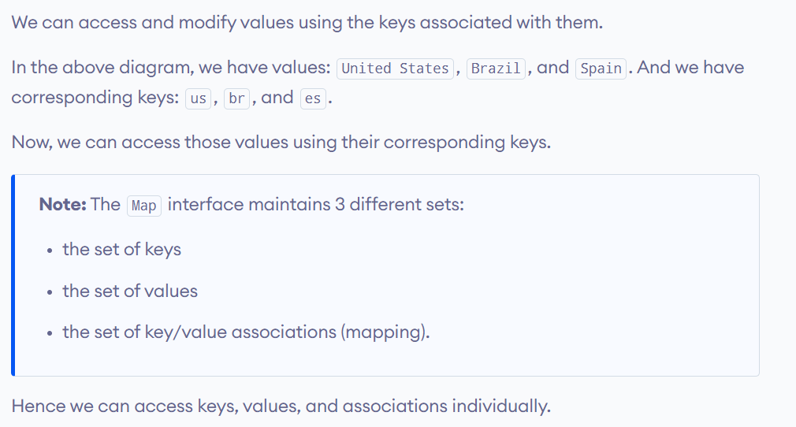
interfaces that extend Map
The Map interface is also extended by these subinterfaces:
- SortedMap
- NavigableMap
- ConcurrentMap

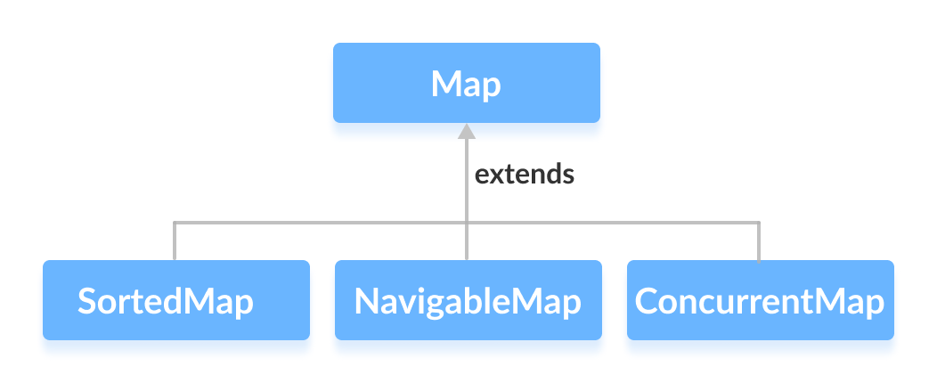

-The Map interface maps unique keys to values. A key is an object that you use to retrieve a value at a later date.

- Given a key and a value, you can store the value in a Map object. After the value is stored, you can retrieve it by using its key.
- Several methods throw a NoSuchElementException when no items exist in the invoking map.
- A ClassCastException is thrown when an object is incompatible with the elements in a map.
- A NullPointerException is thrown if an attempt is made to use a null object and null is not allowed in the map.
- An UnsupportedOperationException is thrown when an attempt is made to change an unmodifiable map.

Map Interface Methods
Sr.No. | Method & Description
1 | void clear( )  Removes all key/value pairs from the invoking map.
2 | boolean containsKey(Object k)  Returns true if the invoking map contains k as a key. Otherwise, returns false.
3 | boolean containsValue(Object v)  Returns true if the map contains v as a value. Otherwise, returns false.
4 | Set entrySet( )  Returns a Set that contains the entries in the map. The set contains objects of type Map.Entry. This method provides a set-view of the invoking map.
5 | boolean equals(Object obj)  Returns true if obj is a Map and contains the same entries. Otherwise, returns false.
6 | Object get(Object k)  Returns the value associated with the key k.
7 | int hashCode( )  Returns the hash code for the invoking map.
8 | boolean isEmpty( )  Returns true if the invoking map is empty. Otherwise, returns false.
9 | Set keySet( )  Returns a Set that contains the keys in the invoking map. This method provides a set-view of the keys in the invoking map.
10 | Object put(Object k, Object v)  Puts an entry in the invoking map, overwriting any previous value associated with the key. The key and value are k and v, respectively. Returns null if the key did not already exist. Otherwise, the previous value linked to the key is returned.
11 | void putAll(Map m)  Puts all the entries from m into this map.
12 | Object remove(Object k)  Removes the entry whose key equals k.
13 | int size( )  Returns the number of key/value pairs in the map.
14 | Collection values( )  Returns a collection containing the values in the map. This method provides a collection-view of the values in the map.

1.HASHMAP

-HashMap however, store items in "key/value" pairs, and you can access them by an index of another type (e.g. a String).
- Java HashMap contains values based on the key.
- Java HashMap contains only unique keys.
- Java HashMap may have one null key and multiple null values.
- Java HashMap is non synchronized.
- Java HashMap maintains no order.
- The initial default capacity of Java HashMap class is 16 with a load factor of 0.75.

Following is the list of constructors supported by the HashMap class.
Sr.No. | Constructor & Description
1 | HashMap( )  This constructor constructs a default HashMap.
2 | HashMap(Map m)  This constructor initializes the hash map by using the elements of the given Map object m.
3 | HashMap(int capacity)  This constructor initializes the capacity of the hash map to the given integer value, capacity.
4 | HashMap(int capacity, float fillRatio)  This constructor initializes both the capacity and fill ratio of the hash map by using its arguments.
Apart from the methods inherited from its parent classes, HashMap defines the following methods −
Sr.No. | Method & Description
1 | void clear()  Removes all mappings from this map.
2 | Object clone()  Returns a shallow copy of this HashMap instance: the keys and values themselves are not cloned.
3 | boolean containsKey(Object key)  Returns true if this map contains a mapping for the specified key.
4 | boolean containsValue(Object value)  Returns true if this map maps one or more keys to the specified value.
5 | Set entrySet()  Returns a collection view of the mappings contained in this map.
6 | Object get(Object key)  Returns the value to which the specified key is mapped in this identity hash map, or null if the map contains no mapping for this key.
7 | boolean isEmpty()  Returns true if this map contains no key-value mappings.
8 | Set keySet()  Returns a set view of the keys contained in this map.
9 | Object put(Object key, Object value)  Associates the specified value with the specified key in this map.
10 | putAll(Map m)  Copies all of the mappings from the specified map to this map. These mappings will replace any mappings that this map had for any of the keys currently in the specified map.
11 | Object remove(Object key)  Removes the mapping for this key from this map if present.
12 | int size()  Returns the number of key-value mappings in this map.
13 | Collection values()  Returns a collection view of the values contained in this map.

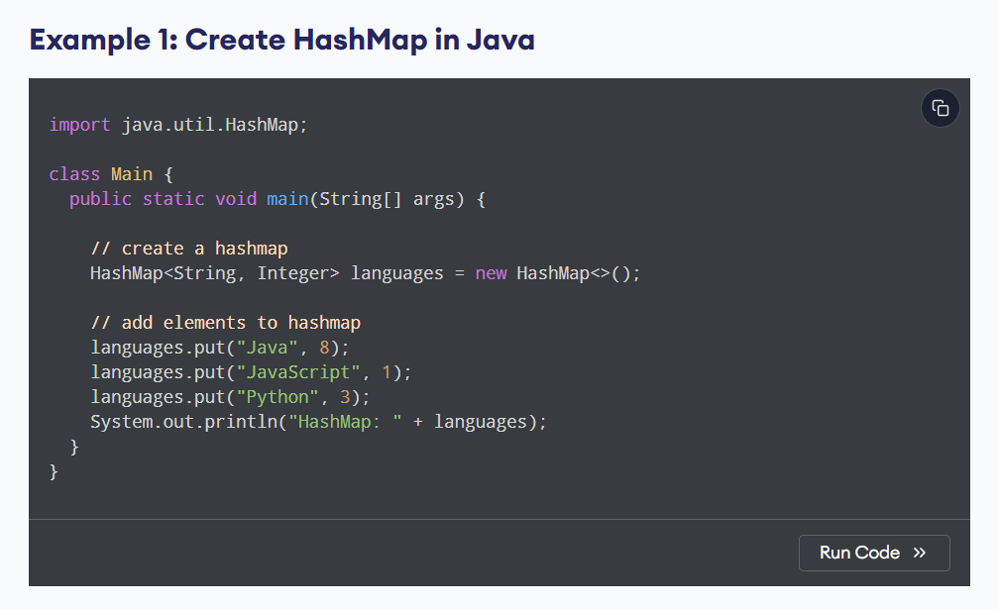
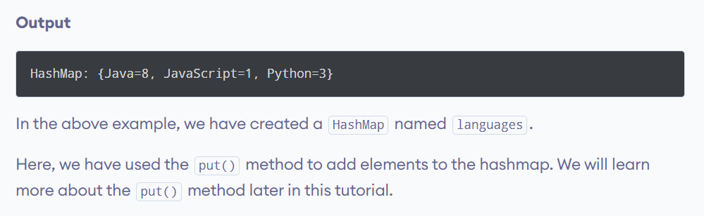

INTERVIEW QUESTION

QNO1:- Write a Java program to find the Positive and Negative Number?
//QNO : Find The Positive and Negative Number
class PositiveNum
{
public static void main(String[] args)
{
int num = -2;
// 1nd Way
/*if (num>0)
{
System.out.println("POSITIVE");
}
else
{
System.out.println("Negative");
}*/
// 2nd Way
String res = num>0 ? "POSITIVE" : "NEGATIVE";
System.out.println(res);
}
}

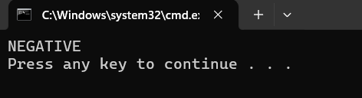

QNO2 : -Write A Program to Find The Prime Number?
class PrimeNumber
{
public static void main(String[] args)
{
int num = 23;
boolean flag = false;
// 0 and 1 ar not Prime Numbers
if (num == 0 || num == 1)
{
flag = true;
}
for (int i= 2;i<=num/2 ;++i)
{
//Condition for Not Prime Number
if (num %2==0 )
{
flag = true;
break;
}
}
if (!flag)
{
System.out.println(num + " : Is a Prime Number");
}
else
{
System.out.println(num + " : Is Not Prime Number");
}
}
}

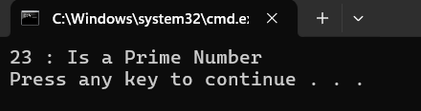

QNO3 : - Write A Program to swap a number without using Third Variable?
class SwapNum
{
public static void main(String[] args)
{
int a=10;
int b=20;

a=a+b;//30
b=a-b;//10
a=a-b;//20

//a=b;
//b=a-10;
System.out.println(a);//20
System.out.println(b);//10
}
}

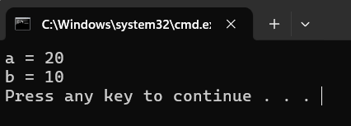

QNO3 : - Write A Program to find The Even And Odd ?
class SwapNum
{
public static void main(String[] args)
{
int a=10;
int b=20;

a=a+b;//30
b=a-b;//10
a=a-b;//20

//a=b;
//b=a-10;
System.out.println(a);//20
System.out.println(b);//10
}
}

